Strange: Lightning kills 36 cows on Ondo sacred hill – Nigeria
Nwafor
23 Sept 2019 - 17 hours ago
…It’s an act of God—Miyetti Allah
…It’s a natural disaster— Police
By Dayo Johnson
https://www-vanguardngr-com.cdn.ampproject.org/v/s/www.vanguardngr.com/2019/09/strange-lightning-kills-36-cows-on-ondo-sacred-hill/amp/?amp_js_v=0.1#referrer=https%3A%2F%2Fwww.google.com&amp_tf=From%20%251%24s&ampshare=https%3A%2F%2Fwww.vanguardngr.com%2F2019%2F09%2Fstrange-lightning-kills-36-cows-on-ondo-sacred-hill%2F
NO fewer than 36 cows, belonging to a herdsman identified as Ladam, were struck dead, Saturday, by lightning at Ijare sacred hill in Ifedore Local Government Area of Ondo State.
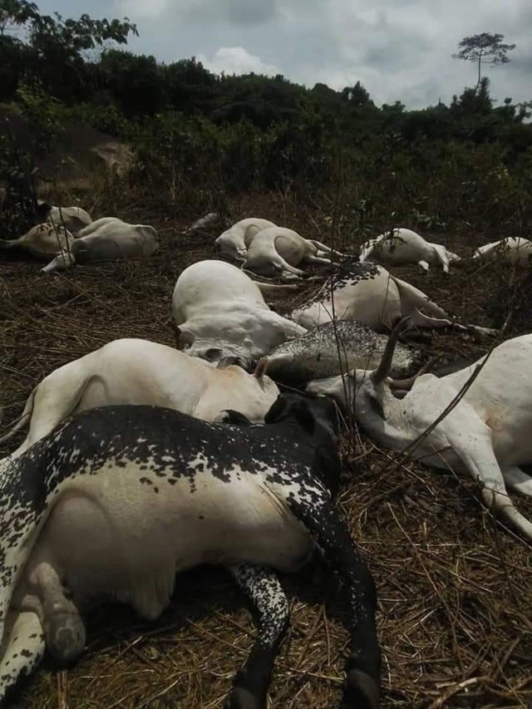

Ladan, who is based in Kwara State, had come to the hill, known as Oke-Owa, on the outskirts of the agrarian community, to graze his herd, when the incident occurred.
Anti-Open Grazing Law: Miyetti Allah drags Benue govt to A’Court(Opens in a new browser tab)
The hill is said to be only visited by the king of the town and some chiefs once in a year, during the celebration of the new yam festival, to perform some rituals.
The incident was said to have been accompanied by a thunderstorm.
When the traditional ruler, Olujare of Ijare, Oba Adegbamigbe Oluwagbenigun, was informed he delegated some chief to confirm.
A report was later made to the Police to avoid breakdown of law and order, after which the hill became a tourist centre, as people from within and outside the community trooped to the scene to see the dead cows.
It’s taboo to go there—Chief
Reacting on behalf of the traditional ruler, his second-in-command, Chief Wemimo Olaniran, the Sapetu of Ijare, said it was “an the act of God.”
Olaniran said: “The herdsmen had been destroying our farmland for a very long time, leading to confrontations on many occasions. We have also warned against their cows going to the sacred hill, but they won’t listen.”
He said it was surprising to them when they heard, days ago, that some herdsmen were ascending the sacred hill to settle after they had destroyed many farmlands and created fears in the minds of the people.
His words: “We were there this morning (yesterday) and we saw about 36 cows dead, besides the ones inside the bush. It has happened and there is nothing we can do. We regard it as the act of God, which nobody can be query.
“There have been occasions like that, but not this massive. In the past, we did witnessed thunderbolt attack when you desecrated any part of Ijare, particularly the sacrifice places; the grove.
“The dead cows will be there forever. It is part of the history in our land, for people to see as testimony in future that such a thing happens. A whole Oba was buried there live and heaven did not fall, talk less of ordinary cows.
“Oke-Owa is a sacred hill, where the Oba and some of his chiefs visit once a year during new yam festival to offer sacrifices on behalf of the community.
“Even those chiefs accompanying the Oba must not go to the inner part of the hill, because there is a particular place where only the Oba has to enter and spend a night. That is what these herdsmen wanted to desecrate with their herds. It is a taboo.
Cattle market in our place is not a blessing, but a curse — Abia monarch (Opens in a new browser tab)
“When we heard about the incident, we invited the herdsmen and they confirmed that it was thunder that struck the cows. We went to the Police station to report the matter and the Divisional Police Officer was contacted before chiefs, including myself, went there.
“Those cows would remain there and rot because nobody must touch them, otherwise there would be problem.”
Miyetti Allah reacts
Chairman of Miyetti Allah in the state, Alhaji Bello Garuba, who confirmed the incident, described it as sad.
Garuba said: “There is nothing we can do about it, because it was an act of God. We have told the owner of the cows to take heart.”
Police image maker, Femi Joseph, who also confirmed that the matter was reported at Ijare Police Station, described the incident as a natural disaster, that is unfortunate and which nobody can do anything about.
*************************
From another newspaper -

MYSTERIOUS: Herdsmen flee after thunder kills 36 cows - Nigeria
ghanaguardian.com Sep 23, 2019 11:20 AM
http://opr.news/1212ef75190922en_ug
A mysterious incident in a remote Nigerian village has drove some herdsmen away.
The herdsmen reportedly took to their heels after 36 cows they took to graze at the mountain top of Ijare community in Ifedore Local Government Area of Ondo State without permission from the community leaders, were allegedly struck dead by thunder on September 21.
The cows the herdsmen took to graze at Owa mountain which is reportedly reserved for Kings, were scattered all over the mountain by the thunder strike.
A community source who confirmed the incident said the Fulani herdsmen incurred the wrath of their gods by desecrating the sacred groove which is forbidden in the town.
Here are photos below;

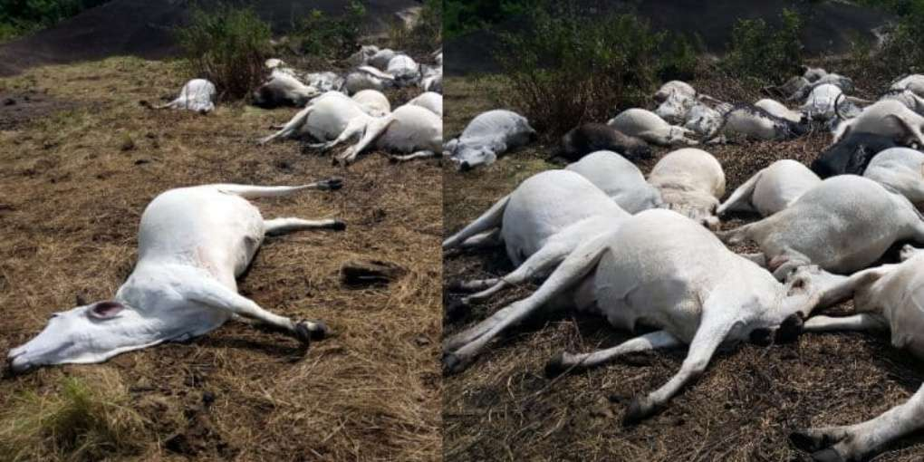

Herdsmen Flee As Strange Thunder Kills 36 Cows In Ondo (Photos)

