Two Dead In Livingstone After Lightning Struck (Zambia)
George Mwenya | March 7, 2018
https://zambiareports.com/2018/03/07/two-dead-livingstone-lightning-struck/
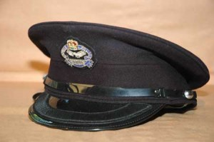
Two people have died after they were struck by lightning on Tuesday at Livingstone Central Hospital.
Police spokesperson Esther Katongo has identified the deceased as Brian Muleya, 25, and Joyce Hakalima, 60, both of Batoka area in Choma while three other people suffered injuries and are admitted to the same hospital.
She said the incident occurred when the deceased persons and the survivors who all had patients at the Health facility were sitting under a tree which was later hit by lightning.
The bodies of the deceased are in the mortuary at the same hospital.

