Six Children Killed in Tshumbe [Democratic Republic of the Congo]
Reported thru ACLENet website ‘Report an Incident’ form by Manuela Erber-Telemaque
28 February 2019
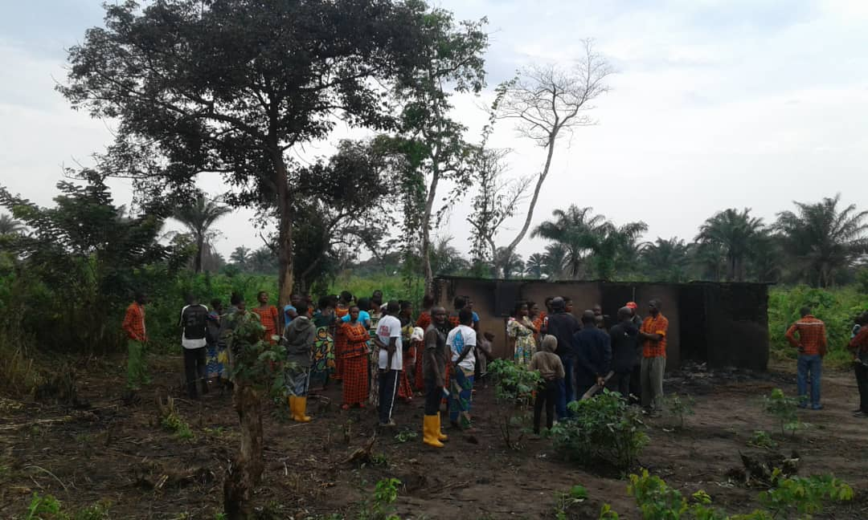
On that night there was a big thunderstorm, as so often, in Tshumbe. A mud hut was hit by lightning strike and the three boys (age of 4, 7 and 18) who slept together in one bed were killed by it. The grandma and mother of the children were in the hut as well but they survived without injuries. The mud hut burned down. This was in the neighbourhood of Okitawongo.
In the same night another mud hut was hit by lightning and another three children (they were triplets - boys and girl) were killed. The adults in the hut were not hit nor injured and the mud hut burned down.
We don't remember the exact time, as the thunderstorm was really loud and bad and everywhere in Tshumbe people shouted of fear and cried for their life.
I am not African, but I live in Tshumbe since six years (most of the time in a year) and run a small local NGO together with the people of Tshumbe. I know the fear of those lightnings in Tshumbe, because i prayed too often myself that nothing would happen. The first incident this night hit a mud hut, which was very close to our kindergarten and primary school. The people in Tshumbe live in fear, especially the children. They don't know what to do during lightning and they have no protection at all from it!

