
Lightning strikes five school children dead (Uganda)
By Vision Reporter
Added 4th November 2015 11:50 PM
https://www.newvision.co.ug/new_vision/news/1411292/lightning-strikes-school-children-dead
BUSHENYI - Shock and grief engulfed residents of Nyakabingo village in Kakanju sub county, Bushenyi district, when lightning struck a classroom block killing five children.
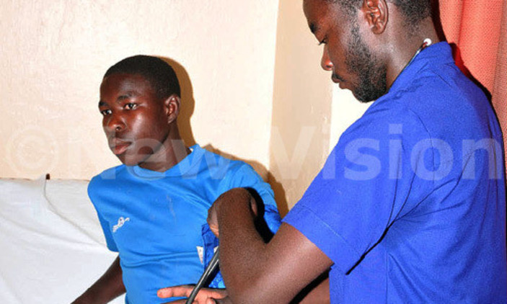
One of the survivors being attended to by a health worker at KIU teaching hospital. Photo/Chris Mugasha
By Chris Mugasha
BUSHENYI - Shock and grief engulfed residents of Nyakabingo village in Kakanju sub county, Bushenyi district, when lightning struck a classroom block killing five children.
The Wednesday afternoon incident took place at Nyakabingo primary school. The dead children were having lunch in the classroom.
The dead were identified as Benson Ahimbisibwe of primary two; Vitas Asasira of primary one; Ophras Mutahunga of primary six; Anxious Tusimirwe and Owomugisha Betina.
They were pronounced dead at the Kampala International University (KIU)-Western campus teaching hospital where they had been rushed.
Reagan Nuwagaba, one of the survivors, being attended to by a relative at KIU teaching hospital. Photo Chris Mugasha
“By the time we reached the hospital following our children, we were told they had died,” said Micheal Mukasa, one of the aggreaved parents. None of the dead pupils was putting on shoes at the time lightning struck.
Near the building that was hit, Mutahunga was helping a goat deliver. The goat also died while its pair of kids survived.
Those who survived were; Reagan Nuwagaba, Abel Muhairwe, Queen Mashal and Osbert Ainebyoona. They are cuurently receiving treatment at KIU.
Deputy resident district commissioner Damiano Turyatunga who rushed to the scene together with other district officials described the incident as a disaster.
“Disaster can happen anywhere at any time,” Turyatunga told journalists. He said the parents had installed one lightning conductor on one of the classroom blocks.
Turyatunga said, “Engineers had advised that one conductor can serve several buildings as parents mobilize for funds to install on every building.”
Last year a similar incident took place at Buramba primary school in the same district.
Geofrey Mbagaya, an uncle to one of the deceased children (Mutahunga), lamented: “Parents struggled and installed one lightning conductor on one building but now they (children) died in another building which was not protected,”
Lauben Kananga, the Kakanju sub county LCIII chairperson said the installation of conductors should not be left to parents.
One conductor costs between sh1.5m - sh2m. Most schools have over ten buildings housing classes, offices while others accommodate children/students as dormitories.
The money for such is decided upon by parents during their annual general meetings but few parents can manage to pay.
“For some parents, paying a contribution of sh10,000 towards the school development is difficult so how do you leave such a sensitive matter to parents,” wondered Paul Aruho, the management chairman for Nyamiko primary school.
Micheal Matigi, one of the district education inspectors said the district council passed an ordinance directing all schools to install conductors but few have implemented it.
Lightning strikes five school children dead

