Lightning kills 17 goats at Namibia farm
Wednesday 14 February 2018 - 12:20pm
https://www.enca.com/africa/lightning-kills-17-goats-at-farm-regina
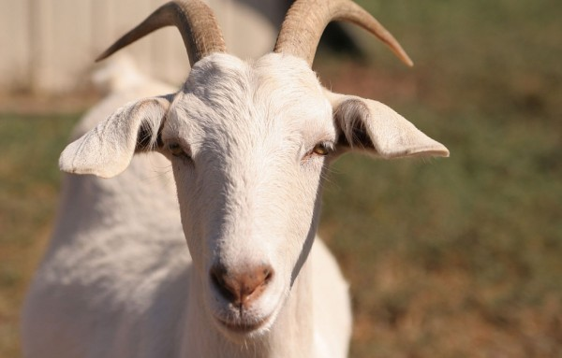
File: Photo: Wikicommons

KEETMANSHOOP, Namibia – Rain is always welcome in the hot and dry areas like Kharas Region, but this natural phenomenon sometimes brings with it troubles and loss to farmers and residents alike.
A strong bout of the late rains of the current season caused one such farmer, Abraham Thomas, to lose a sizeable amount of his livestock at farm Regina, situated four kilometres outside Helmeringhausen in the Bethanie district.
Lightning killed 17 of Thomas’ goats at around 17h00 on Thursday.
Thomas told Nampa on Friday that he recorded between 20 and 40 millimetres (mm) of rain on that day and it was during this downpour that his 17 goats were struck by the lightning.
“One was a stud ram and 15 were in the last stages of their gestation period,” said Thomas. He mentioned that the same thing happened to him in November last year when the rainy season began.
“It is part of the farming business, it is part of the risks that come with farming,” he noted philosophically about his loss.
According to Thomas, so far, the area received close to 178 mm of rain, with two more months to go before the season ends.
African News Agency

