HERO of the MONTH – 2023-06
Mary Ann Cooper, MD
Managing Director ACLENet

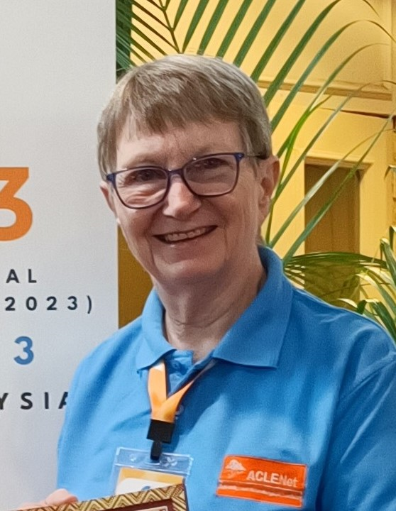

- What is your background?
By training, I am an emergency physician. By avocation, I am a lightning safety expert. I retired from the University of Illinois at Chicago in 2009 as a tenured professor of emergency medicine (honored as a Professor Emerita), have served on the US lightning safety teams (NOAA and National Lightning Safety Council) since 2000, and now work internationally to prevent lightning injuries.
- How and when did you hear about ACLENet?
Along with founder Richard Tushemereirwe, I was part of the beginning of ACLENet since it was first conceived in 2011 in Nepal.
- What motivated you to work with ACLENet?
When Richard and I met at a meeting in Nepal in 2011, we both learned the terrible toll lightning takes on Ugandans. We soon learned this affects most other sub-Saharan African countries. We resolved to start something like ACLENet to address all the things that stand in the way of lightning safety for Africans.
- Please describe your work with ACLENet.
When Richard recruited me to be Director of ACLENet in 2013-14 at its founding, he said, ‘You are retired, you have the time to do this.’ I see my role to an organization like ACLENet as a parent: birthing (incorporation, etc), nurturing, helping it to learn to walk, teaching skills, having fun, and launching as an independent body, while always being available as a backup when called on or needed.
- What are some of your key achievements so far with ACLENet?
As one of the Founding Directors, I have been responsible for directing and guiding nearly all activities at one time or another – incorporation, registration with authorities in the US as a nonprofit which is necessary to be eligible for most grants, fundraising, providing focus and direction, directing staff and programs, holding countless meetings, publicizing, editing the newsletter, recruitment of donors and volunteers, donor management, and so much more.
As we recruit staff, they are taking on more of these responsibilities.
- What are some of the challenges you have encountered in your work with ACLENet? How have you addressed these challenges.
ACLENet has been blessed with many volunteers, friends, and good-hearted people, including our staff. The biggest challenge is money, money, money to fund the activities, salaries, and programs.
- How would you like to see ACLENet develop in the future?
My dream is to turn ACLENet into what Richard and I envisioned when the AFRICAN CENTRES for Lightning and Electromagnetics Network was formed. Although there are a few monetary and US governmental (grants, etc) reasons the org needs to retain its US connections, I firmly believe it should serve, involve, and eventually be run by Africans.
That’s what our new, nascent national committee is one of the seeds for.
- What do you see in the future for ACLENet regarding lightning safety?
I hope for a world where Africans and people from all countries are educated about lightning, have safe places to go during storms, and know the behaviors they can take to prevent injury to themselves, their families, and their workers from lightning. This includes governments adopting, implementing, and enforcing international lightning protection standards and providing timely weather forecasts to their people.
ACLENet in Uganda has been a leader in this and can be the inspiration for expansion to other countries across Africa. In fact, ACLENet’s work has already spread to Asia (South Asian Lightning Network- SALNet, founded in 2019) and Latin America (Latin American Lightning and Education Network – LALENet, founded in 2022.
- Encouragement note
With God’s Blessings and the good hearts of all our donors and those who work with us and believe in lightning injury prevention, I hope we can make the lives of all safe from the dangers of lightning. While we will never be able to prevent all injuries and deahts, we can aim at making the biggest impact possible.
- Is there anything else you would like to include – personal information, family, goals, etc?
I have been blessed with a family, worked in my church (choir, deacon, Sunday school teacher, and more), mentored many students, researchers, and others who have grown to be leaders. I hope I have helped to make the world a better and safer place. I can see where all my faults, challenges, education, people I have been privileged to work with and call friends, and work experiences have all prepared me for this work now. Additionally, this work has kept my familial dementia at bay – at least a little. To God be the Glory!
Your answers to these questions will be posted on ACLENet’s website at:
https://aclenet.org/news-publications/newsletters/hero-of-the-month-column.html

THANK YOU for all you do for ACLENet and for saving lives - MA

