Man Injured while Sheltering Inside House in Robere Village - Rwanda
https://umuseke.rw/2023/03/nyanza-inkuba-yakubise-umuturage-aryamye-nibikoresho-bye-birashya/
Last Wednesday evening, 15th March 2023, lightning struck one Hitabatumye, 43 years old, and severely injured him, while he was sheltering inside a house. It also burned other items, such as clothes, telephone devices, bedsheets, among others.
This tragedy occurred in Rebero Village, Kibinja Cell, Busasamana Sector, Nyanza District, within the Southern Province of Rwanda.
Mr Egide Bizimana,the executive secretary of Busasamana sector confirmed this report.

-----

Nyanza: Inkuba yakubise umuturage aryamye n’ibikoresho bye birashya
Yanditswe na: Ange Eric Hatangimana
2023/03/16 9:08 PM
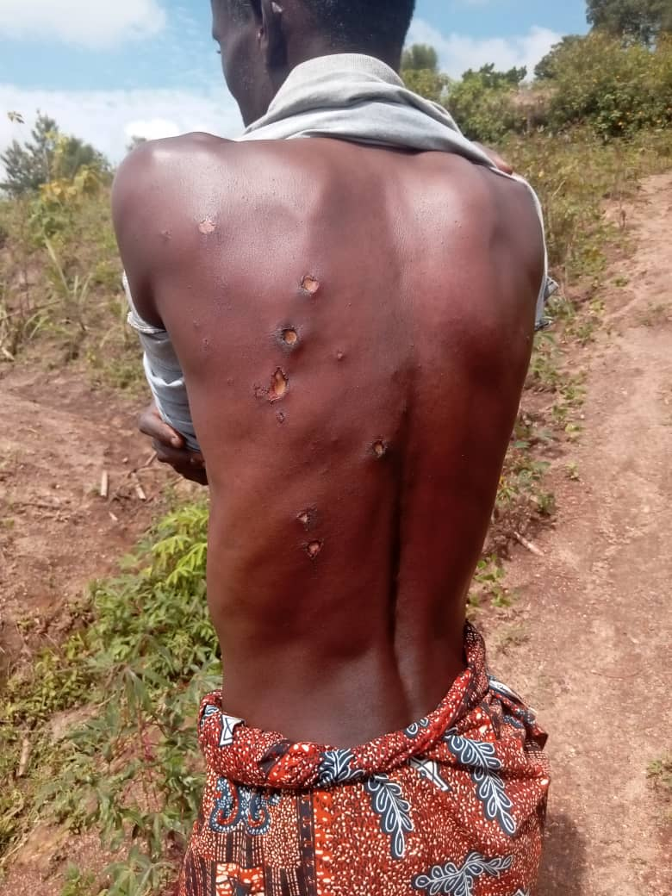
Mu mvura yariho igwa mu masaha y’umugoroba wo ku wa Gatatu, inkuba yakubise umuturage n’ibikoresho bye birashya, gusa we yakomeretse.
Byabereye mu murenge wa Busasamana, mu kagari ka Kibinja, mu mudugudu wa Rebero. Inkuba yakubise umuturage witwa HITABATUMYE w’imyaka 43 y’amavuko.
Umunyamabanga Nshingwabikorwa w’umurenge wa Busasamana, Egide Bizimana yabwiye UMUSEKE ko uriya muturage yakomeretse.
Ati “Uriya muturage yari yugamye mu nzu, inkuba iramukubita iramukomeretsa mu mugongo no ku kibero imusanze aho yari aryamye.”
UMUSEKE wamenye amakuru ko inkuba yatwitse ibintu bitandukanye birimo matelas, supernet, telefone, imyenda, amashuka, ikiringiti n’ibindi.
Uwakubiswe n’inkuba yari mu nzu wenyine. Ubu yagiye kwivuriza ku Kigo Nderabuzima cya Kibinja bamuha imiti.
-----
Report by email from Frank Shumbusho at tct2020@gmail.com.

