**LIGHTNING KILLS THREE!**

By  Thabisile KhomoMonday, February 15, 2016 06:00 **(FROM IAN JANDRELL Feb 16 2016)**

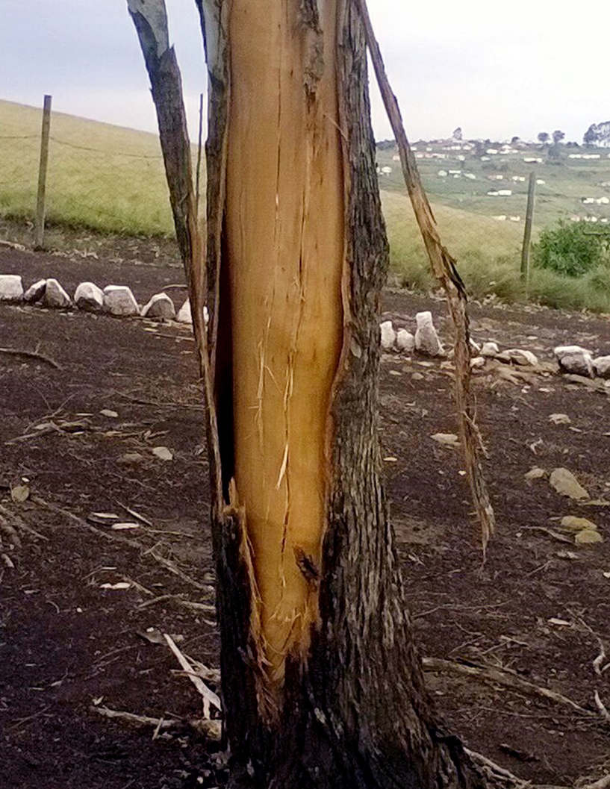

Some trees at Fantini temple where the Shembe church members had gathered for church service were left wrecked on Saturday afternoon after the lightning had struck. Photo by KZN Emergency Medical Services  ~

**A SHEMBE church service ended in tragedy on Saturday when more than 40 members were struck by lightning!**

They had gathered at Fantini temple in KwaMachi near Harding, KZN for their usual weekend service when the incident happened.

Three women died and 38 people were rushed to hospital with serious burn wounds. The lightning allegedly struck near a tree while the church members were kneeling in the open veld.

Duduzile Cwele (50) was identified as one of the women killed, but the names of the other two remained unknown.

Duduzile’s niece Nomzamo Cwele (32) said she got an urgent call at 2pm, telling her about the incident.

“When I arrived at the scene the paramedics were already there,” she said.

“My aunt was rushed to hospital but a few minutes later I got a message to say she had died.” Nomzamo said survivors told her the lightning struck just before the church leader was about to end the service. Robert McKenzie of KZN emergency services said the injured were in a stable condition.

KZN traditional affairs MEC Nomusa Dube-Ncube said: “I appeal to people in rural areas who use trees for community gatherings to disperse once clouds show there could be a storm. We’d like to send our heartfelt condolences to the families of all the victims.”

Mhlaliseni Hlatshwayo, spokesman for the Ebuhleni region couldn’t be reached for comment.

*Daily Sun* later heard that he was at a church event in Joburg.

KZN police spokesman Major Thulani Zwane confirmed that three inquest dockets were opened at Harding Police Station.

|  |
| --- |
| MORE BELOW |

**From:** Maphuti Lamola [<mailto:lamolama@sabc.co.za>]   
**Sent:** Tuesday, July 10, 2012 4:53 PM  
**To:** Piet Maseema  
**Subject:** FW: Mahlalepepeneng/IKS Science of Light. 11/07/2012 .



**Please find the script for the below programme.**

**Programme: Mahlalepepeneng.**

**Topic: Science of Light.**

**Br/Date: 11/07/2012.**

**Br/Time: 21h30-22h00.**

**Presenter: Maphuti Lamola.**

**Senior Producer: Mr. S.H. Maphalla.**

**Studio guest: Mr. Peter Maseema.**

**21h30:  SABC Education jingle followed by sigtune.**

**21h32: Presenter’s greetings and welcome, set the scene, introduce topic and guest and discussion starts.**

**Ke sa buša ke tšea sebaka se go le amogela le gona go le tamiša gohle moo le ka bego le re theeleditše le le gona go lenaneo la Mahlalepepeneng. Re sa buša bagešo re mema bohle bao ba nago le kgahlego mererong ya tša mahlale ka kakaretšo!**

**Bagešo re šetše re dio tseba gore ge letšatši le sobela gosasa le lengwe le tla hlaba mme ra ba le seetša! Taba ke gore a naa ge le ka se hlabe go tla ba bjang? Ke realo bagešo gobane lehono le yeo re ilego go šetšana le yona ke seetša. Motho a ka ipotšiša gore ge seetša se ka se be gona bophelo bo tla ba bjang? Naa ele gore seetša se se tšwa kae gona mohola wa sona ke ofe maphelong a rena? Go kwa tše ntši moeng wa rena ke.......Mr Peter Maseema.........................................................**

**21h34: DIPOTŠIŠO.**

**1. Naa re ka re seetša  ke eng?**

**2. Naa re na le mehuta ya seetša?**

**3. Naa mehuta yeo ya seetša e fapana bjang?**

**4. Naa re ka ahlologanya bjang seetša le lesufi?**

**21h40: Advert/promo then discussion continues.**

**Vox pops: Naa le kwešiša eng ka ga seetša le gona le bona bohlokwa bja sona ele bofe?**

**21h42: DIPOTŠIŠO.**

**5. Naa ele gore gabotse mothopo wa seetša ke eng?**

**6. Naa seetša se šomišwa kae maphelong a rena a tšatši ka tšatši?**

**7. Naa go na le ka fao re ka bolokago seetša?**

**21h50: Advert/promo then discussion continues.**

**21H51: DIPOTŠIŠO.**

**8. Naa bophelo bo ka ba bjang ntle le seetša?**

**9. Naa seetša se kalwa bjang le gona ka eng?**

**10. Naa ge motho a rata go tseba kudu ka ga seetša a lebalebe kae go ya go ithutela eng?**

**21h52: Presenter open lines for listeners’ interaction and motivation. Studio numbers: 015 297 1848.**

**2158: Presenter rounding off the programme, thank guest and listeners for their time and bye-byes.**

**21h59: Sigtune followed by SABC Education jingle.**

**22h00: End of the show/news on hour.**

**Regards**

**Maphuti Lamola.**

**Cell: 082 762 5365.**

[](http://www.sabc.co.za/wps/portal/SABC/SABCRADIO)