Lightning strikes four in drinking den - Kenya
Kennedy Gachuhi 03rd Jun 2019 01:00:00 GMT +0300
https://www.standardmedia.co.ke/article/2001328228/lightning-strikes-four-in-drinking-den
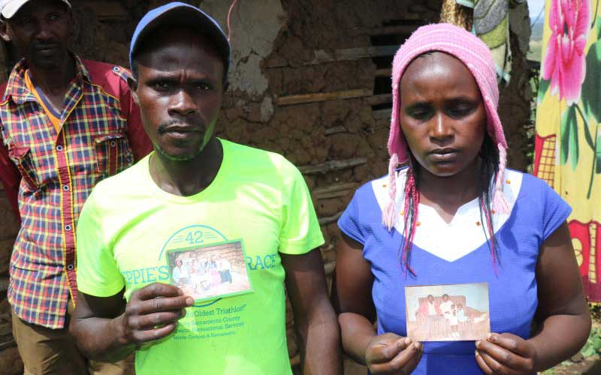
Elijah Iragu and Veronicah Wairimu whose father, Paul Muigai, was struck by lightning. [Kennedy Gachuhi, Standard]
A drinking session turned tragic after lightning struck five people in a house in Piave village, Njoro, on Saturday evening.
Four men died instantly while a woman who was selling the alcohol was taken to the Nakuru Level Five Hospital in critical condition.
Mary Mugure, a community policing leader, said tragedy struck after the area received above-average rainfall.
“I was at my doorstep when I saw a flash of lightning. It was followed by loud thunder that echoed through the entire village. We didn’t know it had struck people until 6pm,” said Ms Mugure.
SEE ALSO :Form two student dies after being struck by lightning in Kisii
The five victims were in a room in an incomplete building next to Piave Dam.
“It was by luck that those who had taken shelter in the next room were not struck. They informed the rest of the village immediately. The four died on the spot while the woman appeared to have suffered internal injuries,” said Mugure.
Yesterday, most activities in the area came to a standstill as residents joined the four families in mourning the loss of their loved ones, whose bodies were taken to the Egerton University mortuary.
All the victims lived in homes located within a one-kilometre radius of each other.
Battle alcoholism
Family members who spoke to The Standard appeared to blame the men’s death on what they described as their “heavy” drinking habits that had seen them separate from their spouses and battle alcoholism.
The oldest victim was identified as Paul Muigai, 53, - a father of seven who separated from his wife last year.
“Our mother left with two children after a disagreement with our father. Our father has been drinking and that is why he was at the scene,” said Elijah Iragu, one of Muigai’s sons.
A few metres from Muigai’s house, Mary Wanjiku was at home mourning her 38-year-old son, Dennis Maina.
“Maina had a wife and five children. He had been drinking a lot lately. He previously worked as a lorry co-driver before his sister bought him a boda boda,” said Ms Wanjiku.
Maina’s wife, Esther Murugi, said he had left home at around 1pm headed to Piave trading centre.
Less than 100 metre away, Joel Kirweya sat with neighbours making burial plans for his 39-year-old son Jonah Ndung’u.
“He is my eighth child and his death is a great loss to me. I have been speaking to him to quit drinking but my advice fell on deaf years. It is unfortunate he died in a chang’aa den,” said Mr Kirweya.
Kirweya further revealed that his son had separated from his wife, leaving him to care for their three children.
Solomon Gitau also lost his son, David Kamami, 27. According to Mr Gitau, his son, who married at the beginning of last year, had recently separated from his wife.
“It is less than two weeks since his wife left. They were yet to get any children. He was drinking illicit brews and did not heed my advice when I asked him to stop,” said Gitau.
Another resident, John Kariuki, whose daughter was nursing injuries, gave thanks that she was still alive.
“She has three children and is currently with her brother at the hospital. All I can say is I am glad she survived the lightning,” said Mr Kariuki.
The affected families expressed their anger at what they termed as laxity by police to crack down on the sellers of chang’aa.
Njoro Police Commander Mohammed Huka said they were investigating the matter.
“We have been acting on any reports of illicit brews and will ensure those accused of making chang’aa are arrested.”

