**Lightning kills one child and burns another in Kribi [Cameroun]**

Sun, 25 Apr 2021

<https://mobile.camerounweb.com/CameroonHomePage/NewsArchive/La-foudre-tue-un-enfant-et-brule-un-autre-Kribi-592834>

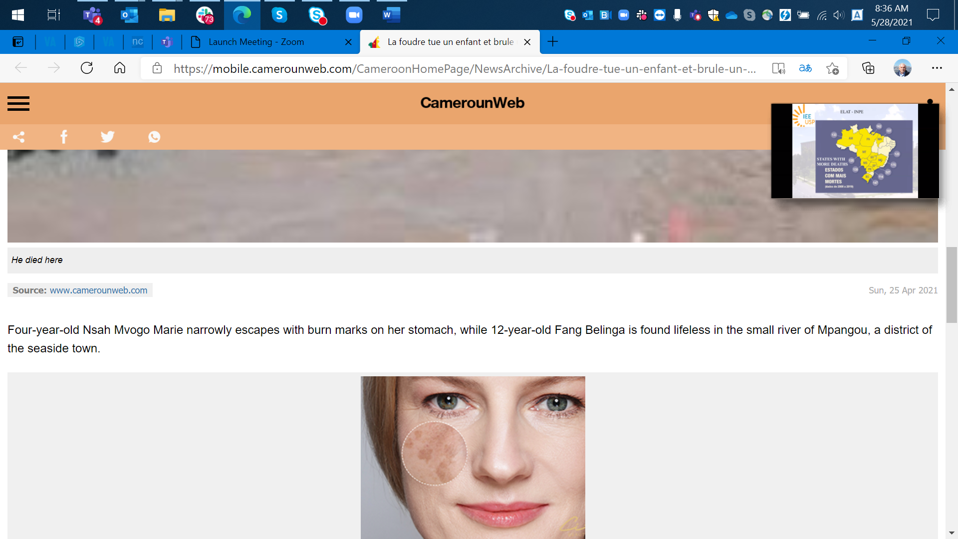

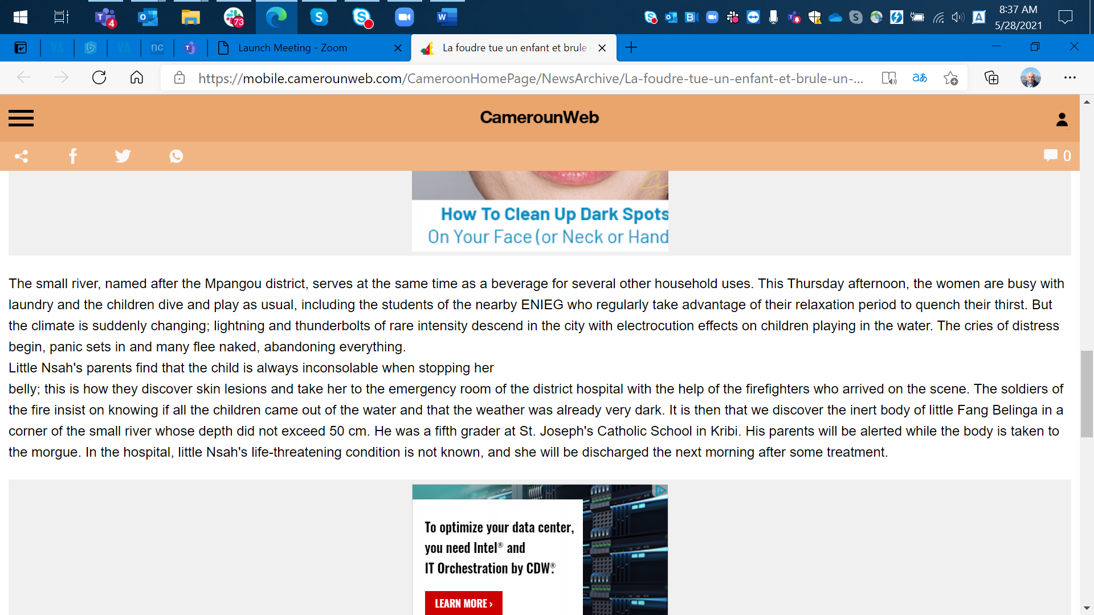

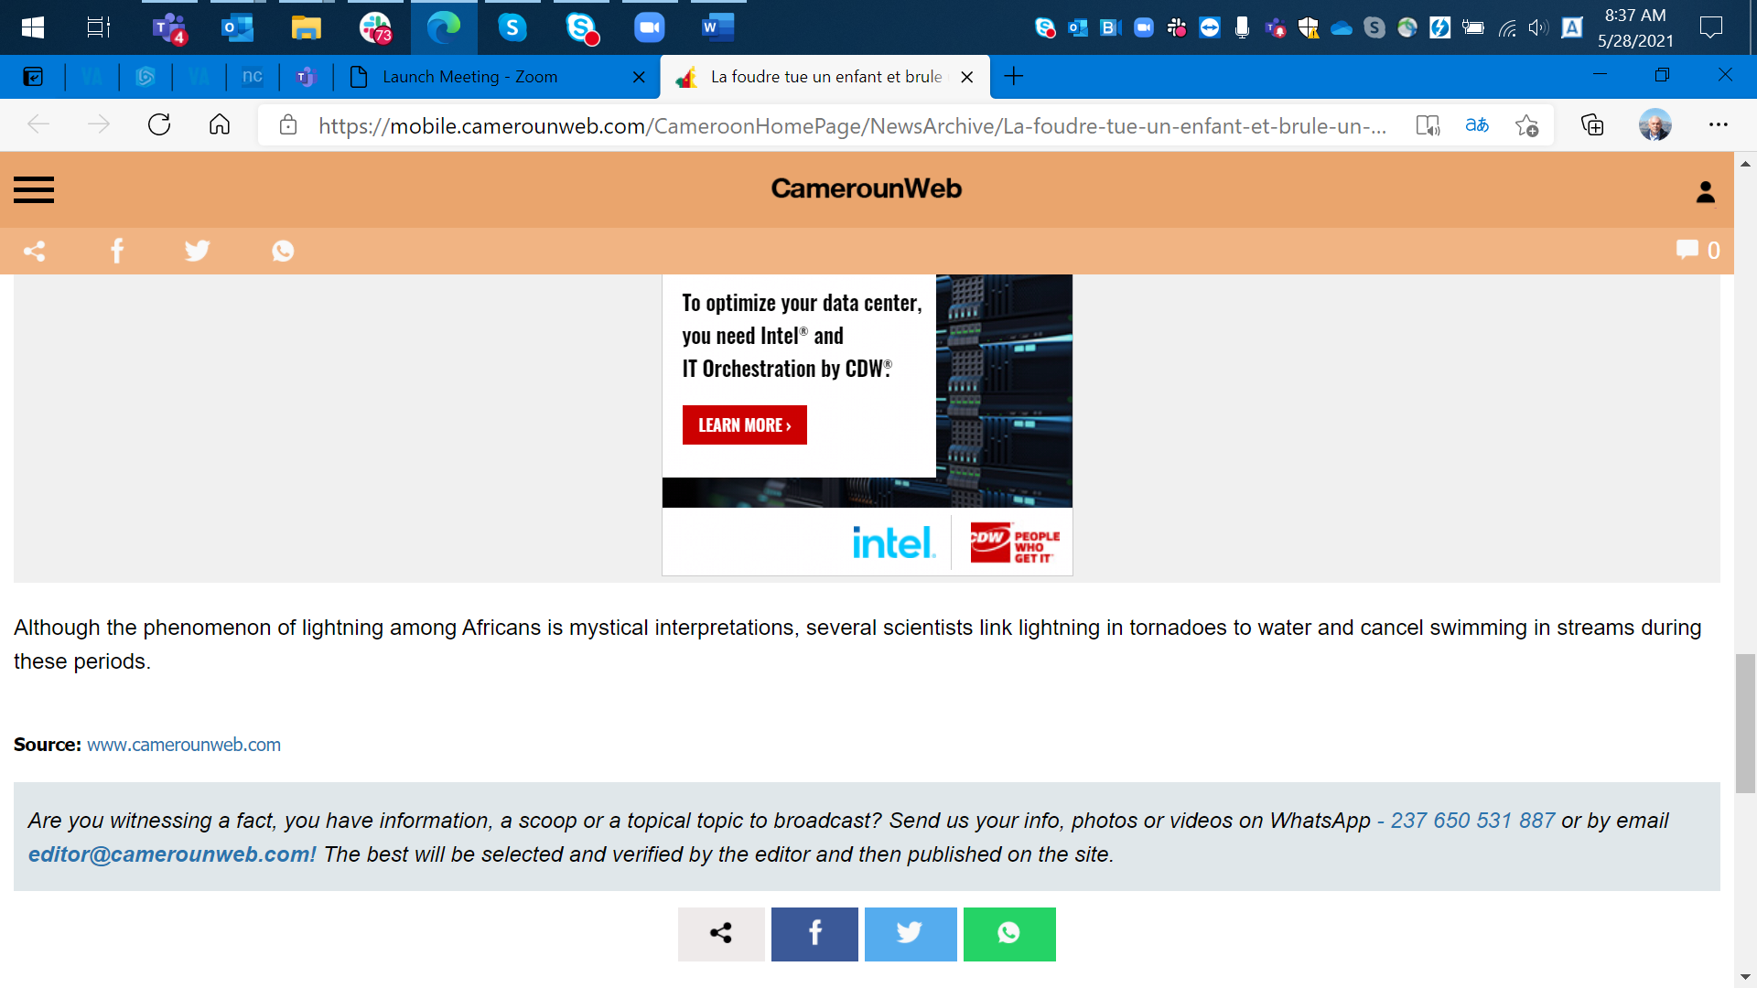

------

Source: Dr. Rayangnewinde Donald Auguste Yanogo in Burkina Faso by email at dyanogo8@gmail.com.