Two trees struck by lightning over weekend in Pretoria
April 3, 2023
https://rekord.co.za/452113/two-trees-struck-by-lightning-over-weekend-in-pretoria/

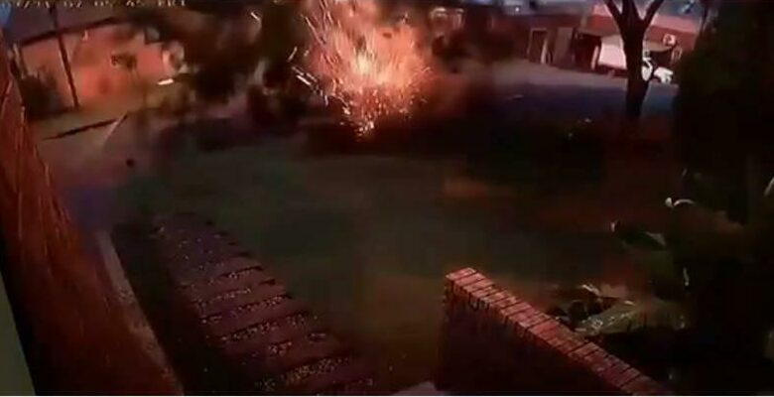

Two reports of trees being struck by lightning in Pretoria did the rounds on social media.
In the first incident, no one was injured when a palm tree was struck by lightning on Himalaya Street in Laudium on Friday morning.
According to eyewitness Sanjay Dhubey, the lightning struck the tree mere meters from where he was standing.
“Luckily, there was no one under the tree when the lightning struck.
“This is unusual. We don’t normally experience such things in our neighbourhood,” Dhubey said.
In another incident, a video shared on social media showed a tree in Moreletapark being reduced to splinters after it was struck by lightning at around 07:00 on Friday.
From the video footage shared by Storm Report SA, it does not appear as if anyone was injured.
Here are tips to avoid being struck by lightning during heavy rains and thunderstorms:
– Avoid being outside in an open space during thunderstorms.
– If you can hear any thunder, it means you are in the range of a lightning strike. Seek shelter immediately.
– Avoid contact with conductive material, such as computers and landline telephones.
– Do not carry tall metal objects such as golf clubs or fishing rods during thunderstorms.
If there is no shelter:
– Crouch down.
– Put your hands on your knees or over your ears to protect them from the noise of the thunder.
– If you have other people with you, ensure you are all at least four to five meters apart.
If someone is struck by lightning:
– A person struck by lightning is safe to touch.
– Immediately start CPR if the person is not breathing and does not have a pulse.
– Seek emergency medical care immediately.

