Lightning Kills 3 In Napak (Uganda)
12 Aug 2013, 06:46
https://ugandaradionetwork.com/story/lightning-kills-3-in-napak
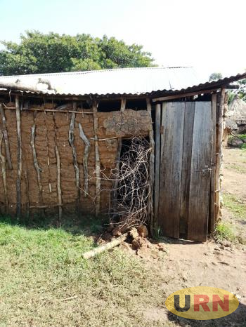
By Olandason Wanyama
The local bar in Irriri hit by lightning after a drizzle in the evening.Login to license this image from 1$.
In short
A lightning strike killed three people and injured another in Napak district on Saturday.
Three people were struck dead and another injured critically by lightning in Napak district on Saturday evening.
The incident occurred during a drizzle at Irriri Trading Centre, Irriri Sub County, some 96 kilometers South West of Moroto town.
Police has identified the dead as William Longole, the Irriri Sub County Gombolola Internal Security Officer - GISO, Logit Apalamer and Awas Apalopetasia, both residents of Nabilatuk Sub County in Nakapiripirit district.
The injured who is nursing burns at Irriri Health Centre III is Apale Lomongin. Joshua Risa, an eyewitness says that the trio were struck by lightning and thrown out of the bar, which created a huge a rectangular hole in the wall. He says more than 10 people who were inside the bar scampered to different directions for safety. Irene Aceng, the Karamoja Police attributes the incident event to changes in climate.
She encourages residents to be conscious and wearing rubber shoes whenever it rains.
This is not the first time lightning has struck Karamoja region. In 2011 lightning killed a UPDF soldier at Narengapak village in Kathile Sub County in Kaabong district. Another incident in Kaabong 2011 occurred at Kapedo and Kawalokol sub counties where five people were killed in one day.
Also in June 2012, Kotido Army School lost Daniel Moding a P.3 pupil while on his way back home.

