Letters from Madagascar: When lightning strikes, the villagers eat well

Posted February 11, 2024
Vanessa Paolella Special to the Sun Journal
https://www.sunjournal.com/2024/02/11/letters-from-madagascar-when-lightning-strikes-the-villagers-eat-well/
Being a good neighbor here means buying the butchered meat of a cow killed by lightning. When lighting strikes here, as it often does, it strikes to kill. Such was the case for three cows belonging to a family in the village next to mine last month. It was the strongest storm I’ve seen in Madagascar. And as much as I love a good thunderstorm, the strikes were so close, even I was jumping in fright inside my dark, brick home.
After the hour-long storm had passed, I learned about the cows. Not one, which would itself be a tragic loss, but three. It was the strongest storm I’ve seen in Madagascar. And as much as I love a good thunderstorm, the strikes were so close, even I was jumping in fright inside my dark, brick home. After the hour-long storm had passed, I learned about the cows. Not one, which would itself be a tragic loss, but three. So I did what any good neighbor would do here in Madagascar: I stopped by the next morning and bought some fresh, lightning-struck beef. (As I write this letter on Jan. 16, I’m finishing the last few pieces. Delicious).
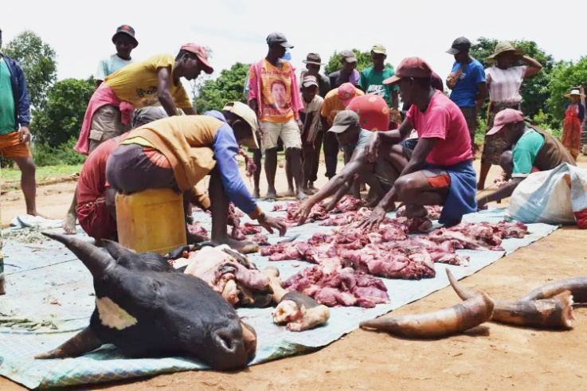
A group of men spent more than four hours butchering one of three cows struck dead by lighting last month. With no way to preserve the meat, it was critical for the men to distribute it quickly. Vanessa Paolella photo
When I arrived around 9 a.m., I found dozens of people gathered around a group of men butchering one of the deceased cows. I came at a time when the legs still looked like legs, and the ribcage was easily identifiable. To the side sat piles of skin and innards, opposite of the three cow heads staring blankly ahead.
I learned that the the owners’ six cows had been out grazing on a mountain slope near a stand of trees when the storm hit. It took just a single lightning strike to kill half of the herd, a small fortune by Malagasy standards.
After the rain subsided, family members quickly trekked out to the site to cut the cows into pieces and carry them back to the village. The dismembered cows were then stored inside a room in someone’s house overnight.
When morning came, two of the cows were loaded onto kingas — small three-wheeled vehicles not unlike tuktuks — and brought to Ambalavao, where they were sold to a butcher at a steep discount. At the same time, the men got to work butchering the third cow at home.
All through the morning, family members and others stopped by to take a share of the meat. With no refrigeration here, time was of the essence, and no one wanted to see good meat go to waste.
When I returned for a second visit, camera in hand, I found that the men had moved on from butchering the cow to stringing chunks of meat for people to carry home.
Generally, meat is sold in my village just twice a year: on New Year’s Eve in December and the nation’s Independence Day in June. Other than that, if you want to get meat here, you’ll have to buy a live chicken and kill it yourself.
Once there was a butcher in my village. But the people here are too poor to afford meat regularly, and the seller went out of business.
Personally, I buy meat every time I head to Ambalavao, about three times a month. It makes me especially happy to share it with my pregnant host sister and her son; protein deficiency is a serious issue here.
I’ve learned how to ask for just the muscle alone.
Even so, the next time lightning strikes and kills livestock here, you can be sure I’ll be there bright and early with money and a container in hand. It’s the least I can do.
Vanessa Paolella is a Peace Corps volunteer in Madagascar, a former award-winning staff writer for the Sun Journal and a Bates College graduate. The views expressed in this column are hers alone and do not reflect the views of the U.S. government, the Peace Corps, or the Madagascar government.

