**Fatal lightning strike at the stadium during the Africa Cup of Nations match in Cameroon**

By The Bharat Express News

January 25, 2022

<https://www.thebharatexpressnews.com/fatal-lightning-strike-at-the-stadium-during-the-africa-cup-of-nations-match-in-cameroon/>

[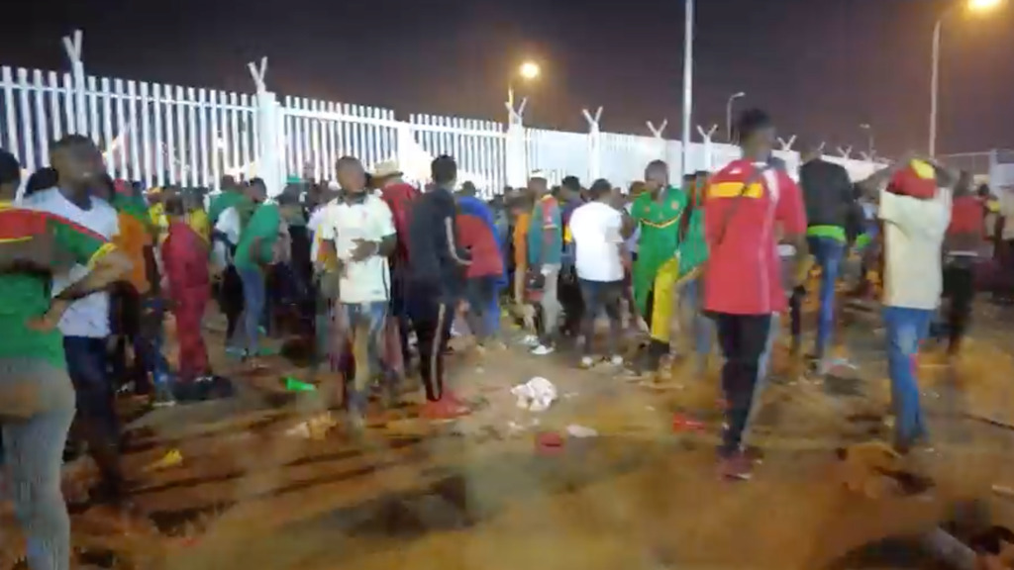](https://s.france24.com/media/display/b92fa6b0-7d86-11ec-b11b-005056bfb2b6/w:1024/p:16x9/camroun.jpeg)

Published on: 01/25/2022 – 00:26

At least eight people died in a crash outside a stadium hosting a game of Africa’s biggest football tournament in Cameroon on Monday, a local government official said, aware of fears over the country’s ability to stage the biggest continental sporting event.

Naseri Paul Biya, the governor of Cameroon’s central region, said there could be more deaths.

“We are not able to give you the total number of victims,” ​​he said.

The thunderbolt came as crowds struggled to gain access to the Olembe stadium in the capital Yaounde to watch the host country take on Comoros in a last 16 African Cup knockout tie of Nations.

Officials at nearby Messassi hospital said they had received at least 40 injured people, who were rushed to hospital by police and civilians. Officials said the hospital was unable to treat them all.

“Some of the injured are in desperate condition,” said nurse Olinga Prudence. “We will have to evacuate them to a specialist hospital.”

People were seen lying motionless on their backs near a stadium entrance the day after the crush. A man knelt down next to one of the victims and appeared to be trying to resuscitate the victim. Colorful shoes, caps and wigs – part of some of the fans’ in-game costumes – were strewn across the floor.

Witnesses said children were among those caught in the stampede. Witnesses said it happened when stadium stewards closed the gates and stopped allowing people to enter. It wasn’t immediately clear if the crash happened before or during the game.

Football officials said around 50,000 people tried to attend the game. The stadium has a capacity of 60,000 but was not expected to be more than 80% full for the match due to restrictions on crowd sizes due to the coronavirus pandemic.

The Confederation of African Football, which organizes the African Cup, said in a statement that it was aware of the incident.

“CAF is currently investigating the situation and trying to get more details about what happened,” he said. “We are in constant communication with the Cameroonian government and the local organizing committee.”

One of the federation’s top officials, general secretary Veron Mosengo-Omba, went to visit the injured fans in hospital, the statement said.

Cameroon is hosting the Africa Cup for the first time in 50 years. The Central African nation was due to host the tournament in 2019, but the event was taken away from them that year and awarded to Egypt due to serious concerns over Cameroon’s preparations, particularly the readiness of their stadiums.

Olembe Stadium was one of the venues that came under scrutiny. It is the main stadium for the month-long tournament and will host three more matches, including the final on February 6.

Monday’s incident was the second major blow to the country in a day, after at least 17 people died when a fire triggered a series of explosions at a Yaounde nightclub on Sunday.

Following the incident, Cameroonian President Paul Biya has urged the country to be on guard as it hosts its biggest national sporting event in half a century.

Cameroon won Monday’s match 2-1 to advance to the quarter-finals.