SFC officer dies after being struck by lightning (Uganda)
TUESDAY MAY 3 2016
http://www.monitor.co.ug/News/National/SFC-officer-dies-after-being-struck-lightning-/688334-3187358-tvpxe5/index.html
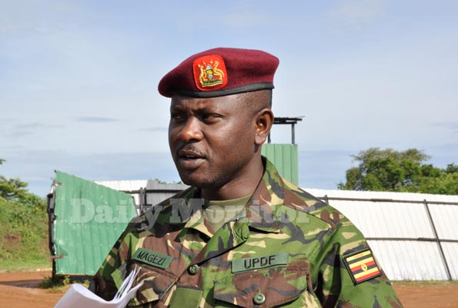
SFC spokesperson, Maj Chris Magezi said Tuesday that one of officers died on spot while two others were rushed to Entebbe hospital. File photo
By Job Bwire
Three Uganda People’s Defence Force (UPDF) officers attached to the Special Force Command (SFC) have been struck by lightning.
Without revealing the identity of the officers, the SFC spokesperson, Maj Chris Magezi, said Tuesday that one of officers died on spot while two others were rushed to Entebbe hospital.
“One of the [three] victims was not seriously injured. He might be discharged by closure of today,” he said.
According to him, the officers were struck at around 6:30 am while guarding the outer perimeter post at State House Entebbe.
“I cannot reveal their identity now because we don’t want to alarm their families. But as actively serving soldiers, this is just one of the hazards we face from time to time,” Mr Magezi added.
This comes a week after a special police constable, Abas Muwaira who had been deployed to State Lodge in Jinja town was found hanging near the kitchen.

