Lightning strikes seven cows dead in Nyagatare [Rwanda]
By IGIHE
On 4 June 2019 at 09:48
http://en.igihe.com/news/lightning-strikes-seven-cows-dead-in-nyagatare.html

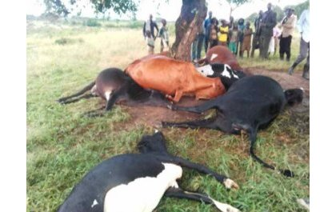

Lighting has struck and killed seven cows belonging to Rutayisire James from Nyagatare sector, Nyagatare district in Eastern Province.
The incident took place yesterday night. The executive secretary of Nyagatare sector, Ingabire Jenny has told IGIHE that lightning struck the cows under a tree where they were sheltered.
“It is true that lighting struck and killed all the seven cows sheltered under a tree," she said.

