Rare straight lightning over Zimbabwe
By Peter Lowenstein in Today's Image | March 11, 2015
http://earthsky.org/todays-image/rare-straight-lightning-over-zimbabwe
No zig-zagging. No branching. A lightning expert said this single, straight bolt of lightning was extremely rare …
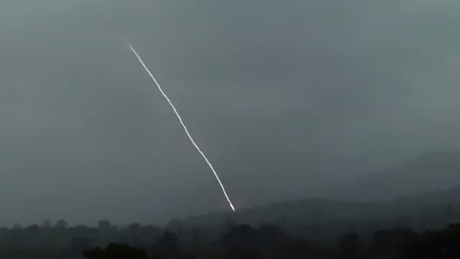
Animated gif by Peter Lowenstein in Mutare, Zimbabwe
A friend in Zimbabwe, Peter Lowenstein, created the animated gif image above from a video he captured of a rare straight lightning bolt. He wrote:
… a most unusual lightning strike occurred during an afternoon thunderstorm in Mutare on 15 February 2015. Unlike most lightning which travels in zig-zag fashion and has branches, this single bolt descended in an almost straight line to strike the ground about two kilometers away. This was followed a few seconds later by a very loud bang which was sufficient to cause alarm and then a distinct echo which returned from the surrounding hills. The lightning must have been very energetic as it was so bright that it completely over-exposed the first flash frame on the gif and produced thunder that was so loud that it frightened people over a wide area. I believe that straight lightning is very rare and wonder if anyone else has either observed it firsthand or seen it in other photos or videos?
The video of this strike can be seen below. Peter Lowenstein captured it at 30 frames per second with a Panasonic Lumix DMC-TZ10 compact camera in scene mode.
Richard Orville, an expert on lightning from the Department of Atmospheric Sciences at Texas A&M University, wrote:
…straight lightning is extremely rare, indeed very rare.
The atmosphere appears to have a high amount of moisture which suggests many small droplets may be in between the channel and our eyes. This will obscure any branches. But there is no evidence of ANY branching. This is highly unusual. The straight channel suggests a lack of small particles in the atmosphere or in other words, a very clean atmosphere. It appears to homogeneously clean! A uniform atmosphere devoid of particles and with a uniform density.
Peter Lowenstein added that the consensus between experts consulted on this image is that his capture is:
… of a positive cloud-ground (CG) strike.
These are much less common than negative strikes and tend to be smooth and less branched.
Thank you for sharing your image, Peter!
Has anyone else seen straight lightning, either in person or in a photo?
Bottom line: Animated gif and video of a rare straight lightning strike over Mutare, Zimbabwe on February 15, 2015, as captured by Peter Lowenstein.

