Lightning Strike Kills Three Family Members in Dowa – Malawi
https://www.faceofmalawi.com/2026/02/12/lightning-strike-kills-three-family-members-in-dowa/
12 febrary 2026
By Evance Kapito
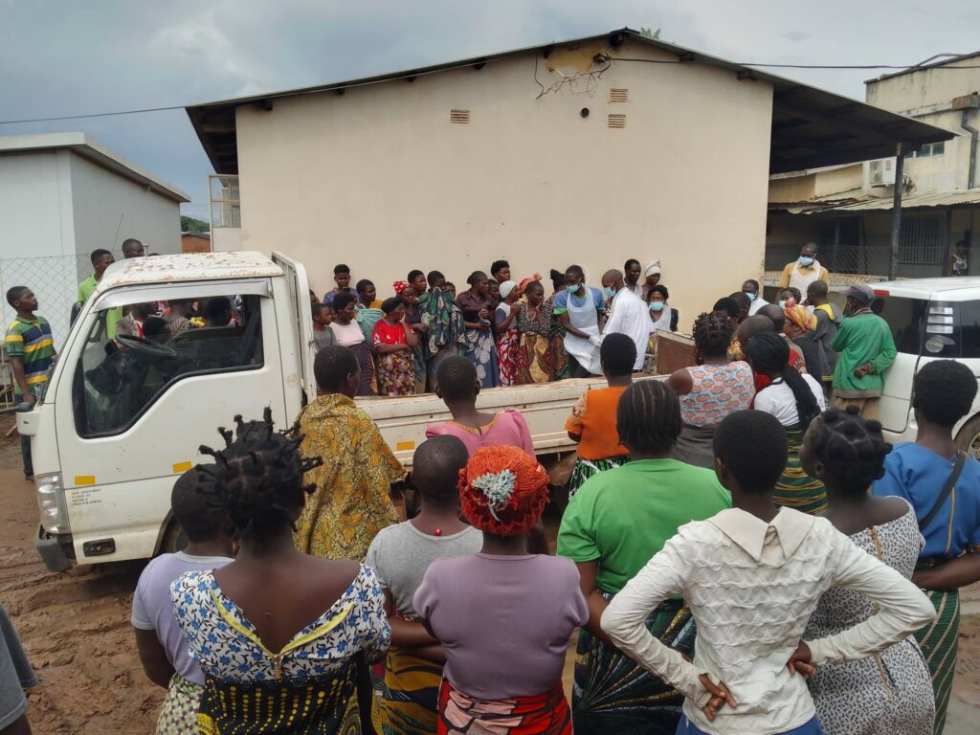
Three members of the same family have died after being struck by lightning at Lipenga in Dowa District.
Mponela Hospital in-charge Owen Chipewa said the incident occurred today while the victims were at their home during rainfall in the area.
The deceased have been identified as Maliya Joseph and her two children, Sikaliyoti Petro and Jere Petro.
Chipewa added that another child from the family survived but is currently admitted at Mponela Hospital after sustaining injuries and is receiving medical treatment.

