**Urgent: 9 Cows Killed by Lightning on a Farm in Kalehe – DR Congo**

<https://lapresseafricaine.net/article/urgent-9-vaches-foudroyees-dans-une-ferme-a-kalehe/1322>

12 August 2025

By Richelieu Byamana – LPA South Kivu

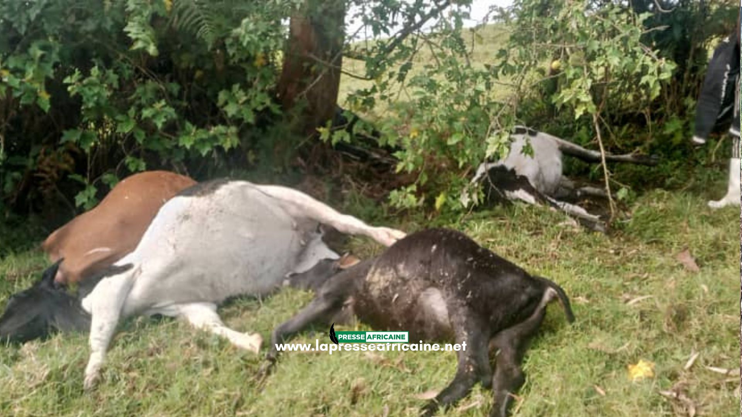

Torrential rains that hit the Kalehe territory in South Kivu, in the east of the Democratic Republic of Congo, caused enormous material damage.

Cows were struck by lightning in the Ndikumwami Numbwe pasture in Lushebere in the Mbinga-Sud group in the Buhavu chiefdom, Mr. Lévis Chinyabuguma, one of the local residents and a civil society actor, confirmed to [La Presse Africaine .](https://lapresseafricaine.net/)

*"On the night of Sunday, August 10, 2025 at 9 p.m., 9 cows were struck by lightning  in the Ndikumwami Numbwe pasture in Lusheberel during  the rain that fell in our area,"* he explains.

It should be noted that in the same area, in Kalangala in the village of Kabulu 1, a young girl of about 15 years old also lost her life on the evening of Saturday, August 9, in another rainstorm in which she was struck by lightning.

Report courtesy DRC citizen reporter network through Jacques KAMBETI MASUMBUKO for ICCOD ONG [ongiccod@gmail.com](mailto:ongiccod@gmail.com)

|  |  |
| --- | --- |
|  |  |