***MAC - Seems to be rain – lightning not reported here.***

**DRC 2024 - Heavy rain damage in Idjwi: SOS for Radio Kalinga silenced**

https://lapresseafricaine.net/article/degats-de-fortes-pluies-a-idjwi-sos-en-faveur-de-la-radio-kalinga-reduite-au-silence/592

12 Sept 2024

The heavy rainfall that hit the Mpene group in Idjwi territory in South Kivu caused enormous damage in several sectors of the population's lives on Tuesday 10 and Wednesday 11 September 2024.

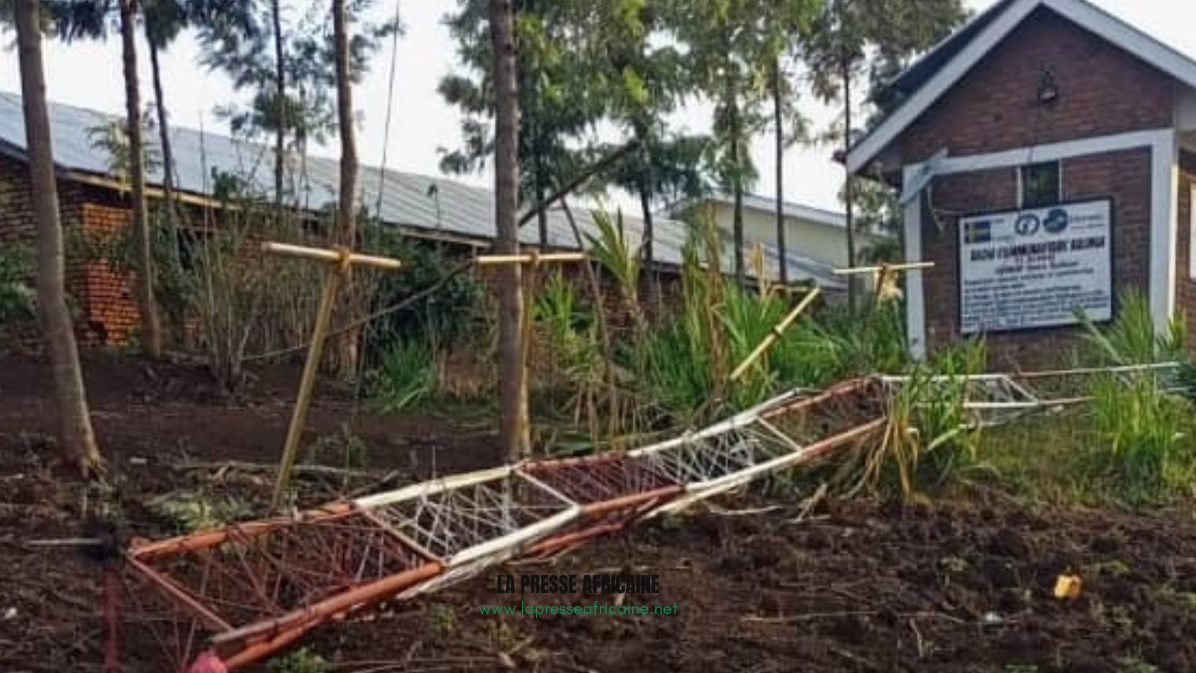

For example, in the media sector, Kalinga Community and Associative Radio suffered huge losses as a result of these natural disasters. Its director, Albert Cinyabuguma, indicated that the radio station's 25-meter antenna and four dipoles were destroyed.

Three panels and the mixer are also damaged along with other devices that facilitate the transmission of broadcasts and relay with other media.

"Radio Kalinga has just lost its 25-meter mast and its dipoles, following the violent winds of the rain that just fell this evening in Idjwi. The radio is almost non-existent now, we are sending out an SOS to all our partners, collaborators and people of good will to come to our aid in order to once again restart the broadcasting of our programs," he explains.

This radio station, which trains farmers and breeders, is now silent and the resumption of its activities may take longer, because the cost of the destroyed equipment is very high, adds our source.

Three schools and residential homes were also destroyed by the torrential rains. Local civil society is calling on the provincial and national governments and individuals of good faith to intervene urgently.

Richelieu BYAMANA – LPA South Kivu

Report courtesy DRC citizen reporter network through Jacques KAMBETI MASUMBUKO for ICCOD ONG [ongiccod@gmail.com](mailto:ongiccod@gmail.com)