Lightning strike kills over 20 cattle at Tatale – Ghana
https://www.myjoyonline.com/lightning-strike-kills-over-20-cattle-at-tatale/
By Myjoyonline.com
26 May 2026
A devastating thunderstorm that swept through Tatale in the Northern Region on Monday evening has reportedly killed more than 20 cattle belonging to a herdsman, leaving him counting heavy losses.
The owner of the animals, Sarkin Amaru, said the incident occurred during a heavy downpour accompanied by intense lightning and thunder.
Narrating the ordeal, Mr Amaru explained that he had sought shelter in his hut when the storm intensified.
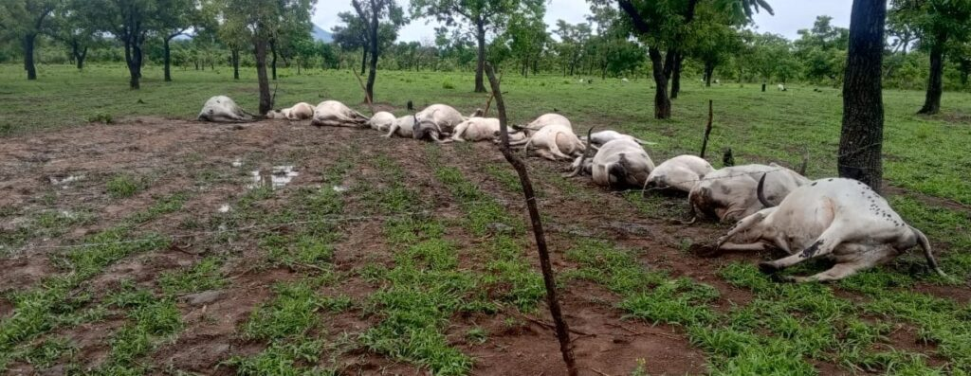
According to him, moments after a flash of lightning and a loud thunderclap, he noticed that one of his cows had collapsed.
He said he immediately rushed out in an attempt to salvage the situation by slaughtering the affected animal, only to discover that several other cattle had also fallen to the ground.
“In all, more than 20 cattle died instantly,” he said, describing the incident as the biggest setback he had suffered in recent years.
The tragic incident has reportedly thrown the herdsman and his family into distress, as the cattle constituted his principal source of income and livelihood.
Residents in the area who visited the scene after the rainfall expressed shock at the scale of destruction caused by the lightning strike.
Some community members described the development as unfortunate, particularly at a time when many livestock farmers were already grappling with rising feeding and maintenance costs.
Mr Amaru said the loss had left him financially stranded and uncertain about how to cater for his family.
“I’m appealing to the government, district assembly, individuals and organisations to come to my aid. Any amount will be appreciated,” he appealed.
The incident has renewed concerns about the vulnerability of livestock to extreme weather conditions during the rainy season, especially in open grazing areas where animals are often exposed during storms.

