**Panic as Second Thunder Strike Hits Koidu City Days After Deadly Storm – Sierra Leone**

<https://sierraloaded.sl/news/second-thunder-strike-hits-koidu-city/>

20 May 2025  
  
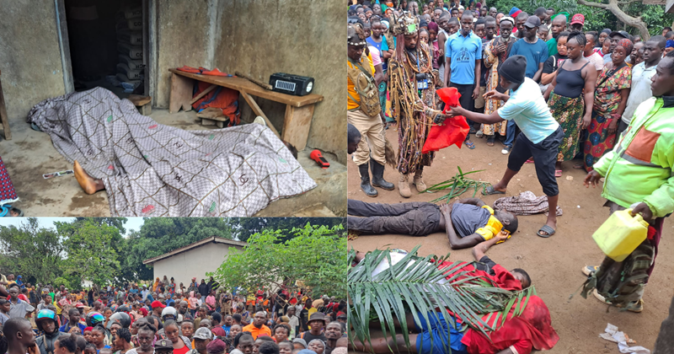

By Fatmata Grace Bangura

Residents of Koidu City are gripped by fear and demanding urgent answers after a second thunder strike hit the area this evening, just days after a deadly thunderstorm claimed three lives in the broader Kono District.

Eyewitnesses described a terrifying sequence: a bright flash in the sky, immediately followed by a loud explosion that rattled nearby homes and buildings. While there are no confirmed casualties from this latest incident, the community remains deeply unsettled.  
  
“People are living in fear. We need answers and protection,” expressed one concerned resident, reflecting the widespread anxiety.

The repeated incidents have prompted traditional leaders to suggest that the phenomena may require a deeper, spiritual investigation. Some have even proposed involving “Ariyogbo Boss,” a spiritual arm of justice in the community, to help understand the true nature of what is occurring.

Community members are calling on the government, weather officials, and traditional authorities to take swift action, with many believing these events transcend normal weather patterns. Meanwhile, authorities have urged the public to seek shelter indoors during storms and adhere to safety guidelines as investigations continue.

This evening’s thunder strike follows a devastating storm that battered Kono District on Tuesday, May 13. That incident, characterized by heavy rainfall, intense thunder, and vivid lightning, resulted in the tragic deaths of three individuals in the Tankoro area who were struck by lightning while outdoors around 7:00 PM.

Local authorities and traditional leaders had already summoned “Ariyogbo,” the spiritual investigator of Kono, to probe the circumstances of that fatal storm.