**Bukavu: Man struck by lightning, mother and three children die in landslide in Kadutu**

https://www.ratecordc.org/post/bukavu-un-homme-foudroy%C3%A9-une-m%C3%A8re-et-ses-trois-enfants-meurent-dans-un-%C3%A9boulement-%C3%A0-kadutu-1

11 August 2025

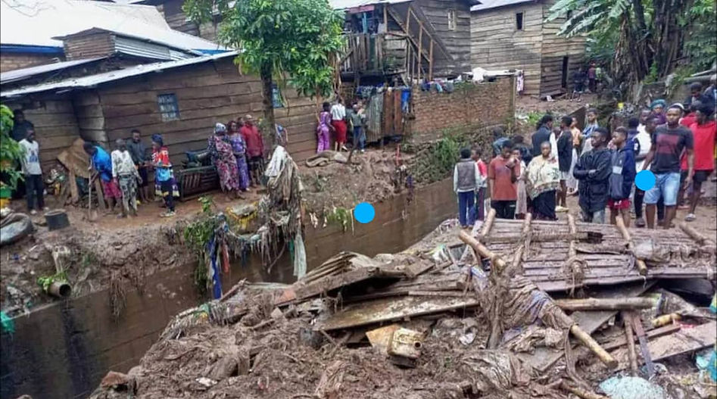

Heavy rains that fell on the city of Bukavu caused human and material damage during the night of Sunday 10 to Monday 11 August 2025.

According to the Civil Society, five people died, including four from the same family, including a mother and her three children who were surprised by the collapse of a wall that fell on their house, on Buholo III Avenue, in the Mosala district in the Kadutu Commune.

On the same night, our source added, a young man was struck by lightning and lost his life in Ciriri in the Commune of Bagira, still in Bukavu.

This assessment comes in a tense state marked by growing insecurity throughout the city of Bukavu and elsewhere.

Report courtesy DRC citizen reporter network through Jacques KAMBETI MASUMBUKO for ICCOD ONG [ongiccod@gmail.com](mailto:ongiccod@gmail.com)