Lightning Strike Kills Resident and Livestock in Rakai - Uganda
https://www.nilepost.co.ug/news/242595/lightning-strike-kills-resident-and-livestock-in-rakai
12 February, 2025
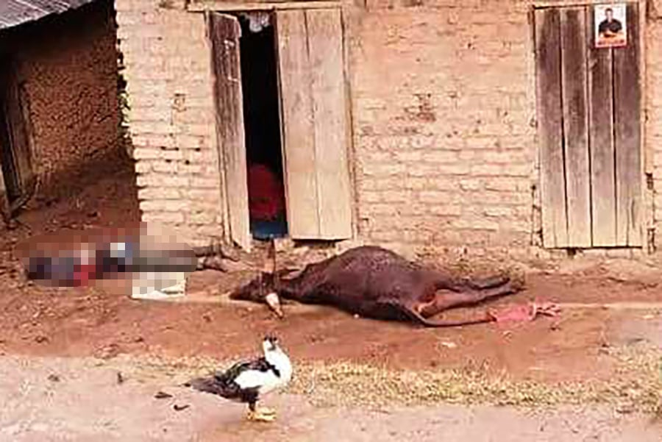
A man and a cow were killed in the lightning strike
By Zainab Namusaazi Ssengendo

A lightning strike during a heavy storm in Rakai District has claimed the life of 37-year-old Experito Mugera and killed a cow in Kizira village, Kagamba Parish, Byakabanda Sub-County.
The fatal incident occurred in the afternoon as violent winds, heavy rain, and hailstones battered the area.
Witnesses say Mugera had stepped outside to collect rainwater when a sudden bolt of lightning struck, killing him instantly.
A cow standing nearby also perished in the strike.
Residents of Kizira have been left in shock, mourning the loss of a man they described as humble and peaceful.
Village chairperson Husein Katurebe expressed deep sorrow, urging locals to take precautions during severe storms by staying indoors.
Police from Rakai District examined the scene before allowing the family to proceed with burial arrangements.
Mugera’s tragic death highlights the growing threat of extreme weather in Uganda, as erratic and severe storms continue to hit various regions.

