Death toll from KZN lightning strike rises to 3 – South Africa
https://www.ecr.co.za/news/news/death-toll-kzn-lightning-strike-rises-3/
11 February 2026
By Kubobonke Luthuli
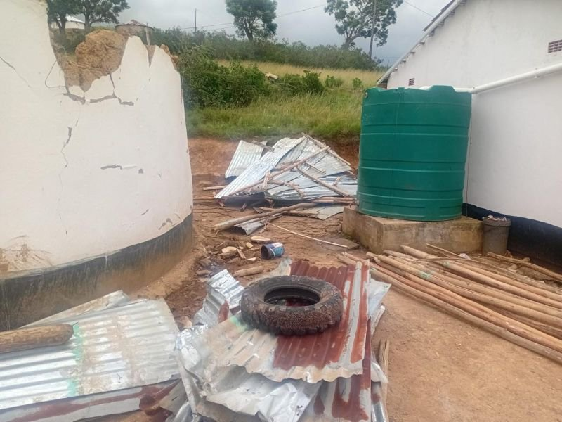
The latest victim is 66-year-old Shonaphi Phikisile Mhlongo, who was killed in Springvale near Ixopo on Wednesday.
The other two victims died in the same region on Saturday.
KZN Cooperative Governance says the weekend storms damaged homes and infrastructure, affecting more than 126 households and over 460 people.
The department spokesperson, Senzelwe Mzila, says Provincial Disaster Management teams are providing support to those affected.
“The MEC is calling upon communities to continue to be vigilant as the province continues to experience weather conditions that pose a serious risk to human life.”
The South African Weather Service has issued a Yellow Level 4 warning for more severe thunderstorms, expected in the interior of KZN on Thursday.

