Walungu: two dead and a hundred houses destroyed after the torrential rain in Kaziba – DRC
https://actualite.cd/2025/11/06/walungu-deux-morts-et-une-centaine-de-maisons-detruites-apres-la-pluie-diluvienne-kaziba
6 November 2025
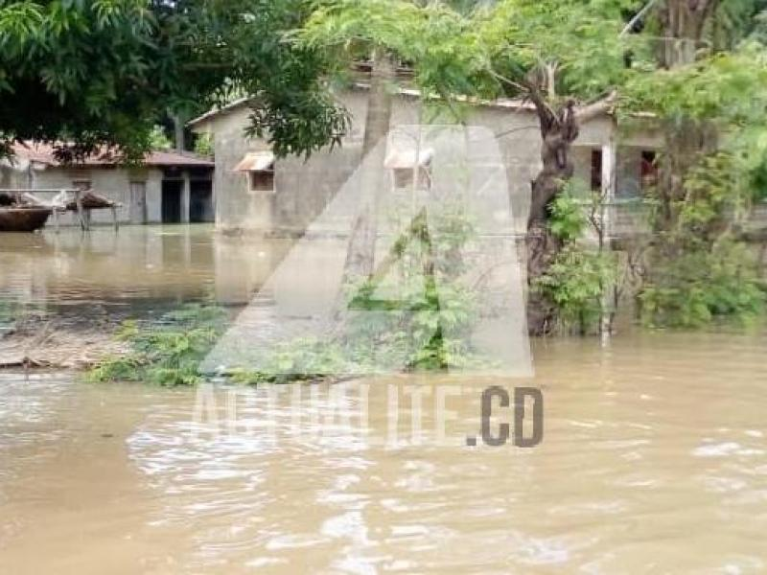
Two people died and a hundred houses completely damaged after the heavy rain that fell on the night of Wednesday to Thursday, November 6 in the chiefdom of Kaziba (Walungu territory) in South Kivu. According to local sources, several villages were affected by the disaster. Many families are in distress.
“It was a torrential rain accompanied by a strong wind. The damage is enormous: several roofs of the houses washed away, floods in the Kalamba, Luzinzi marshes, the villages of Kabembe, Kashosi and Butuzi have not been spared. Several families remain homeless,” the sources of civil society report.
Civil society adds that a person has died struck down. “It’s in Mufo where there was human damage. Five people were struck by lightning but two died.”
In the neighboring grouping of Kamanyola, we mention a toll of the dozens of damaged houses and the enormous damage caused by the rain in the last two days.

