Lightning strike kills 13 cattle during heavy rains in Zimba
https://www.lusakatimes.com/2026/03/10/lightning-strike-kills-13-cattle-during-heavy-rains-in-zimba/
10 March 2026
By Guest Editor
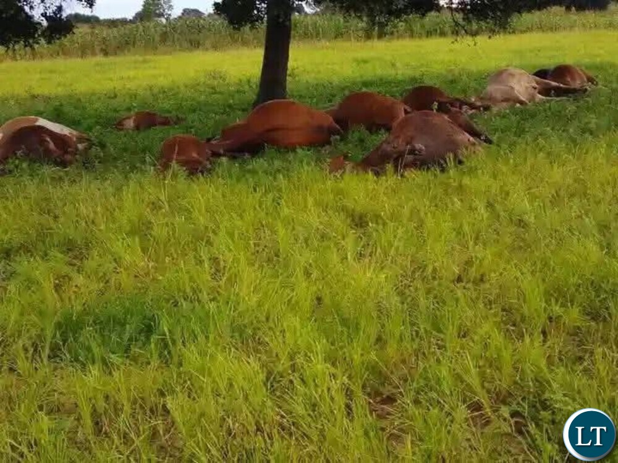
Thirteen heads of cattle belonging to a farmer of Sicheelo Village in Chief Simwatachela’s chiefdom in Zimba District have died after being struck by lightning during heavy rainfall.
‎The incident occurred on March 8, 2026 around 13:00 hours when lightning struck a herd of cattle that were grazing in the area.
‎Southern Province Police Commanding Officer Moono Namalongo confirmed the incident in a statement.
‎Mr Namalongo said the matter was reported to Choma Central Police Station on March 9, 2026 at about 12:25 hours by Mr Chrispine Ndeleki, 47, of Sicheelo Village.
‎“Mr Ndeleki reported that thirteen heads of cattle of assorted colours, branded 2T2B, died after being struck by lightning during heavy rainfall,” he said.
‎Mr Namalongo explained that earlier on the same day, around 09:00 hours, Mr Ndeleki had instructed his son to take 37 cattle for dipping before allowing them to graze within the village.
“Later around 13:00 hours, heavy rains started and the boy decided to drive the cattle back home. However, before reaching home, lightning struck the herd, killing thirteen of the animals,” he stated.
‎He said the matter was first reported to the village headman who advised the farmer to take the carcasses to Choma Police Station for police clearance.
‎Mr Namalongo said police officers verified the report and confirmed with Zimba Police Station that the cattle were not stolen.
‎“The Veterinary Department and Health Inspectors have since been engaged and the carcasses are currently being kept at an abattoir pending clearance,” the police chief said.

