### Mozambique: Lightning strikes cause 17 deaths in Zambézia - Mozambique <https://clubofmozambique.com/news/mozambique-lightning-strikes-cause-17-deaths-in-zambezia-276994/>

28 February 2025

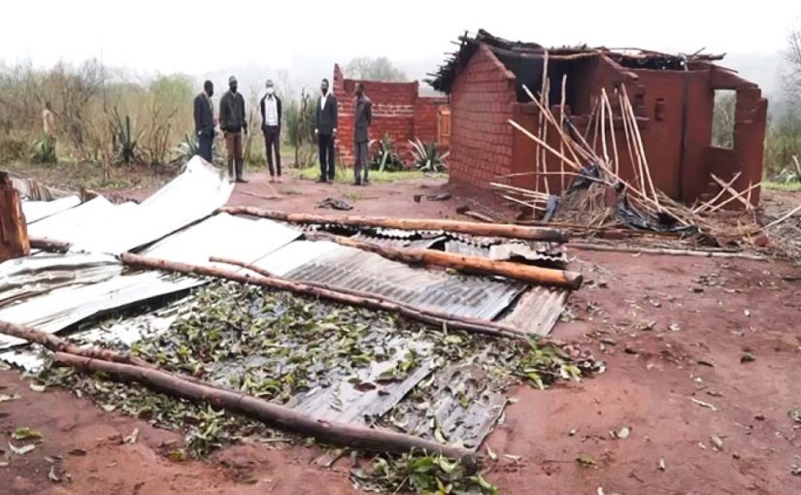

By Moz editor

At least seventeen people have died as a result of lightning strikes and another 46 have been injured since October last year in the province of Zambézia.

Data from local authorities indicate that assistance was provided to 120 families affected by heavy rains and flooding during the same period.

The information was shared this week in Quelimane by the provincial delegate of the National Institute for Natural Disaster Risk Management and Reduction (INGD), Hélder da Costa, at the 1st Ordinary Session of the State Representation Council.

According to the source, since the beginning of the rainy season, the province has recorded moderate, locally heavy, rainfall, reaching 30 millimetres in 24 hours, mainly in the districts of Morrumbala, Alto Molócuè, Maganja da Costa, Chinde, Milange, Mocuba and Quelimane.

As a result, more than 800 homes were completely destroyed and another 1,300, including nine health units and 46 schools, were partially damaged, affecting classes for 22,000 students and 390 teachers.

He said that 63.94 kilometres of roads were damaged, 44 electricity transmission poles fell and 36 hectares of agricultural land were flooded.

Da Costa said that INGD had pre-positioned essential goods, such as oil, soap, rice, flour, tents and other items in the districts vulnerable to the weather, namely Luabo, Maganja da Costa, Mopeia, Morrumbala, Namacurra, Chinde Inhassunge and Nicoadala.

According to the delegate, 120 families received multi-purpose assistance in the districts of Gurué, Luabo and Molumbo, in the form of food and non-food items, including tents, buckets and water purifiers.

The official added that nine vessels have been pre-positioned and will be allocated to Chinde, Namacurra, Nicoadala, Maganja da Costa and Mopeia, with one boat for each district and two for the district of Quelimane. The source assured that in addition to the INGD resources, there will be vessels from partners.

The Secretary of State for Zambézia, Avelino Muchine, urged the INGD to improve communication and strengthen partnerships with the media to reduce the impacts of disasters.

The official said that the current situation challenges the government to mobilise resources and imposes the need to seek national and international partnerships for the rapid replacement of the destroyed infrastructure.