Lomami: a PNC agent struck down in Mwene-Ditu – DRC
https://journaldesnations.net/lomami-un-agent-de-la-pnc-foudroye-a-mwene-ditu/
16 February 2026
BY William MABALA
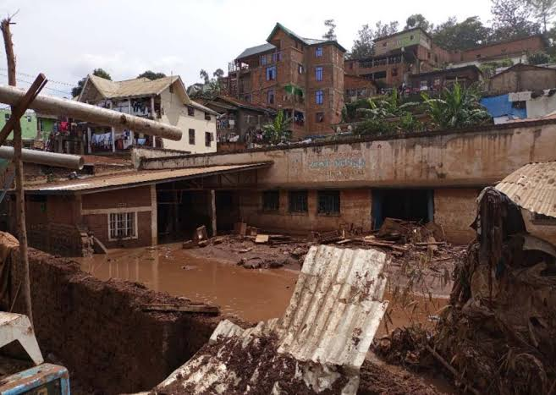
A torrential rain fell on the city of Mwene-Ditu, in the province of Lomami, on Monday, February 16, 2026, causing significant material damage in several neighborhoods. The most striking tragedy remains the tragic death of a Congolese National Police (PNC) officer.
Stationed in the Mukaya district of Musadi commune, police officer Tshizanga Tshiza was struck by lightning while performing his service in the face and died on the spot. Originally from Bakwa Mulumba, in the territory of Ngandajika, the deceased leaves a widow and several children.
According to information gathered on the spot, the remains were first transported to her family home in the Kasanza neighborhood, before being transferred to the Bukasa morgue while waiting for the funeral to be organized.
Beyond the emotion aroused by this tragedy, the event recalls the vulnerability of populations and agents of the order in the face of climatic hazards, especially in times of heavy rains.

