Ambohidratrimo: A woman dies struck, several injured – Madagascar
https://midi-madagasikara.mg/une-femme-meurt-foudroyee-plusieurs-blesses/#google_vignette
13 November 2025
By T.M
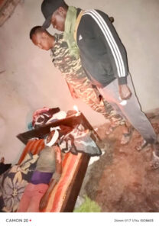
A violent storm, accompanied by lightning, caused a tragedy in the rural commune of Mahazaza, district of Ambohidratrimo, on the afternoon of Tuesday, November 11, 2025. Around 4:30 p.m., a lightning bolt struck Fokontany Antoby Atsimo, causing the death of a 25-year-old woman and several injured.
Alerted by residents, the gendarmes of the advanced post of Antanetibe Mahazaza immediately went to the scene to see the facts and to help the victims.
The death toll is one person who died, four seriously injured and five minor injuries. Health services quickly intervened to take care of the victims, while the remains of the deceased were handed over to her family.
Anspirab II
Two days earlier, on November 9, 2025, another similar accident occurred in the rural commune of Ambohidranandriana, district of Antsirabe II.
Heavy rains accompanied by wind, hail and lightning struck two houses in the hamlet of Tongahasina, causing the death of a couple, including the husband aged 70 and 68, the wife, and seriously injuring two teenagers.
The gendarmes and the local authorities went to the site as soon as the alert given by the inhabitants, in order to provide assistance and evacuate the wounded to the hospital of Antsirabe.
These two successive dramas highlight the vulnerability of rural populations to extreme weather events, which are increasingly frequent with the rainy season.

