VOHIBATO - A so-called lightning maker burned alive – Madagascar
https://www.lexpress.mg/2025/12/vohibato-un-soi-disant-faiseur-de.html
6 December 2025
By Haja Leo
A stranger who had presented himself as a “lightning maker” in the district of Vohibato, bereaved by the death of ten lightning-ridden villagers, was lynched and burned alive.
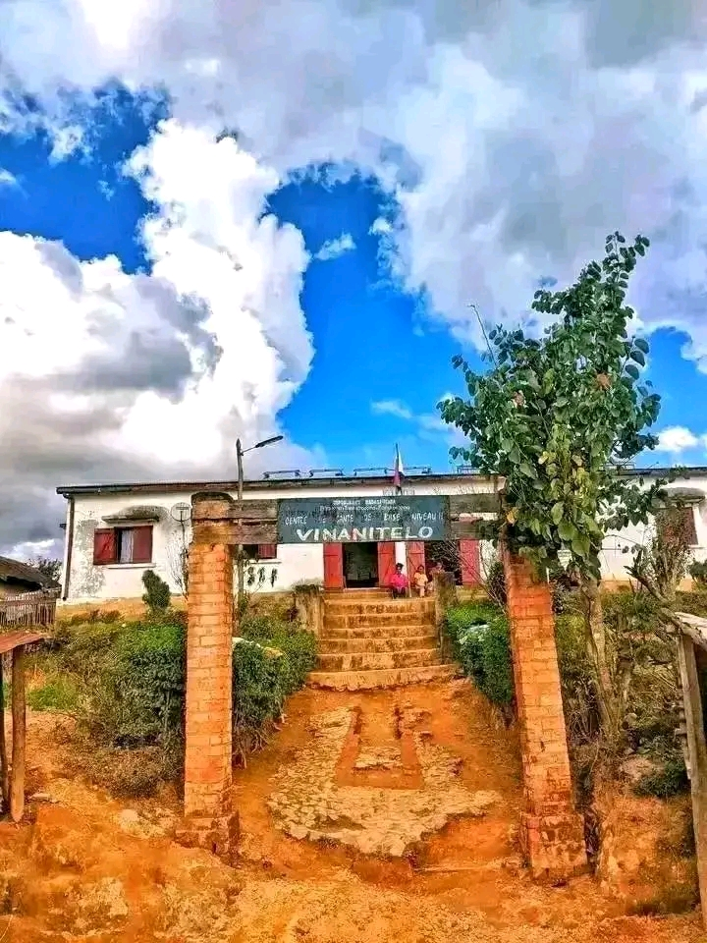
Two of the ten victims of lightning were in Vinanitelo Vohibato.
Popular justice has once again been hit in the district of Vohibato, Matsiatra Ambony region. Thursday, a man in his forties, presented as a native of an ethnic group whose exact identity remains unknown, was lynched and then burned alive by the crowd in Ambatomitsivalana, in the fokontany Soaiombonana.
According to the testimonies gathered, he had gone to the village to sell “lightning eggs” and claimed to be able to cause the fall of lightning. These statements have fueled the anger of residents already upset by a series of recent dramas.
For the past month, the authorities have recorded ten dead and twenty-four wounded in several municipalities in the district — Mahaditra, Alakamisy Itenina, Vinanitelo and Mahasoabe — all victims of lightning falls. Part of the population still interprets these natural phenomena as occult acts. Despite awareness campaigns to recall their meteorological origin, fear and suspicion persist. In this tense climate, anyone suspected of “mastering” or “selling” lightning can become the target of a popular vindict.
Origin
The tragedy reveals the persistence of deep beliefs in some rural areas. Lightning, which has hit several times in recent weeks, is perceived not only as a natural force, but also as a weapon that individuals would be able to manipulate. The man accused of being a “lightning-maker” has thus paid with his life the collective fear and the search for a manager in the face of these disasters.
The National Police has been seized of the case and is conducting the investigations. The authorities assure that the situation of public order is now calm, while remaining vigilant in the face of the risk of further violence.
The inhabitants are waiting for clear explanations about the origin of the lightning falls and the means to protect themselves from them. Meanwhile, the line between natural phenomenon and mystical belief remains fragile, and popular justice continues to establish itself as a brutal response to collective anxieties.

