Irumu: 16 schoolchildren struck by lightning in the chiefdom of Banyali-Tchabi -DRC
https://depeche.cd/2026/02/03/irumu-16-ecoliers-frappes-par-la-foudre-dans-la-chefferie-de-banyali-tchabi/#google_vignette
3 February 2026
By The Editorial
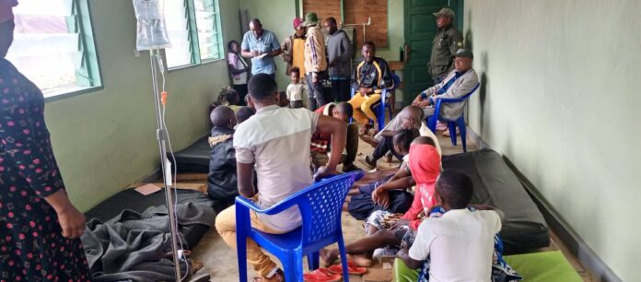
Bunia, February 03, 2026 – A dramatic incident occurred in the chiefdom of Banyali-Tchabi, in the territory of Irumu, in the province of Ituri where sixteen schoolchildren from the Tchabi primary school were struck by lightning while they were in the school.
According to a Civil Protection alert, corroborated by local sources, the tragedy occurred on Monday, February 2, 2026, following a rain accompanied by a violent thunderstorm that fell on the region.
Among the children affected, there are five boys and eleven girls. Alerted quickly, the people present on the scene proceeded to the emergency evacuation of the victims to a health structure of the square.
Schoolchildren are currently in the care of medical staff and are receiving appropriate care. Medical sources indicate that their health is being closely monitored, but does not provide further details on the severity of the injuries.
Faced with this incident, the Civil Protection service calls for increased vigilance in this period of rain, especially in schools exposed to the risks related to the weather.
Civil Protection stresses the need to strengthen preventive measures, including the security of school infrastructure, in order to avoid the repetition of such tragedies.

Denis MUNGURIEK AN

