WEATHER - Lightning kills sixteen victims – Madagascar
https://www.lexpress.mg/2025/11/intemperies-la-foudre-fait-seize.html
29 November 2025
By Mialisoa Ida
In four days, lightning has claimed sixteen lives across the country. The authorities reiterate the importance of respecting safety measures during the storm season.
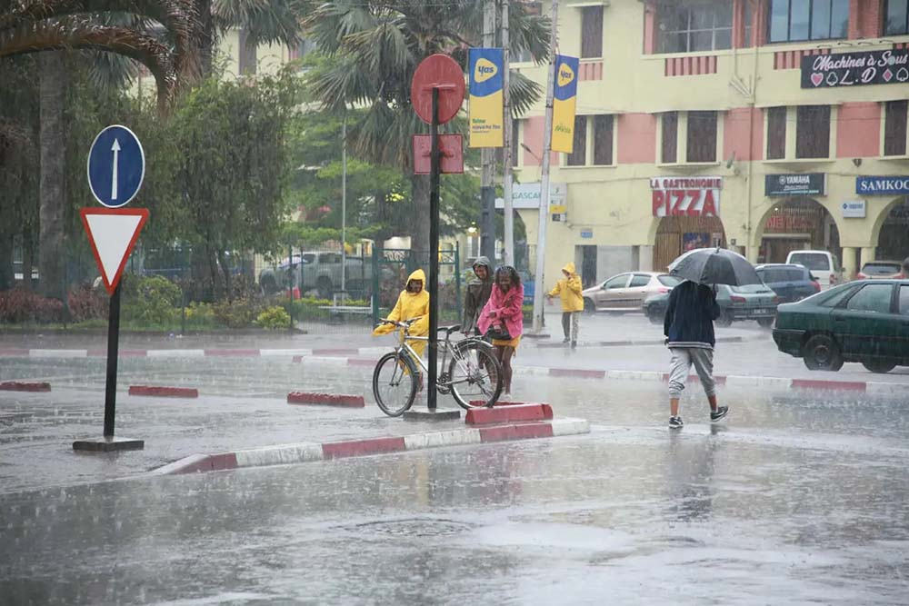
The heavy rains of recent days have resulted in several lightning impacts that have claimed victims.
Lightning struck multiple times in four days. From Sunday to Wednesday, this phenomenon caused the death of sixteen people, according to a toll recorded by the gendarmerie. Eight victims were recorded in Vohibato (Upper Matsiatra), one in Ivandry (Ambohijatovo), two in Merimandroso (Ambohidratrimo), two in Ambohimangakely, two in Ambositra and one in Antanifotsy. This phenomenon continues to kill and cause destruction in the territory.
People with lightning may suffer from various injuries, ranging from superficial or deep burns to cardiac arrests or immediate breathing disorders. Electricity through the body can cause nerve damage, numbness, temporary paralysis, as well as damage to the eyes and ears caused by lightning and thunder. Impact-related shocks and falls can also lead to physical trauma. Even when the victim survives, certain symptoms such as fatigue, headaches, or memory impairment may appear later.
If lightning is often perceived as a mysterious phenomenon, Lovandrainy Ratovoarisoa, a forecaster at the Directorate General of Meteorology, explains that it is born when a stormy cloud (cumulonimbus) accumulates opposite electric charges.
Corridor
Lightning is formed when there is a difference in electrical charges between a storm cloud and the ground: the bottom of the cloud is negatively charged, and the ground positively. When this difference becomes too big, a small load channel, called a descending tracer, descends from the cloud to the ground. As soon as he encounters an ascending tracer coming from the ground, a very powerful electric current flows through the channel, producing the luminous lightning and the thunder we hear.
A flash can reach 30 meters in length and a temperature exceeding 30 000 degrees, capable of blowing up a tree instantly. Metal objects, water, antennas and sheet metal roofs facilitate its conduction.
From November to March, during the summer season, Madagascar becomes a real thunderstorm corridor, promoting the appearance of lightning before and during the rain. This phenomenon, often described as supernatural, causes human losses, kills livestock and destroys real estate.

