Kikwit: Four dead and significant damage after heavy rains - DRC
https://www.mediacongo.net/publireportage-reportage-162844_kikwit_quatre_morts_et_d_importants_degats_apres_des_pluies_diluviennes.html

19 April 2026

By Badylon Kawanda Bakiman

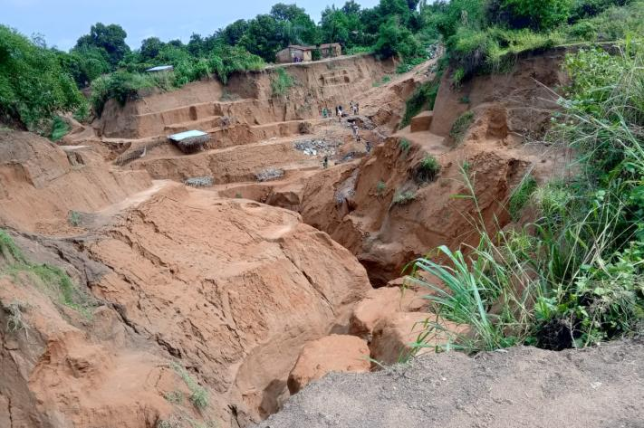
The city of Kikwit, Kwilu province, recorded four deaths, including two women, following the heavy rains that fell from April 16 to 18, 2026.
According to local authorities, three people died in the Post District, in the commune of Lukolela, after the collapse of a wall caused by a landslide that occurred during heavy rains. The fourth victim, a 60-year-old woman, was killed by lightning in the commune of Kikwit 2.
In addition to the loss of life, these bad weather has caused significant material damage, including the destruction of at least 35 houses in the communes of Kazamba and Lukolela.
The rains also worsened the ravines and damaged several infrastructures. The Kanzombi road became impractical, preventing the movement of motorcycles and other craft. In Nzinda, Wazabanga Boulevard has again deteriorated despite the recent rehabilitation work.
In the face of this situation, local authorities and civil society are sounding the alarm and calling for urgent measures to limit the damage from erosion and weather.

