Lomami: Lightning kills 3 girls from the same family in Mwene-Ditu - DRC
https://7sur7.cd/2025/09/24/lomami-la-foudre-tue-3-filles-dune-meme-famille-mwene-ditu
22 September 2025
By Benjamin Kambadi
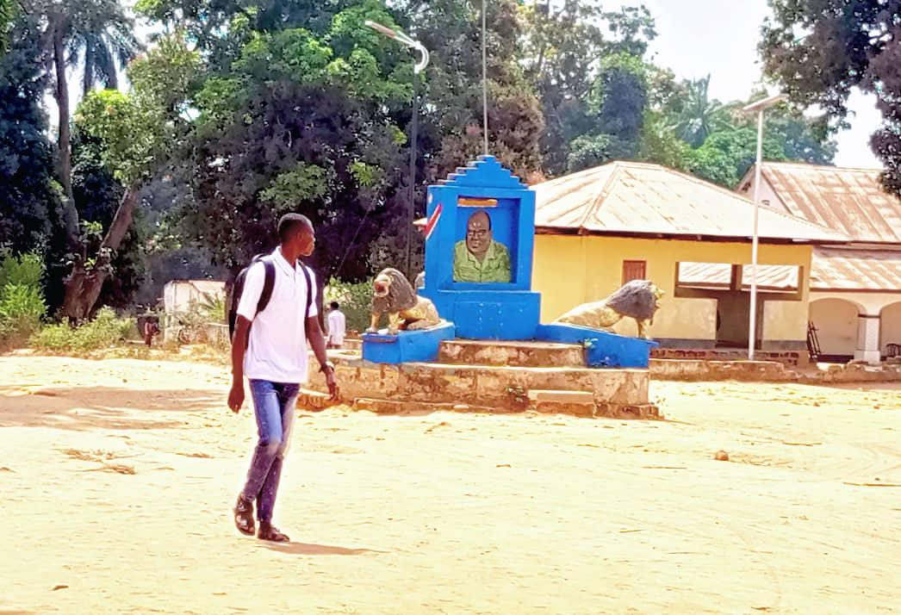
Three (3) daughters of the same family lost their lives on Monday, September 22, 2025, following an electric shock produced by lightning during a rain that fell in this second railway city in the province of Lomami.
The information was confirmed at 7SUR7. CD on Tuesday, September 23, 2025 by the mayor of the city of Mwene-Ditu, Gérard Tshibanda Kabwe.
"These are indeed 3 daughters of the biological parents who follow each other, because in this family there were 5 children. It means that with the deaths of these 3 daughters, parents stay with 2 children. Really, it’s mystical these things, even if someone has a debt of how much you can’t manage to make this taboo,” said Gérard Tshibanda Kabwe, Mayor of Mwene-Ditu.
The same source also said that they were girls aged 8, 11 and 13, who were struck down while sitting in their homes.
Whatever efforts were made to transfer these victims to the health facility, none of them survived.
It should be noted that a meeting with the traditional chiefs of the region will be convened by the number 1 of the railway city to stop certain measures.

