REPORT ON THE INSTALLATION OF A LIGHTNING PROTECTION SYSTEM AT MULABANA PRIMARY SCHOOL, KALANGALA DISTRICT

24 June 2024
This report details the installation of a lightning protection system (LPS) at Mulabana Primary School in Kalangala District. The installation was conducted by Isaac T, Chief Installer, and Omara Martin, Project Manager from ACLENET, from June 11, 2024, to June 24, 2024. The project aimed to safeguard the school buildings and enhance safety for students and staff during thunderstorms.

Objectives
- To protect the school buildings and occupants from lightning strikes.
- To ensure the installation meets the Cape Electric drawing.

Scope of Work
The installation covered the following school blocks:
Protected Blocks: A, B, C, D, F, G, H, I.
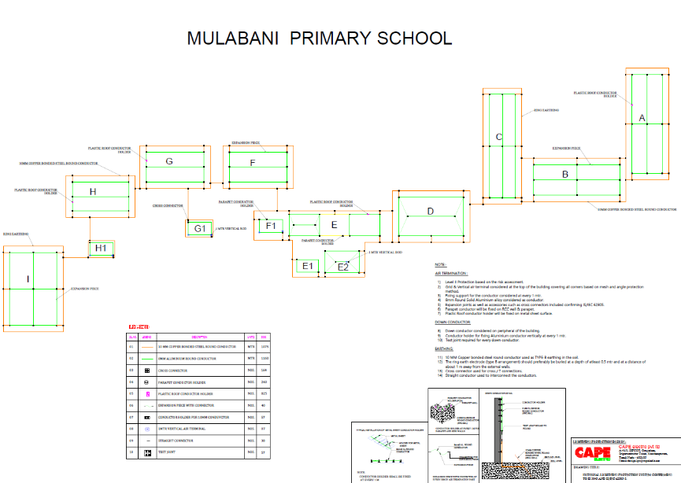

Materials Used
- Cape Electric testing joints
- Cape Electric air terminals
- Cape Electric 8mm² aluminum round wire
- 10mm² electric Cape copper-coated wire
- Cape Electric roof conductor holders
- Cape electric Cross connector

Planning and Preparation
- Initial site survey and assessment of existing roofing conditions.
- Review of Cape Electric drawings and regulatory standards.

Installation
- Air Terminals: Installed according to Cape Electric drawings. Some terminals required longer screws due to the age and condition of iron sheets.
- Conductors: Laid 8mm² aluminum and 10mm² copper-coated wires. Bending the earth wire was challenging.
- Roof Conductor Holders: Fixed to the roof with difficulty due to steep angles and algae growth.
- Trenching: Dug 0.7m deep trenches for grounding conductors, facing obstacles such as rocks.
- Testing Joints: Ensured all connections were secure and met regulatory standards.

Challenges Faced
- Roof Condition: Poor quality and aged iron sheets caused issues with securing screws.
- Steep Roofing: Made installation challenging due to algae growth and steep angles.
- Trenching: Encountered rocks and hard-to-bend earth wires.
- Climate Conditions: Variable weather with little rain and intense sunshine impacted the work schedule. We would experience rain in other days hence affecting our work for the day
- Building Materials: Walls with insufficient cement and poor-quality bricks hindered secure installations.
- Other local materials to be used: its challenging to purchase materials like screws, pvc pipes from the island since no one sells them, so the project manager had to drive up to Kampala to purchase such items and it was sometimes had to come back and meet the ferry time.
- Accommodation: we had challenges of long distance to find a better place to sleep. We had to travel a much longer distance to and from everyday a distance of 80km every day. In that its 40km from Kalangala town to Mulabana school. This has enabled us to use more fuel in travels alone. I appreciate that fuel was provided for, and it was enough.

Solutions Implemented
- Used longer screws for securing air terminals on aged iron sheets. (we had to purchase longer screws of 1.5inch)
- Implemented flexible scheduling to accommodate weather conditions.
- Utilized additional support for weak walls and poor-quality bricks.
- We utilized the support of some semi-skilled casual laborers to try and quicken up the installation job though they were a little slow, but they did a commendable job otherwise if it was Isaac alone he would have taken a whole month because he was working on one building for 3-4days alone.
- Enough fuel was provided to the project manager for travel from one place to another to enable the project move on smoothly. All necessary materials to be bought locally were acquired.

Results
The lightning protection system was successfully installed on the designated blocks. Despite the challenges, the system was installed according to Cape Electric designs and regulatory standards. The project improved the safety and resilience of the school buildings against lightning strikes.
The school administration was so kind and friendly to us during installation.

Recommendations
- Material Quality: Cape Electric materials and design are of high quality but require careful handling and additional time for installation.
- Installation Time: Allocate more time for installing roof conductor holders and air terminals, especially on older buildings.
- Future Projects: Consider the condition of existing structures and plan for additional materials and support as needed.
Photo Journal
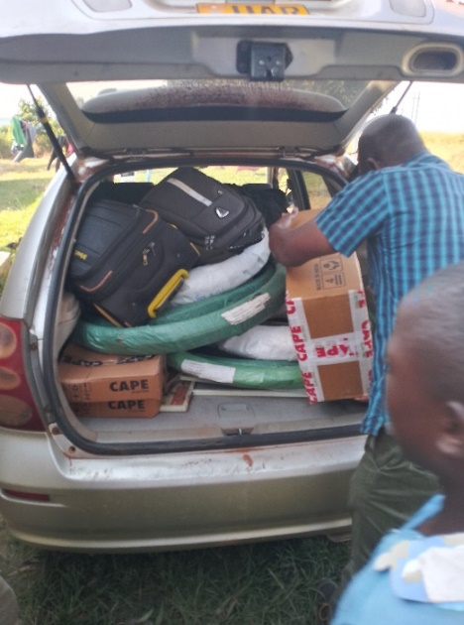
LPS materials loaded on Martin Omara (project manager) vehicle headed for Mulabana primary school.
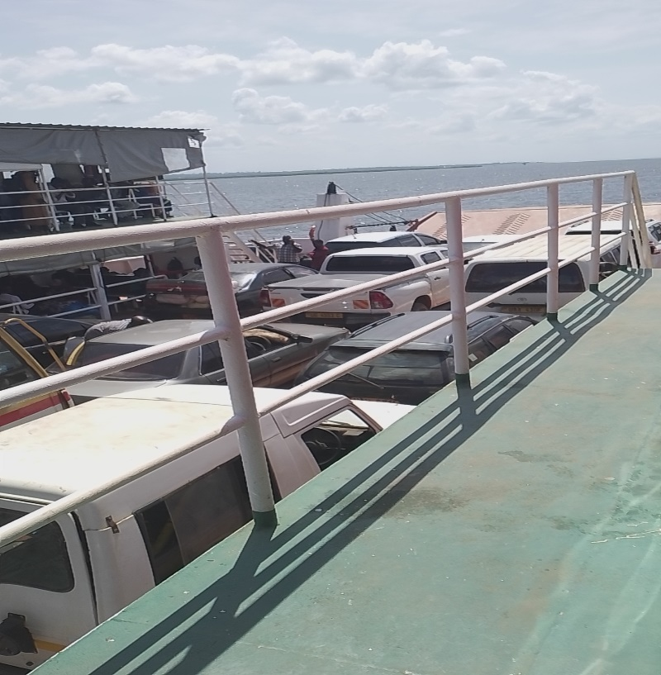
Martin on a ferry with materials to Kalangala island, destination to Mulabana primary school
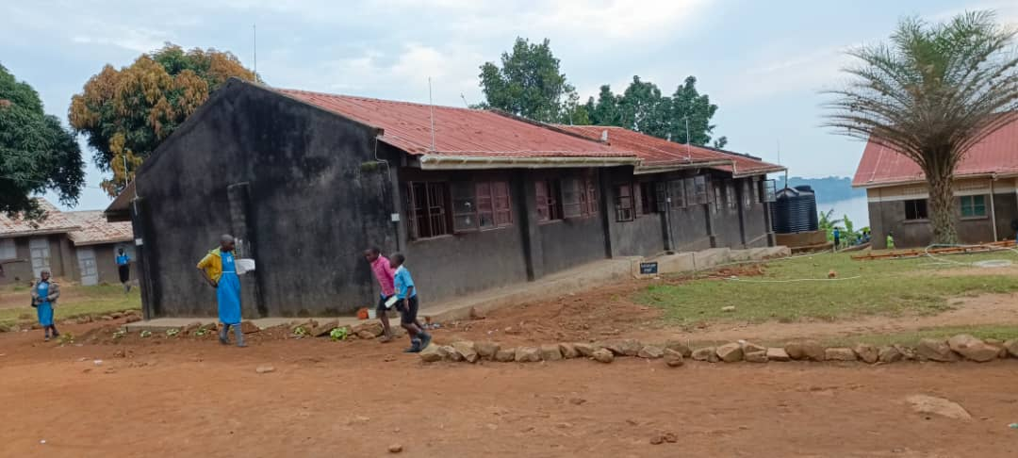
Block C
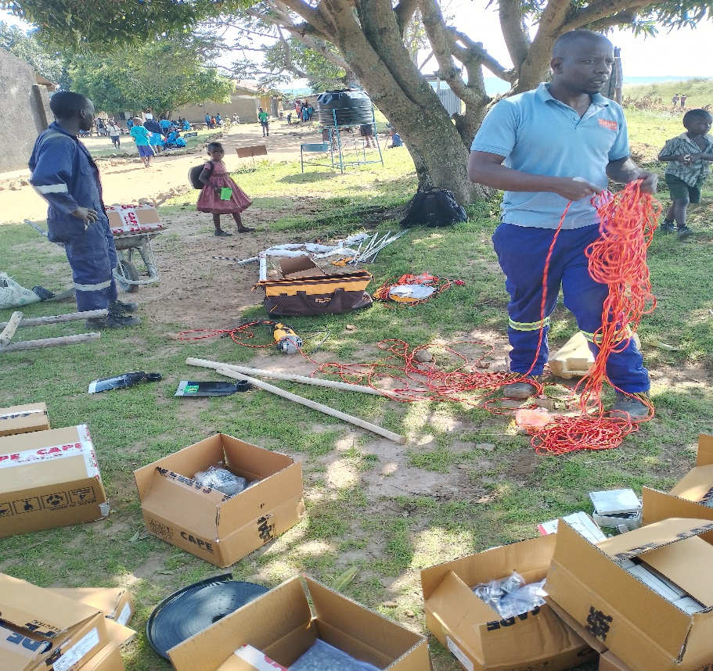
Isaac preparing for the days’ work
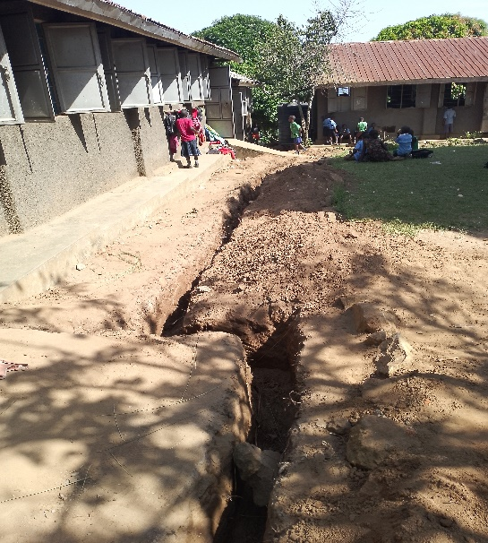
Some of the trenches dug by casual laborers – see more photos later
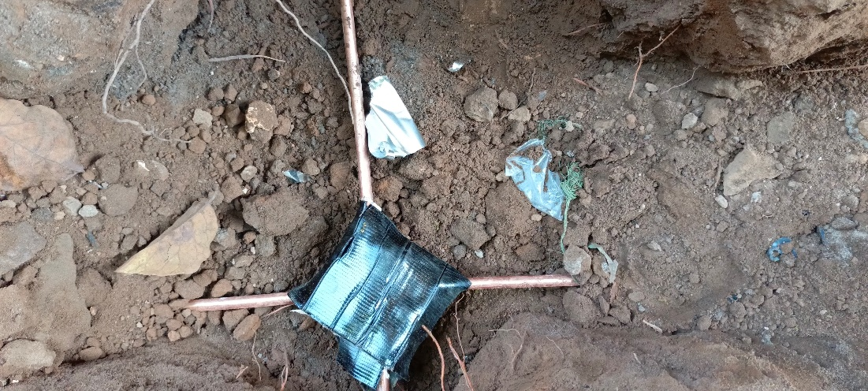
Joint with water proof tape.
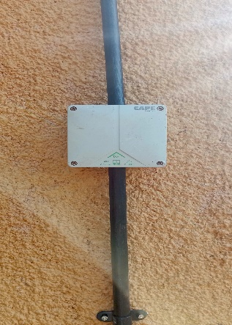
Testing Joint
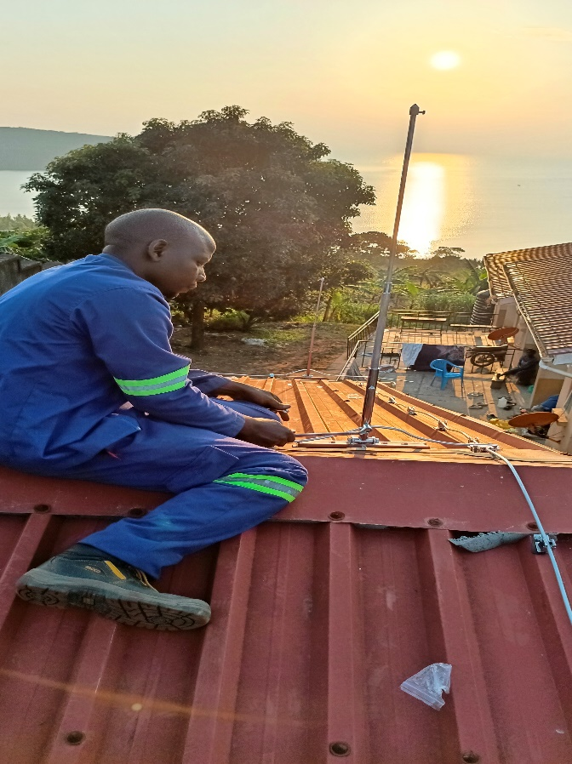
Installing Air terminal on block H
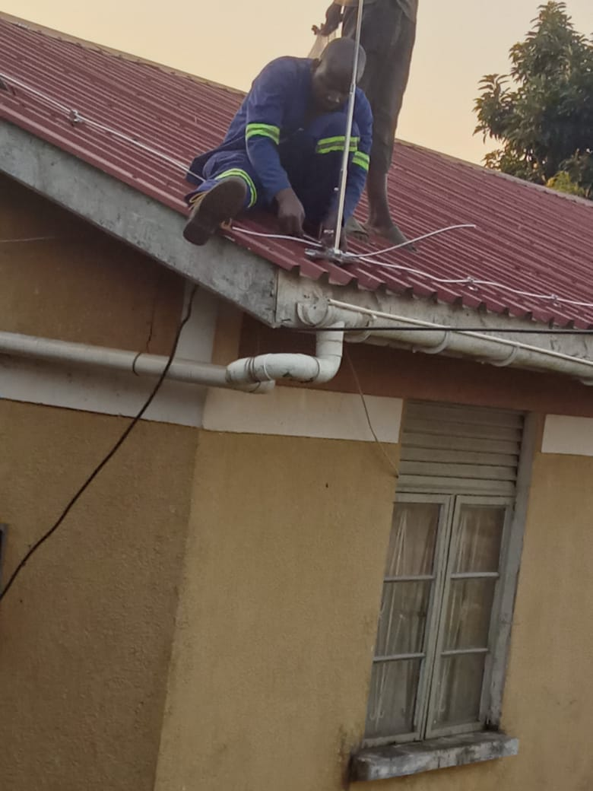
Fixing a down conductor on one of the buildings.
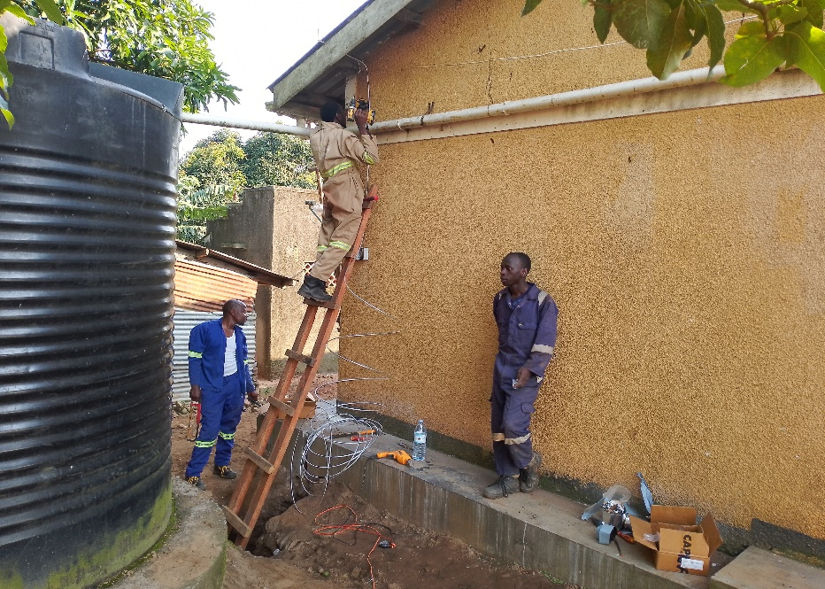
Isaac and team of semi-skilled laborers trying to fix down conductors

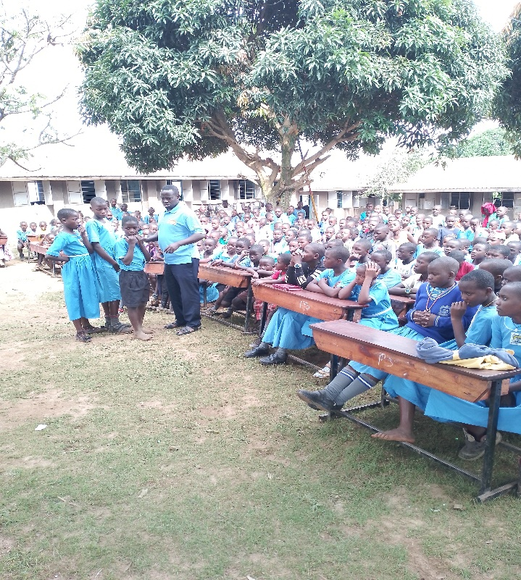
While Isaac and his team focused on installing the hardware, Barnabas and Daile Zhang, one of our Board of Directors visiting from the USA, gave safety education on lightning to students.
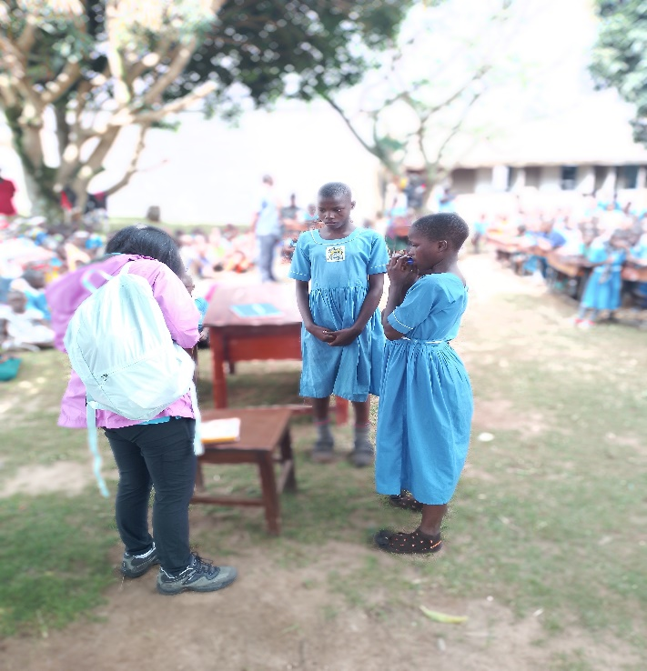
Daile Zhang, ACLENet Board of Directors, giving out some prizes to the winners of the lightning quiz conducted by Barnabas
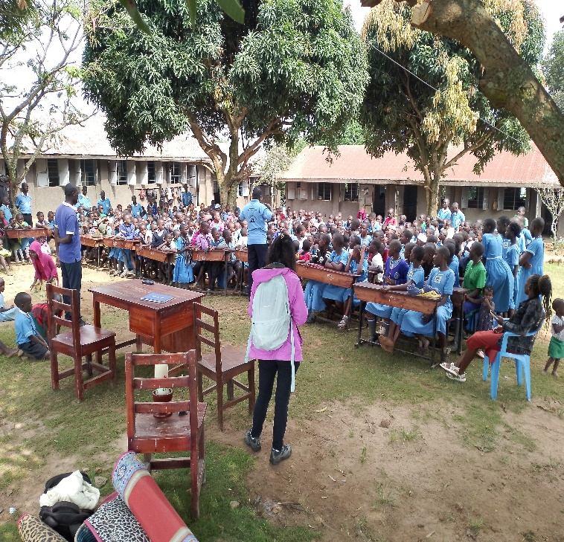
More picture of the children at the school
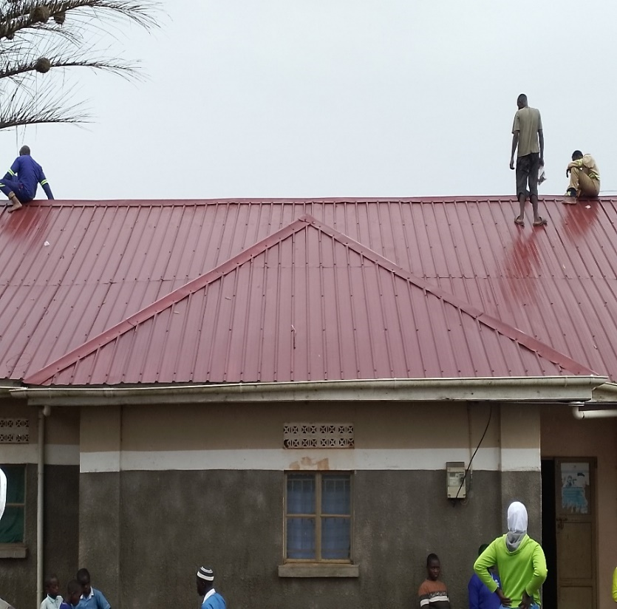
Slippery roof on a rainy day. That’s why you can see Isaac and the team walking barefoot on the roof. It’s worse with shoes on.

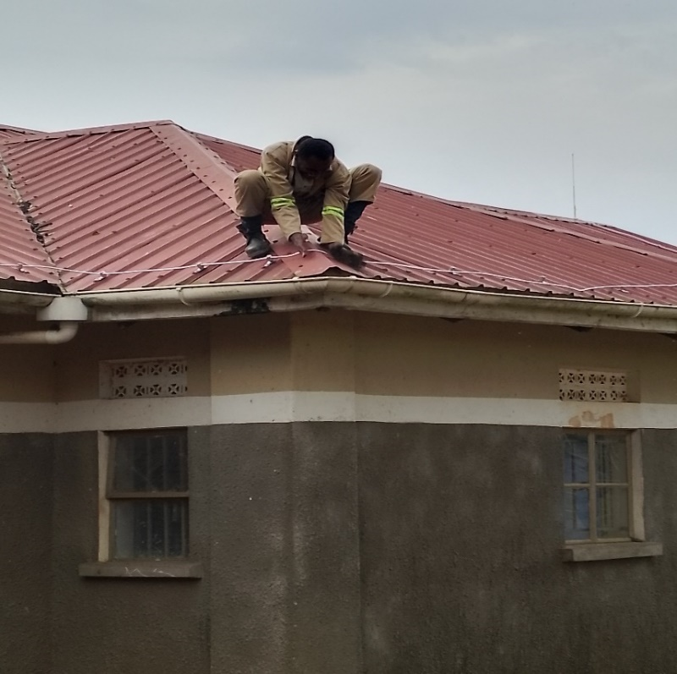

Very steep roof making it hard to fix on the ages
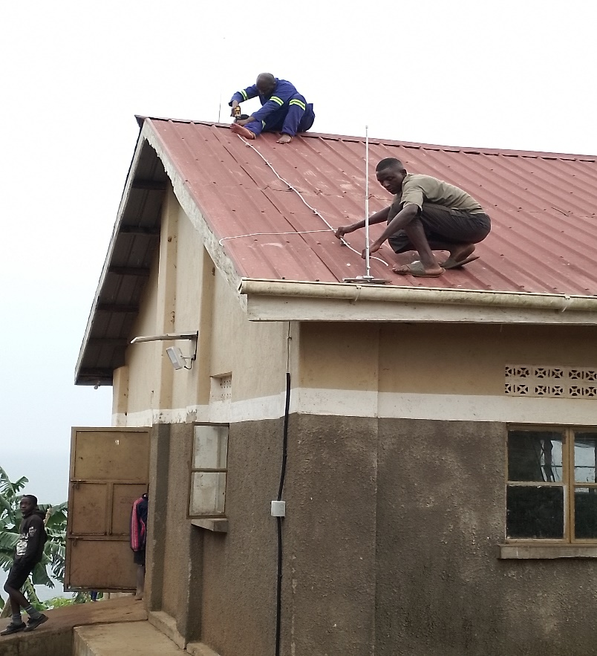
Isaac on top fixing air terminal rods on the roof
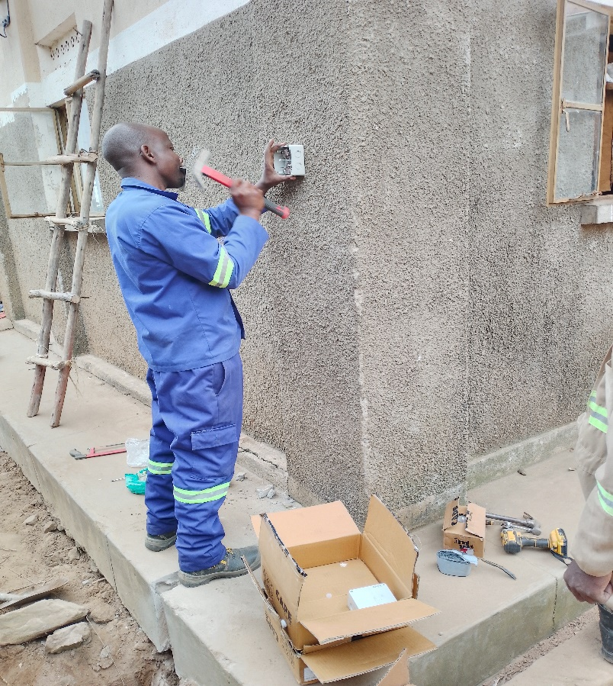
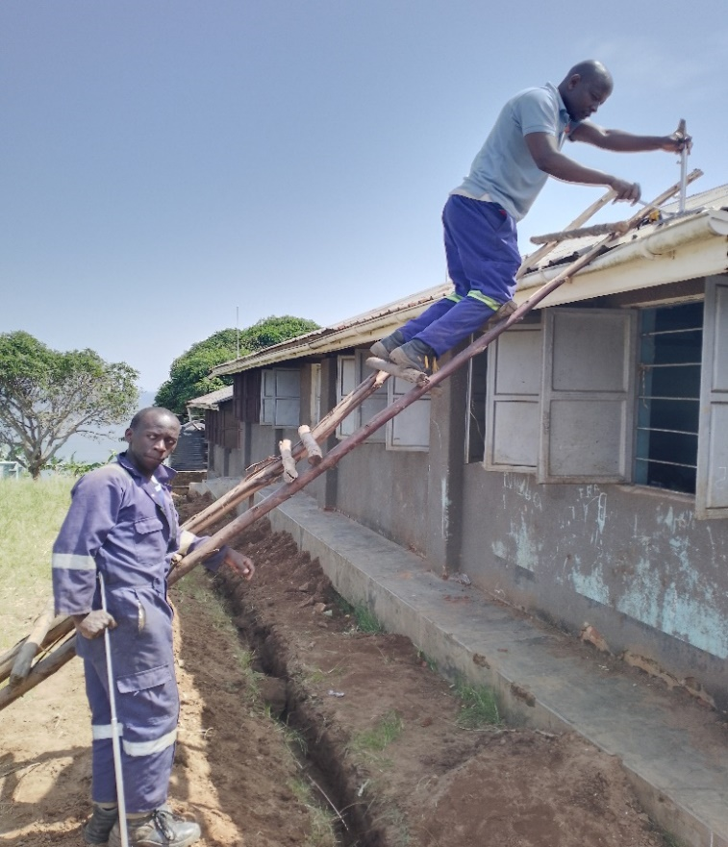
Isaac fixing air terminals

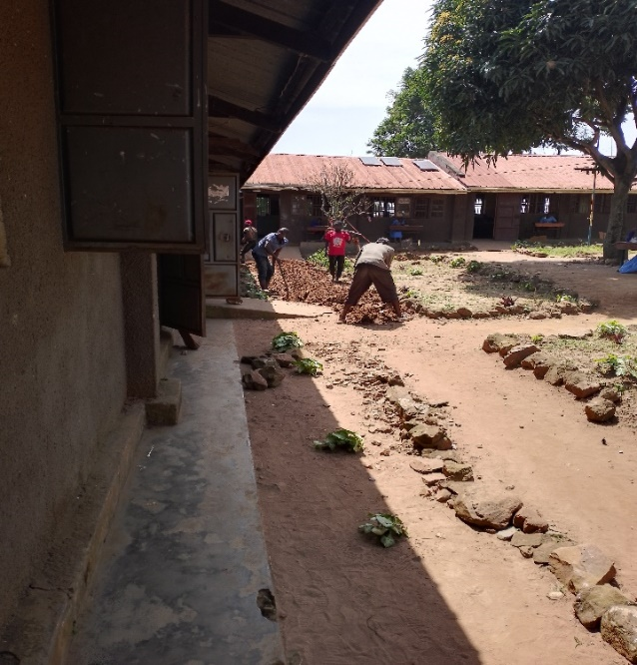
Casual laborers digging trenches around the classroom blocks
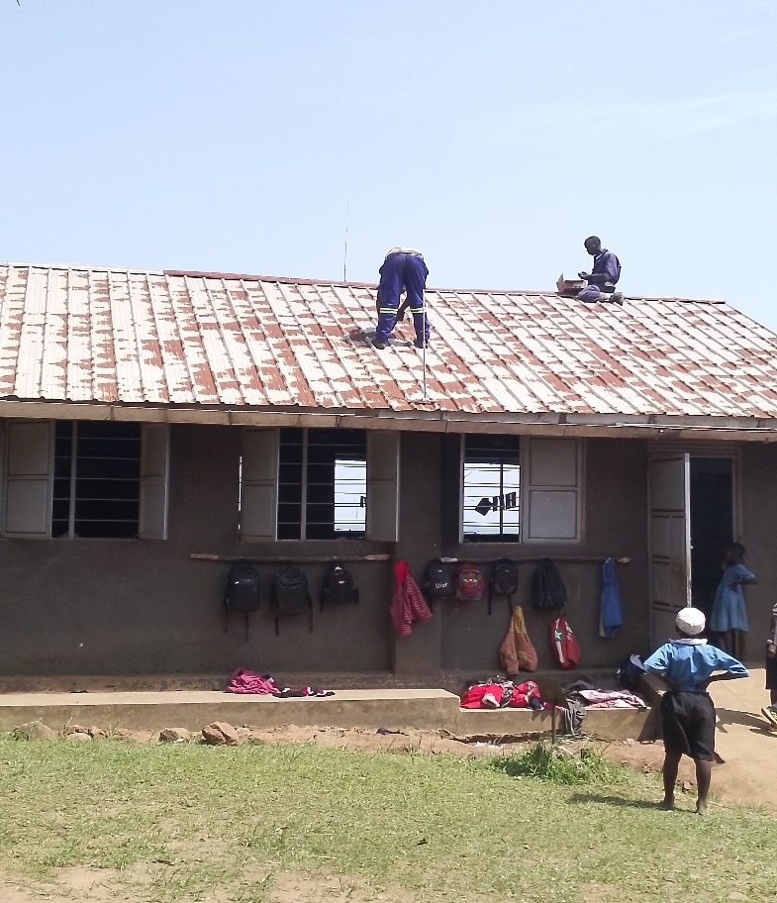
Isaac on the roof
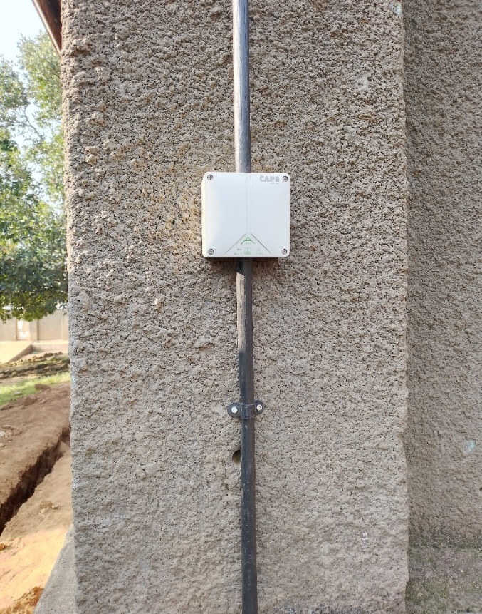
Testing joint
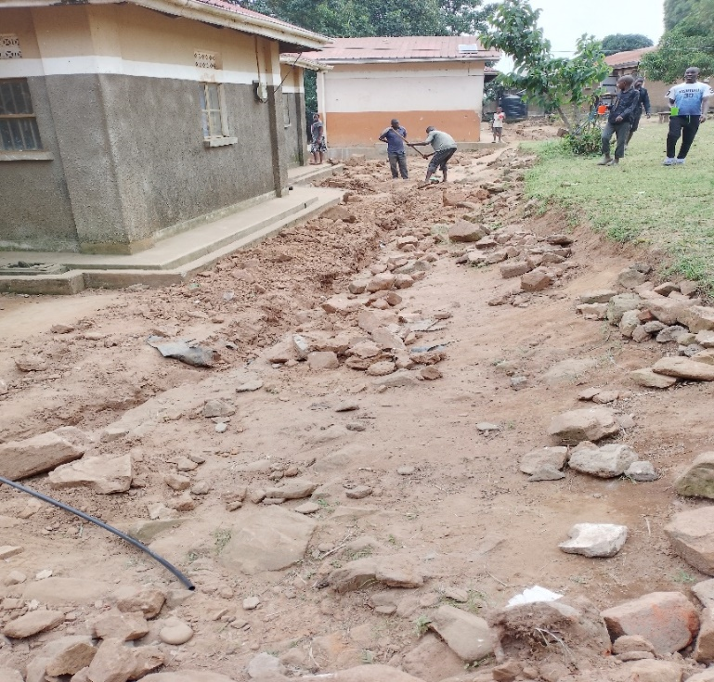
Casual laborers trying to dig through had rocks to get the right depth
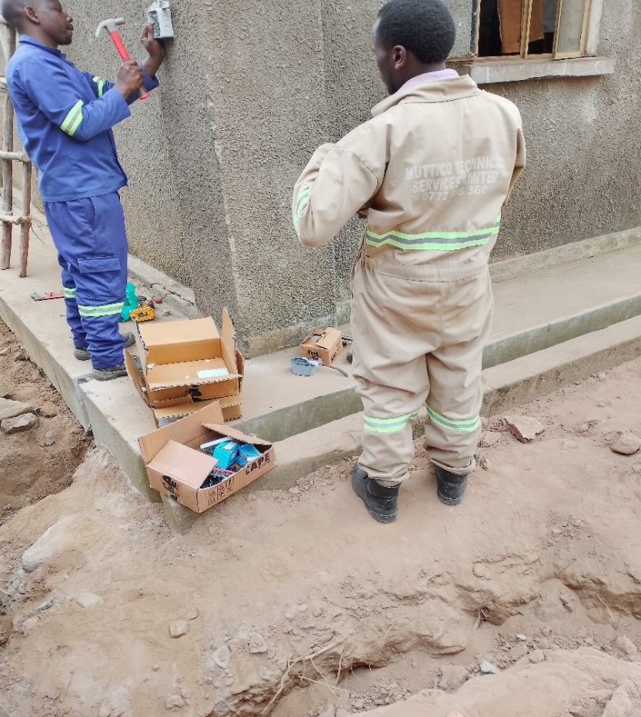
Isaac fixing testing joint on one of the walls
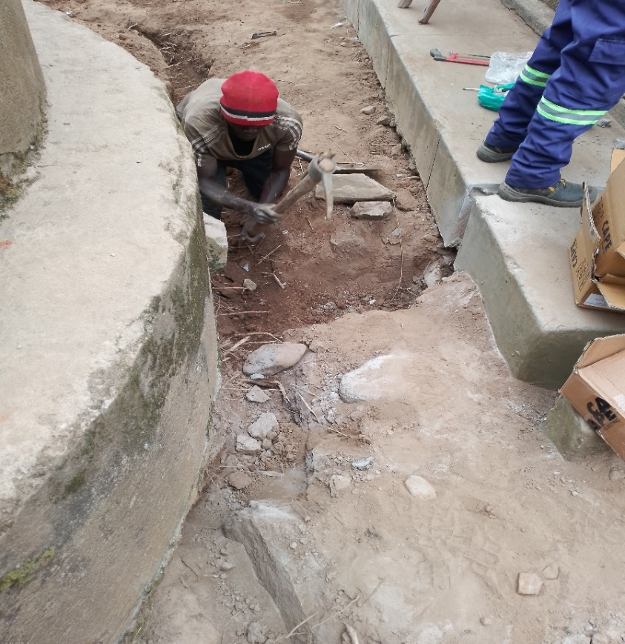
Casual laborer digging through hard rocks
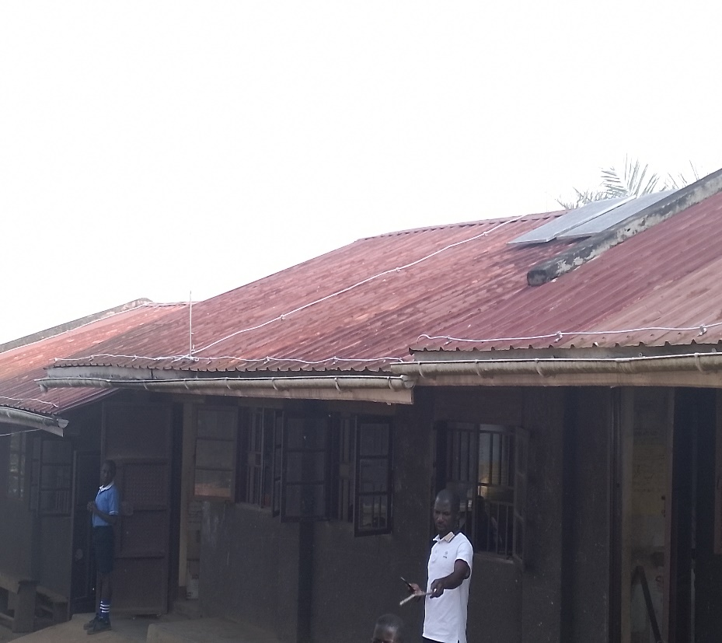
Fully installed block C
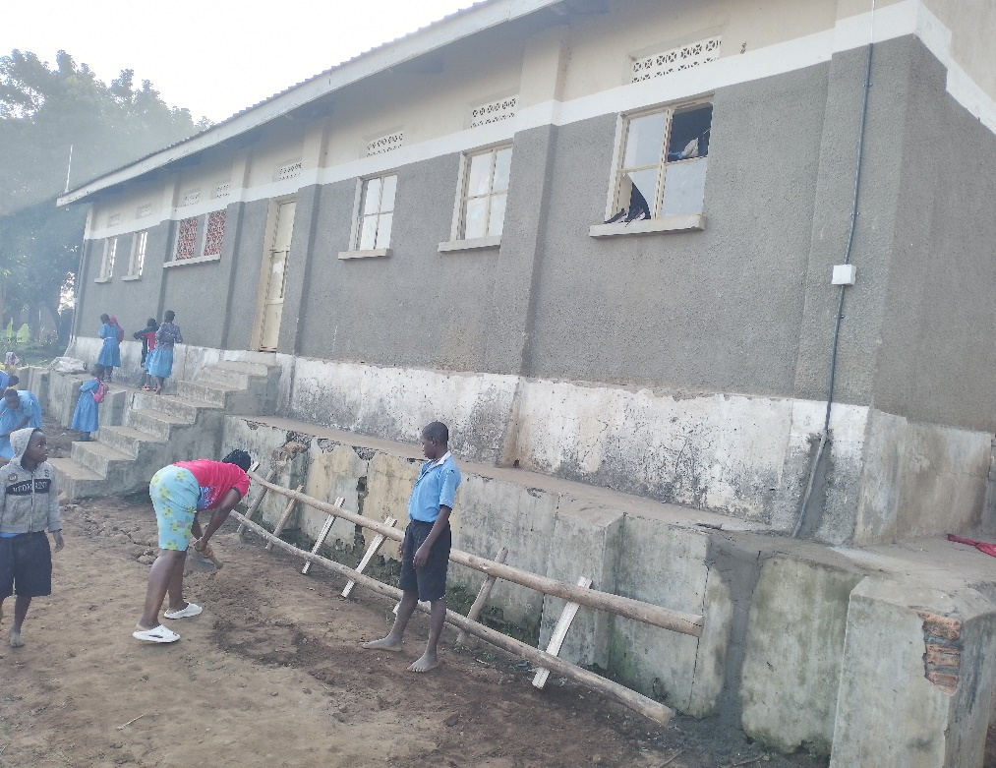
Fully installed block D dormitory
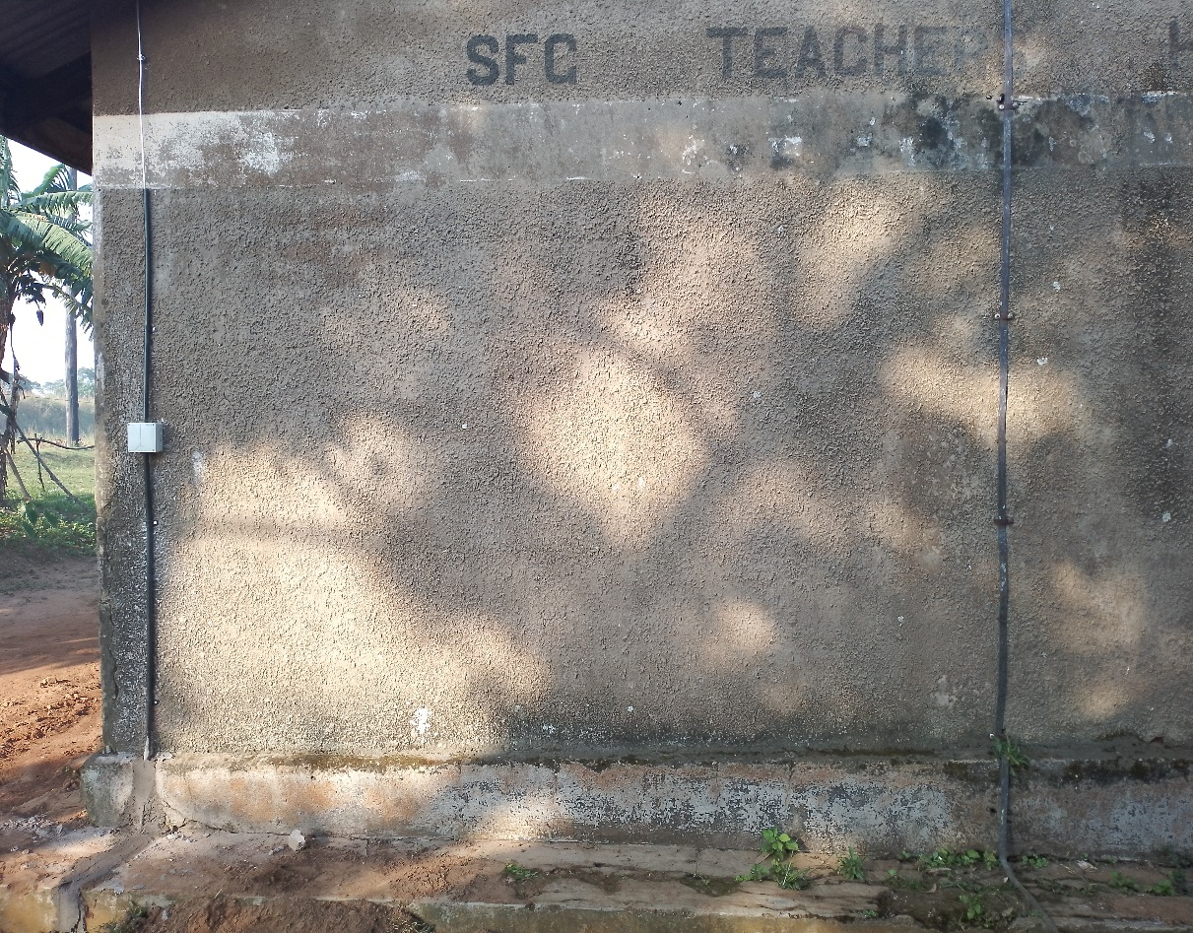
Fully installed one of staff quarters
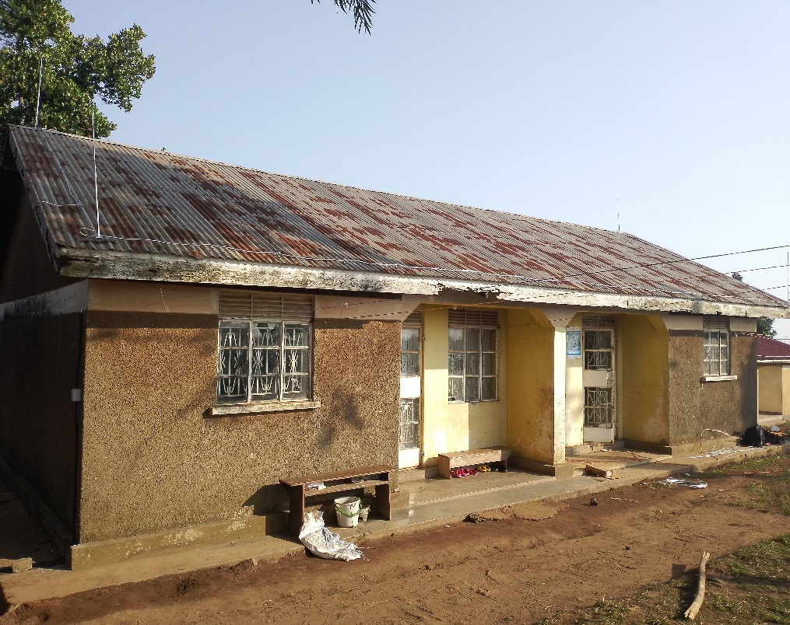
One of staff quarters fully installed
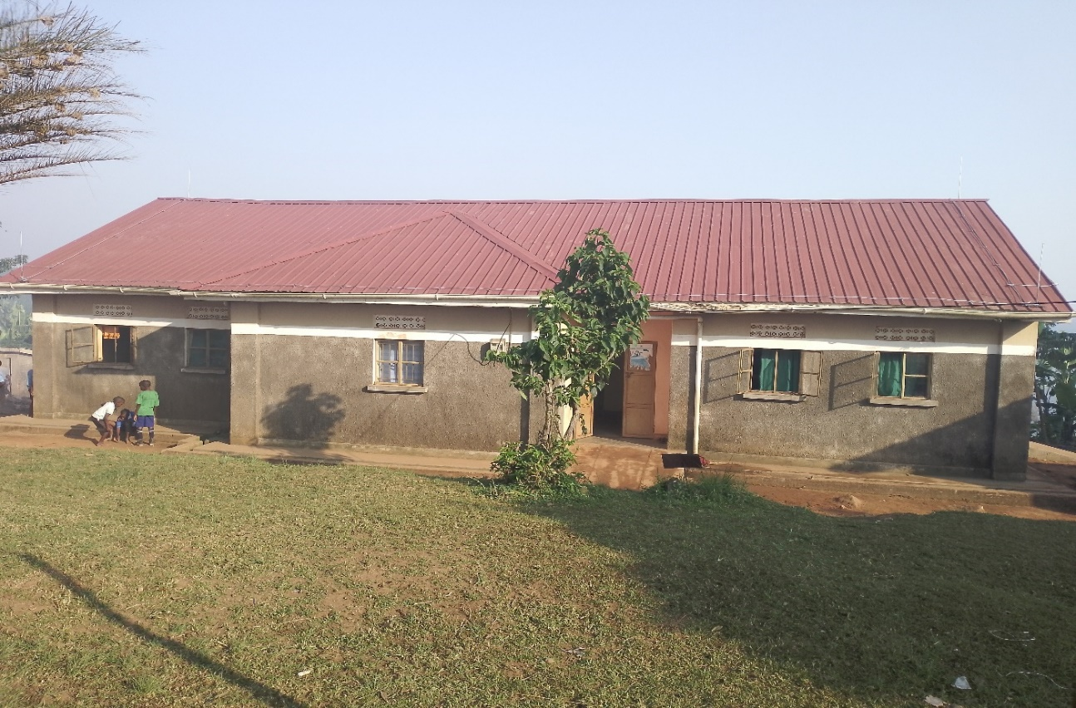Dormitory fully installed
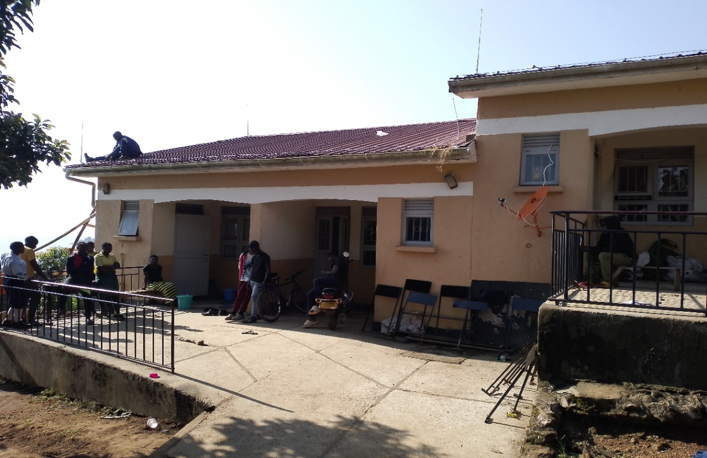
Isaac fixing one of the staff quarters block I
Thank you,
Martin Omara and Isaac Tumuhimbise

