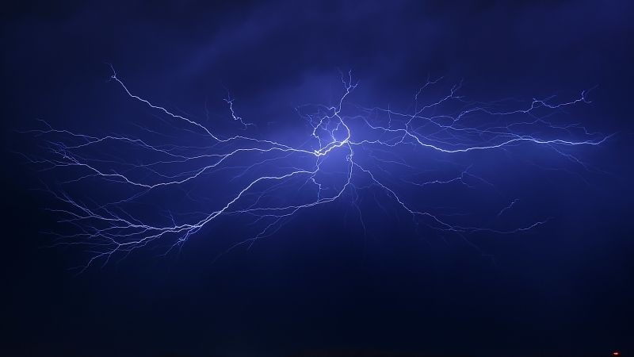

Document No. STI-FF/05/2024 LIGHTNING
(A NAM S&T Centre - SALNet Fact File for Dissemination of Information on
Science, Technology and Innovation in NAM and Other Developing Countries)
Warmest Greetings to all our Esteemed Readers!!
It is with great pleasure that I introduce you to another Fact File published by the NAM S&T Centre on the topic of "Lightning". This Fact File, jointly prepared by the South Asian Lightning Network (SALNet), Kathmandu, Nepal in collaboration with the NAM S&T Centre aims to shed light on the impact of lightning on human life, livestock, infrastructure and the environment.
Lightning strikes cause significant fatalities annually worldwide. Besides human casualties, lightning also triggers devastating forest fires, damages buildings & electrical/electronic systems and disrupts utilities, leading to substantial economic losses. To mitigate these risks, lightning protection systems are crucial. Real-time lightning detection technologies, contribute significantly to early warning systems, aiding sectors such as aviation, defense, utilities and public safety. Despite technological advancements, the impact of lightning remains particularly severe in developing countries, where agricultural workers and outdoor laborers are most vulnerable due to lack of protective infrastructure and awareness. In conclusion, while lightning is a natural phenomenon with complex scientific explanations, its societal impact underscores the need for continued research, robust mitigation strategies and global S&T collaboration to reduce casualties of human/livestock and economic losses worldwide.
We are thankful to Dr. Shriram Sharma, Professor, Tribhuvan University, Nepal and Chairman, SALNet for suggesting this important topic and contributing as the Scientific Editor for this Fact File. We also express our appreciation to Mr. Ron Holle and Dr. Daile Zhang from the National Lightning Safety Council, USA for their valuable contributions in preparing this Fact File. We also express our sincere gratitude to Prof. Mary Ann Cooper, Managing Director, African Centres for Lightning and Electromagnetics Network (ACLENet) for providing us the photographs of the tragic lightning incident that took place on June 28, 2011 in Uganda.
I believe that this Fact File will provide valuable insights and foster greater understanding of the multifaceted challenges posed by “Lightning”.
(Amitava Bandopadhyay)
Principal Contributors: Dr. Shriram Sharma, Tribhuvan University, Nepal; Mr. Ron Holle, National Lightning Safety Council, USA and Dr. Daile Zhang, National Lightning Safety Council, USA; Editor: Dr. Shriram Sharma

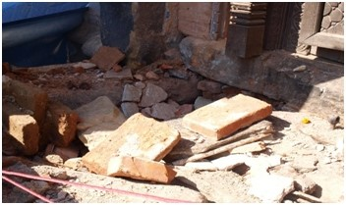
Overview of Lightning Impacts
- Lightning is the most dangerous natural phenomenon that nearly everyone in the world encounters every year. It is estimated to kill up to 24,000 people a year, injure as many as ten times more, sometimes with lifelong debilitating aftereffects. Forest fires from lightning consume large swaths of trees in many countries along with nearby structures. Damages to homes and public buildings (Figs. 1 and 2) are frequent, either in terms of total destruction or impacts on electronics inside a building that may eventually result in house fires gutting the house into ashes. Deaths of livestock due to lightning are as high as ten times the human lives (Fig. 3). Utilities are often impacted by Fig.2. Lightning damaged floor at the entrance of Pratappur temple at Swayambhunath Kathmandu on 13th February 2011. (Photo: Shriram
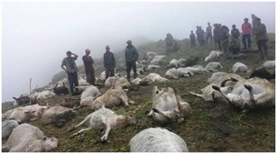Fig.3. Over 500 sheep grazing in pastures high in the mountains killed by a lightning strike on 23 August, 2020 in Masimarema grazing land of Patrasi Fig.1. Lightning damaged Pratappur temple at Swayambhunath Kathmandu Rural Municipality, in the remote Jumla, of western Nepal (Photo: courtesy on 13th February 2011. (Photo: Shriram Sharma) The Rising Nepal)
Sharma)

power surges from lightning strikes to poles, substations, and other infrastructure that are extremely common worldwide. Protection against these utility losses is very expensive to avoid outages that disrupt modern lifestyles dependent on reliable power. Delays in aviation and recreation are taken to prevent damage or injury and often occur in regions with thunderstorms. Large animals are frequently killed by lightning, and the deaths of small herds of livestock impact what is often the only source of income in lesser developed countries.
- All these costs can be easily estimated to be in the tens of billions of U.S. dollars annually, along with the loss of precious human lives. Precise data on nearly all these impacts is lacking, since they tend to occur in relative isolation to one person or structure at a time, so data collection is difficult. Nevertheless, lightning poses a major threat to life and property worldwide. Lightning Phenomenology
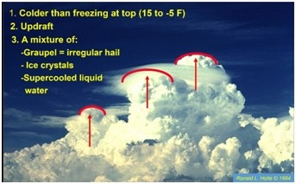
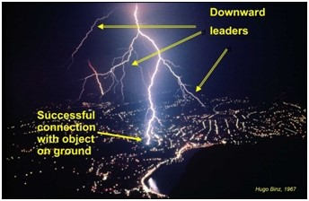
Thunderclouds are large atmospheric heat engines with the input energy coming from the Sun and with water vapor as the primary heat-transfer agent. A thundercloud develops from a small, fair-weather cloud called a cumulus which is formed when parcels of warm, moist air rise and cool by adiabatic expansion (Fig. 4). Electrification of thunderclouds is believed to take place by collisions between graupel (millimeter-size soft hail or snow pellet) particles and small ice crystals in the presence of water droplets, and the large-scale separation of charged particles is provided by the action of gravity. The ice–hail interactions must take place at altitudes where the temperature is considerably colder than freezing, generally -5° C to -15° C, in the presence of unfrozen (supercooled) water droplets. The positively charged ice crystals are carried further upward in updrafts to the top part of the thundercloud, to an altitude near 10 km above sea level in temperate summer storms; while the negatively charged hail resides at an altitude of 6 to 8 km. Thus, the main charge structure of an isolated, mature thundercloud consists of many tens of coulombs of positive charge in its upper portions and a more or less equal negative charge in its lower levels.
Fig.4. Updrafts indicated by arrows carrying a mixture of cloud particles in Colorado, U.S.
The initiation process of lightning discharge in a thundercloud begins with build-up of electrical charge within the cloud. A highly intense electric field is created by the formation and separation of positive and negative electric charges that eventually reaches a critical value at which electrical breakdown occurs between two regions of the cloud cell. Irrespective of the mechanism of initiation, breakdown occurs within the cloud that may lead to bridge the two charge centers within the cloud or two charge centers between the cloud and the ground [3].
A cloud-to-ground flash starts aloft in this charging layer colder than freezing between -5° C and -15° C or higher in altitude. The flash then starts toward the ground in steps of about 50 meters in length. The physical mechanism for moving the negative charge to Earth is an electrical discharge called the ''stepped leader''. The stepped leader progresses towards the ground in a discrete manner covering about 50 meters at a time and pausing for about 50 microseconds until the next step and the process continues until it is attached with the objects on the ground (Fig. 5). The average downward speed of the stepped leader during its trip is about 2×105ms⁻¹ completing its trip in about 20 milliseconds and carries about 5 coulombs of negative charge resulting in an average current of about 100 to 200 amperes. The magnitude of pulsed currents that generate the leader steps is of the order of 1000 amperes.
Once it contacts the ground, the light travels back up the channel. Yes, the charge is lowered but the light goes up. The downward part of the flash is nearly invisible, and all of this takes place within a portion of a tenth of a second.
When lightning reaches within 50 meters of the ground, it looks for something tall, isolated, and/or pointed, and contacts it. If there is nothing tall, isolated, and/or pointed, the flash comes to flat ground or water. Note that the lowest tip of the lightning is only reaching outward around 50 meters from the lowest tip, so the downward flash has no idea of what is below until it is very near the tall, isolated, and/or pointed object. When it starts in the cloud, it does not know if there is a small hill a kilometer away, or any water body on the surface or any underground mine or a particular kind of tree underneath and it certainly has no idea of what a person is carrying, wearing, or how that person is standing.
Fig.5. Cloud-to-ground lightning flash photographed from observatory on Mt. San Salvatore in Lugano, Switzerland
While cloud-to-ground lightning is the type that causes damages and injures people, in-cloud lightning actually occurs three to as much as ten times more times as often. Note that in-cloud lightning also starts in the -5° C to-15° C layer and feeds off the variations of the mixture of charged particles. When the cloud layer is very wide, a single incloud flash can propagate tens or hundreds of kilometers. Such in-cloud flashes typically drop a few cloud-to-ground flashes along the long path, and the cloud-to-ground flashes follow the same process as mentioned earlier. Lightning Protection
Lightning poses significant risks to structures, infrastructure, and human lives worldwide. In order to protect a building and its occupants from possible lightningrelated damage a comprehensive structural protection system is required. The internationally accepted standard called International Electrotechnical Commission IEC62305 provides comprehensive guidelines in designing, installing, and executing maintenance for protecting structures against lightning strikes. This code focuses on the design and installation of lightning protection measures to minimize the risk of physical damage to structures and the danger posed to occupants and includes the selection and placement of air terminals, conductors, and grounding systems. Another standard, IEC 62305-4, provides specific guidance on protecting electrical and electronic systems against lightning-induced surges.
I. External Protection: The purpose of a lightning protection system designed for a structure is to intercept a
- Air termination system
lightning stepped leader reaching the building and pass the lightning current safely into ground without creating any dangerous potential rise. An external lightning protection system (LPS) is intended to:
- Intercept a direct lightning flash to the structure with an air termination system
- Conduct the lightning current safely towards earth using
a down conductor system
c. Disperse the lightning current into the earth using an
earth termination system
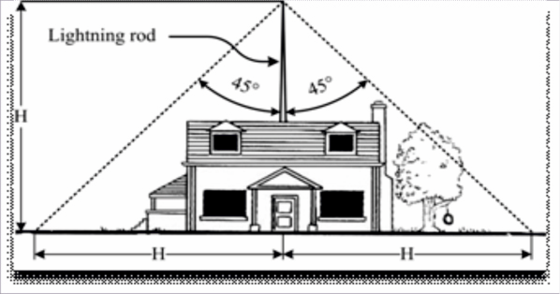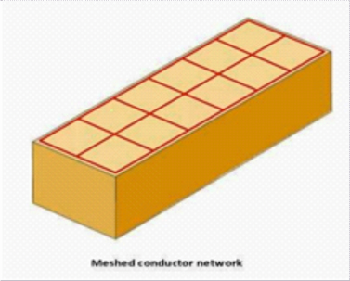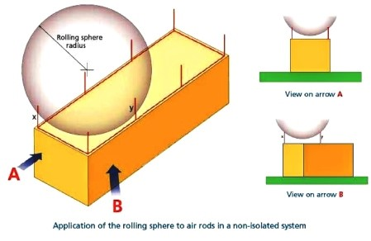
Fig.6. Methods of installing the air terminal system on a structure as prescribed by IEC 62305. Left: protective angle method; Center: rolling sphere method;
Lightning Protection Le (LPL ) | vAverage spacing of the d  conductors (m )
LPL 1 | 10
LPL 2 | 10
LPL 3 | 15
LPL 4 | 20
Air-termination components installed on a structure shall be located at corners, exposed points, and edges (especially on the upper level of any facades) in accordance with one or more of the methods shown in Figs.6 and 7:

Right: mesh method.
- Down conductor system
Down conductors are the electrically conductive paths between the air terminal system (ATS) and the earthtermination system (ETS) whereby the intercepted lightning currents will flow in such a way that:
a) Several parallel current paths exist; b) The length of the current paths is kept to a minimum; and c) Equipotential bonding to other conductive parts of the structure is performed.
IEC 62305-3 provides a reference table for positioning the down conductors as follows according to how stringent the lightning protection is designed as indicated by the Lightning Protection Level (LPL):
Lightning  Protection Lev (LPL) | Minim um  e current (k A | Radius o sphere  (m ) | f Mesh siz  ( m × m )
LPL 1 | 3 | 20 | 5× 5
LPL 2 | 5 | 30 | 10× 10
LPL 3 | 10 | 45 | 15× 15
LPL 4 | 16 | 60 | 20× 20
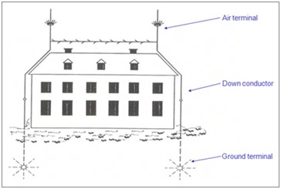
Air terminal
Down Conductor
Ground terminal
Fig.7. Lightning protection system on a building depicting air termination system, down conductor system and earth termination system.
c. Earth termination system
The primary purpose of a lightning earth termination system is to provide a means to direct the lightning current from the down conductors dispersing into the Earth while minimizing the voltage rise on the protection system. It is advised that the contact resistance of earth electrode be brought to less than 10 Ohms for an effective earth termination system. II. Internal Protection System
The fundamental role of the internal protection system is to ensure the avoidance of dangerous sparking occurring due to a lightning discharge. This is achieved by means of equipotential bonding or a safety distance between the components of the LPS and other conductive elements inside the building or structure. The protection equipotential bonding reduces the potential drops caused by the lightning current. This is achieved by connecting all separate, conductive parts of the installation directly by means of conductors or surge protection devices (SPD). Lightning Frequency and Detection
Lightning has been observed nearly everywhere in the world. It is much more common over land than the oceans and is most frequent in tropical regions. The amount of lightning decreases toward the North Pole but a few storms have been observed near there in the boreal summer, whereas no lightning has been observed over Antarctica due to the extreme cold.
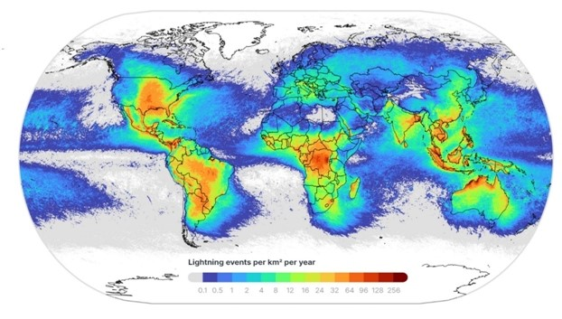
network now detects lightning everywhere with somewhat less precision than the national networks (Fig. 8). Data are available to users through subscription by satellite or on the web, cell phones, and realtime feeds are shown on television weather programs in several nations.
Not long after the ground-based networks were developed, lightning began to be detected by satellite imagery. The earliest sensors only covered an area twice a day, but now there is real-time lightning detection as seen from above. The ground-based and satellite systems complement each other in many ways, and both are used in a number of applications. Fig.8. Worldwide lightning stroke density observed by Vaisala's Global
Lightning Dataset network from 2016-2022. An average of 2.2 billion strokes Lightning Casualties were detected per year.
Many of the largest frequencies of lightning are along coasts and on the slopes of mountains. In coastal areas, especially in the tropics, thunderstorms form on many days due to the sea breeze that only reaches a few tens of kilometers inland. Along mountain slopes, air is forced to rise due to large-scale local wind circulations, which results in lightning maxima that are over the highest terrain in drier regions but along the slopes facing the moist low-level winds in more humid areas. In some areas of the world, mountains are near the coast, so thunderstorms are produced both by the sea breeze and mountain slopes. In other areas in the middle latitudes, organized storms form and last into the night. In the tropics, most thunderstorms form in the late morning and may linger until near nighttime.
Real-time lightning detection over a large area was developed at the University of Arizona in the U.S. during the 1970s. Within ten years, a network based on ground sensors covered all of the U.S. with high accuracy. These antennas detect lightning in the low to very low frequency range. They combine direction finding and time of arrival methods to produce data with a location accuracy as small as 150 meters, detecting 99% of all thunderstorms, and timing to the microsecond. The successful development of these networks depended on intellectual knowledge of lightning by the developers, GPS improvements to reach a reasonable cost, massive advances in computer capabilities, and greatly improved communication systems. Their uses are extremely An estimate of the global number of people killed and injured by lightning is daunting task. An estimate of 24,000 annual deaths, and 240,000 injuries has yet to be verified. Nevertheless, a summary of recently published data on a national basis has shown that about 5,000 deaths are known to occur per year. However, there are many more countries not included in this data (Fig. 9). Since many of the nations with missing data are in nations in Arica and Southeast Asia where lightning is often very frequent, it is simply not known how close the total is to the 24,000 estimate.
Who are these victims and survivors? The most frequent victim of lightning is someone involved in labor-intensive manual agriculture in a developing country. These victims and survivors are typically working on a small plot of land that provides food for a family and perhaps to sell. As a result, farmers and other agricultural workers tend to continue to work despite the threat of lightning, since planting and harvesting

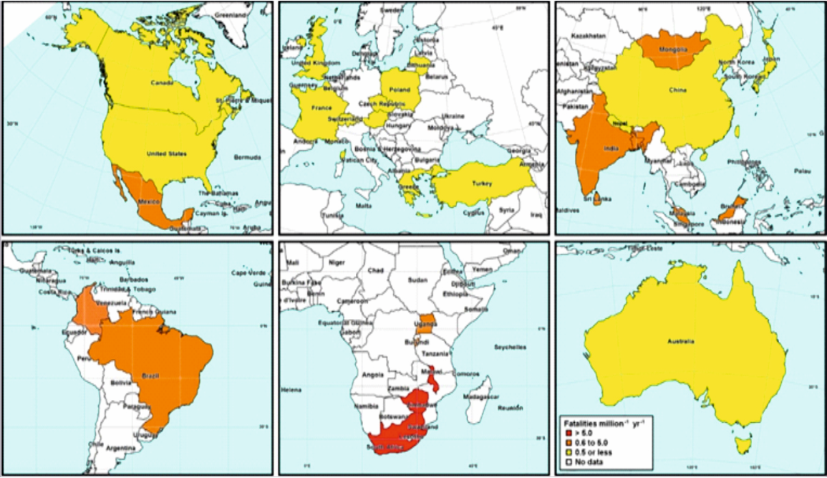
often have a narrow window for best results.
Outside of the farm
workers, victims are more often male, and in the ages of teens and
twenties. These may be involved in recreation such as football and mountaineering. The most common time for lightning casualties in the mid-latitudes is during summer, such as June through August in the Northern Hemisphere. The most common time of day is from around 1200 Local Time to 1800. Those are also the times of the most lightning in midlatitudes. In tropical regions, the monsoon season will affect the time of year, while the passage
Fig.9. Lightning fatality rate per million people per year by continent. Red shading indicates rates of 5.0 fatalities per million
per year, orange is 0.6–5.0, and yellow is 0.5 or less. White indicates no national summaries have been published for datasets of the Equatorial Trough _{ending in 1979 or later.} over a country, especially
in Africa, may result in two lightning maxima and varied, from weather services to aviation, recreation, defense consequently two seasons of lightning deaths and injuries. forces, power utilities, insurance claim verification and many
other uses. In all developed countries, the lightning death rate per million people has plummeted from as large as six or more in Similar networks using much of the same technology have the early 20th century to as low as 0.1 in recent years, as in been installed to cover several dozen countries, and a global
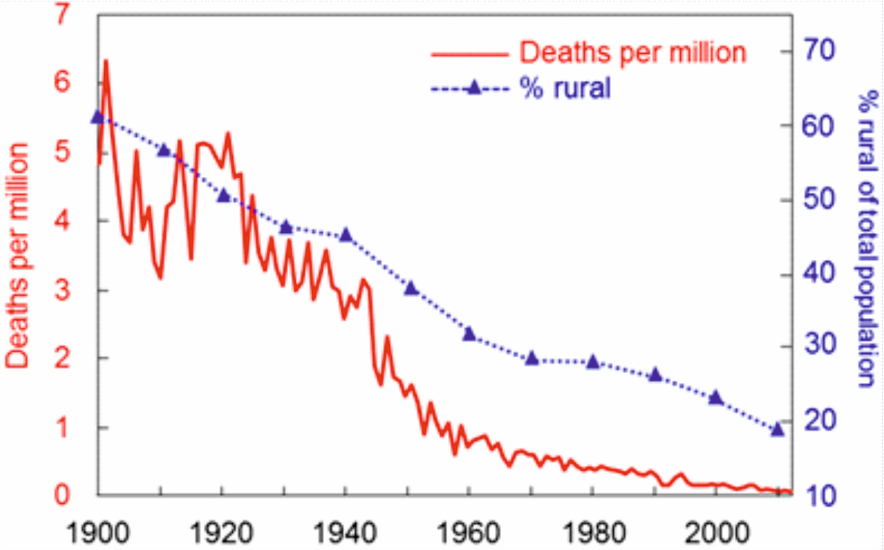
Fig.10. Solid red line is U.S. lightning deaths per million people from 1900 to 2013. Dashed blue line is percent rural population.

Figure 10 for the U.S. However, in developing nations, the rate has not changed due to the large number of people that continue traditional labor-intense manual farming, as well as the lack of available safe places from lightning - a well-constructed building or a fully enclosed metal-topped vehicle.
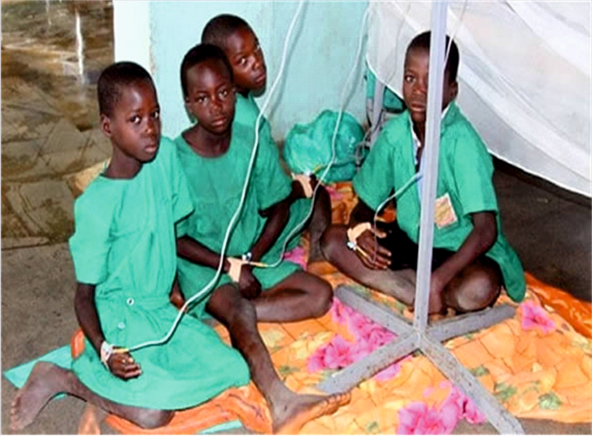
Fig. 11. Children affected by a lightning strike in Uganda on June 28,
2011
A note of caution is needed here. There are many developing counties that are claiming that the number of lightning deaths has risen at an alarming rate in recent years and ideas are proposed that have no merit. The number of lightning deaths and injuries has not changed in developing nations, but the reporting of lightning deaths and injuries has changed. With the rapid expansion of the internet in the last two decades, lightning events are now being reported more often. There is no reason to think that a developing country with modest changes in lifestyles will suddenly have increasing deaths and injuries from lightning. The same number of people doing the same activities in the same place with the same lack of ready access to lightning-safe buildings and vehicles will result in the same number of lightning casualties now as much as 50 years ago, except there may be more people. Again, the reporting has changed, not the exposure to lightning.

Roadmap for Mitigating Lightning Fatalities, Injuries and Property Loss in the Developing Countries
The developing countries are more vulnerable to lightning hazards due to several critical factors, such as 1) limited access to lightning-safe structures such as substantial buildings with grounded plumbing and wiring or fully enclosed metal-topped vehicles, 2) labor intensive agricultural activities, 3) inadequate lightning awareness campaigns, 4) lack of comprehensive demographic data on lightning related fatalities and injuries, 5) lack of lightning risk mapping, and governmental policies recognizing lightning as a major natural hazard, 6) abandoning effective lightning protection systems in favor of inferior installations, exacerbated by the sporadic nature of lightning incidents and widespread misconceptions rooted in folklore. Beyond these challenges, the foremost obstacle lies in establishing cost-effective safe structures.
To mitigate the deleterious effects of lightning, the following roadmap is proposed:
- Advocate for increased investment and commitment from governments, donors, and international organizations toward lightning safety initiatives,
- Forge partnerships with relevant stakeholders to ensure a coordinated and sustainable approach in scaling up protective measures across developing countries.
- Educate communities to raise awareness about the dangers of lightning strikes to debunk prevalent myths and superstitions and promote preventive practices at individual, community, and institutional levels
- Encourage stakeholders to integrate lightning safety protocols into emergency preparedness plans and building codes
- Increase regional cooperation and collaboration to develop and disseminate educational materials, guidelines, and toolkits on lightning safety. These resources are intended to empower the disaster management authorities, educators, and community leaders in promoting awareness and preparedness.
- Foster collaboration among stakeholders in developing early warning systems in the developing countries, involving researchers, academia and humanitarian organizations.

Lightning Quick Facts
- The longest lightning that has been measured is 768 ± 8 km kilometers in length across parts of the southern United States on 29 April 2020.The greatest measured duration for a single lightning flash is 17.102 ± 0.002 s over Uruguay and northern Argentina on 18 June 2020.
- The temperature of lightning is hotter than the surface of the Sun.
- About two billion lightning occurs every year over the globe, but lightning activity varies year to year.
- Not only thunderstorms can produce lightning. Volcanic eruptions can also produce lightning.
- Lightning plays an important role in the atmospheric nitrogen cycle by producing nitrate nutrients to help fertilize the soil.

Lightning Myths/Superstitions
- Is ball lightning real?
Ball lightning has been reported from around the world. However, there are no commonly-agreed-upon hypotheses on how ball lightning forms currently, and no solidly approved visual evidence of ball lightning exists as yet.
- Is there a curse if someone is struck by lightning?
There is no curse if someone is struck by lightning. You can and should save someone who was struck by lightning. You will not be electrocuted by touching their body/skin.
- Does wearing red attract lightning? How about holding a metal or an umbrella?
Wearing red and no other specific clothing will attract lightning. Mirrors do not attract lightning. Holding metals, umbrellas, or cellphones does not attract lightning. Lightning does not seek metal or other objects to hit them. Instead, once a metal body has been hit, it will retain heat for a while. It's an effect not a cause of lightning hitting the object. Being outside during a thunderstorm is dangerous no matter what you wear or what you hold.
- I heard that lightning never strikes the same place twice. Is that true?
Lightning can strike the same place twice or even multiple times. An isolated tall object is easier to be struck by lightning. However, lightning does not always strike the tallest object in the area.
- Do some types of trees attract or avert lightning?
Some types of trees show more damage than others. While some have their bark exploded or catch on fire, other types of trees are nearly unaffected due to large amounts of moisture in the trunk, wet leaves in rain, and other factors. Lightning has no idea what type of tree is tall, isolated, and/or pointed when it travels quickly from subfreezing temperatures to the ground in less than a second.
- Do some metal mines attract lightning?
Nothing in the ground attracts lightning. Lightning starts high in the cloud and does not decide what to strike until its lowest tip is 50 meters from the ground. So, it has no idea what is in the ground at all.
- Do Vajras help in averting lightning?
Small objects such as Vajras cannot be thought to avert lightning. Similarly, wearing red or what a person is carrying or how a person is standing are not relevant to lightning safety. Go inside a substantial building or metal topped vehicle to be safe.

Bibliography
- So You Think You Know Lightning (2017); Vaisala; Holle, R., and Zhang, D.
- New WMO Certified Megaflash Lightning Extremes for Flash Distance and Duration Recorded from Space (2022); Bulletin of the American Meteorological Society; Peterson. M.J. et al.
- Moore CB, Vonnegut B (1977) The thundercloud. In: Golde RH (ed) Lightning, vol 1, Physics of lightning. Academic Press, New York, pp 51–98
- Rakov V A, Lightning, the science, Lecture Notes in Electrical Engineering (2021) (Edited by Chandima Gomes) for Springer Nature
ISSN 1876-1100 ISBN 978-981-16-3439-0, https://doi.org/10.1007/978-981-16-3440-6 t Uman M A, The Art and Science of Lightning Protection (2008) Cambridge University Press, ISBN: 9780511585890, DOI:
https://doi.org/10.1017/CBO9780511585890
- Cooper, M.A., and R.L. Holle, 2018: Reducing lightning injuries worldwide. Springer Natural Hazards, New York, 233 pp. t Said, R., 2017: Towards a global lightning locating system. Weather, 72, 36-40.
- Holle, R.L., and D. Zhang, 2023: Flashes of brilliance: The science and wonder of Arizona lightning. Springer International Publishing, 231 pp.
- Murphy, M.J., J.A. Cramer, and R. Said, 2021: Recent history of upgrades to the U.S. National Lightning Detection Network. J Oceanic and Atmospheric Tech, 38, 573-585.
- Said, R., 2017: Towards a global lightning locating system. Weather, 72, 36-40.
- Holle, R.L., 2016: A summary of recent national-scale lightning fatality studies. Weather, Climate, and Society, 8, 35-42.
- MA Uman, The art and science of lightning protection, Cambridge University Press, ISBN 978-0-521-87811-1 hardback t A. Barwise, Lightning: Science, Engineering and Economic Implications for Developing Countries, (edited by C. Gomes) Springer, ISSN 1876-1100 ISSN 1876-1119 (electronic).
- Electrical knowledge (http://www.electrical-knowhow.com/2014/05/Rolling-Sphere-Method-for-Lightning-Protection)
Editor: Dr.Shriram Sharma Editorial Adviser: Mr. Madhusudan Bandyopadhyay Editorial Assistant: Ms. Abhirami Ramdas
Compilation & Design: Mr. Pankaj Buttan Published by: Dr. Amitava Bandopadhyay, Director General, Centre for Science & Technology of the
Non-Aligned and Other Developing Countries (NAM S&T Centre), Core 6A, 2nd Floor, India Habitat Centre, Lodhi Road, New Delhi-110003 (India)
Phone: +91-11-24645134, 24644974 Email: namstcentre@gmail.com Website: https://namstct.org

