Rwanda: Five killed and fifteen injured after heavy rains in the middle of August – Rwanda
https://www.africaradio.com/actualite-110647-rwanda-cinq-morts-et-quinze-blesses-apres-de-fortes-pluies-en-plein-mois-d-aout
20 August 2025
By Augustin Diop Ndiaye
Miscellaneous facts. Heavy rains, unusual in August, killed five people and injured 15 others in Rwanda. Roads and homes have also been damaged, according to MINEMA.

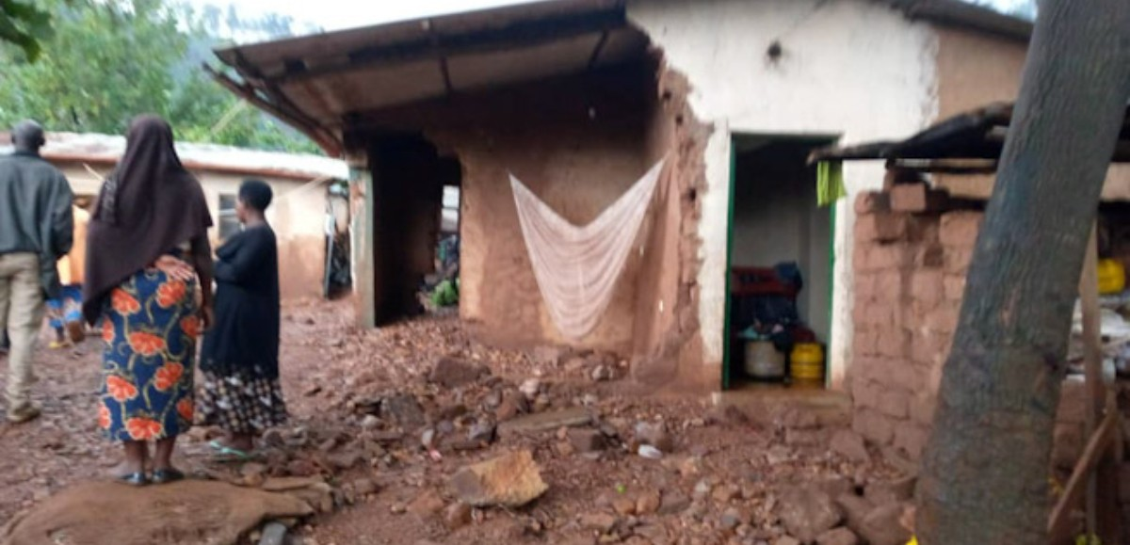
Unusual rains for the season mourned Rwanda - RNA
Rwanda was hit by heavy rains on 16 and 17 August, a rare weather phenomenon for that month considered to be dry. According to the Ministry of Emergency Situations (MINEMA), the death toll shows five deaths and 15 injuries.
Of the victims, four people were struck and another died in the collapse of his house, said the Permanent Secretary of MINEMA, Aristarque Ngoga.
Particularly affected districts
The deaths were recorded in Burera districts (2 victims), Gicumbi, Rusizi and Ngororero. The wounded are scattered in several regions: one in Gicumbi, one in Gisagara, three in Kamonyi, two in Musanze and eight in Nyamasheke, all struck by lightning.
The weather also damaged eleven houses, caused road flooding and blocked some communication routes. The marshes and rivers have spilled, but have not caused major floods.
Recurrent vulnerability to climate disasters
Rwanda, a mountainous country, is regularly exposed to natural disasters, especially during rainy seasons. But these heavy rains in August question climate change and infrastructure resilience in the face of increasingly unpredictable weather events.

