Woman in tears after husband dies, 2 kids injured following lightning strike while asleep-Tanzania
https://www.pinterest.com/pin/911767887057825942/
21 October, 2024
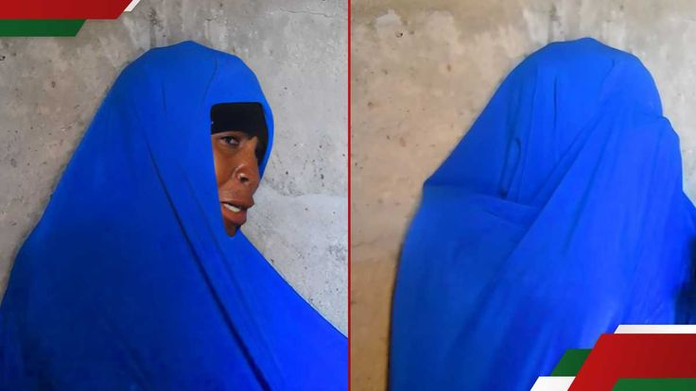
A woman, Rukia Musa has been left with the burden of caring for four young children after her husband died at home following a natural phenomenon.

