**HERO of the MONTH**

**Mohamed Nayel**

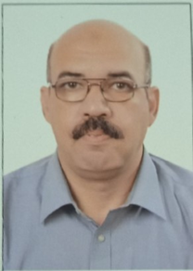

1. What is your background?

Dr. Mohamed Nayel was born in Assiut, Egypt, on April 15, 1973. He is a Professor at Electrical Engineering Department, Assiut University, since 2014. He is electrician engineering department head, Assiut University since 2023. He has been Vise Dean, faculty of engineering, from 2018 to 2021. He had got his B.Sc. and M.Sc. degrees in Electrical Engineering from Assiut University, Egypt, in July 1996 and May 1999 respectively. M.Sc. Thesis title was "Assessment of Electric & Magnetic Fields in Power Substations". He was employed by Assiut University in 1996 as lecturer assistance. He was granted the Doctor of Engineering Degree in March 2004 from Doshisha University, Japan. Doctor of Engineering research topic is " Study of Transient Characteristics of Electric Grounding System". He was postdoctor at China Southern Power Grid company and Tsinghua University from Dec. 2005 to Dec. 2007 in a research project " Lightning Overvoltage Performances and Protection Strategy of UHV DC ±800 kV Transmission Line". He was a university staff at Xi’an Jiaotong Liverpool University from 2010 to 2013. He was the founder of sustainable energy technology MSc program at XJTLU. He is the founder of the smart grid laboratory at Assiut University. He is publishing 42 papers in international and local journals and 56 papers in international and local conferences.

His interests are in electric power systems (generation-transmission-distribution) and electromagnetic fields. He conducts research and teaches undergraduate courses in electric power systems, electromagnetic fields and high voltage. His research interest includes High-voltage measurements and calculations including the assessment of electric and magnetic fields. Electromagnetic transient measurements, EMC, EMI and electromagnetic induction, Harmonic analysis, Grounding System, Grounding electrode modeling, Mutual ground impedance and renewable energy. His recent interest in research and teaching includes smart grids and sustainable energy.

1. How and when did you hear about ACLENet?

I am interested in volunteer work, and I was impressed by medicines sans frontiers. Also, I am African, and I would like to do something to them. So, I searched for volunteer work based on my scientific background.

1. What motivated you to work with ACLENet?

Firstly, it is matched with my main research work. Also, It works in protect peoples, specially children in schools.

1. Please describe your work with ACLENet.

Now, I work in translation of flash from English to Arabic. I had help a student from Mozambique in his project.

1. What are some of your key achievements so far with ACLENet?

I can consider myself do a key achievement but I would like to do more.

1. What are some of the challenges you have encountered in your work with ACLENet? How have you addressed these challenges.
2. How would you like to see ACLENet develop in the future?

I wish to have internet work base to manage ACLNET work and publications.

1. What do you see in the future for ACLENet regarding lightning safety?
2. Encouragement note

Allah helps the servant as long as the servant helps his brother.

1. Is there anything else you would like to include – personal information, family, goals, etc? Is it ok to list your email?

Please send a photo we can use – or I will try to find one in my files –

Your answers to these questions will be posted on ACLENet’s website at:

[*https://aclenet.org/news-publications/newsletters/hero-of-the-month-column.html*](https://aclenet.org/news-publications/newsletters/hero-of-the-month-column.html)

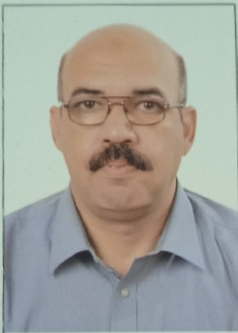*THANK YOU for all you do for ACLENet and for saving lives - MA*