Lightning strikes motorcyclist to death in Zacdon, Grand Bassa- Liberia
https://verityonlinenews.com/lightning-strikes-motorcyclist-to-death-in-zacdon-grand-bassa/
6 May 2026
By Verity News

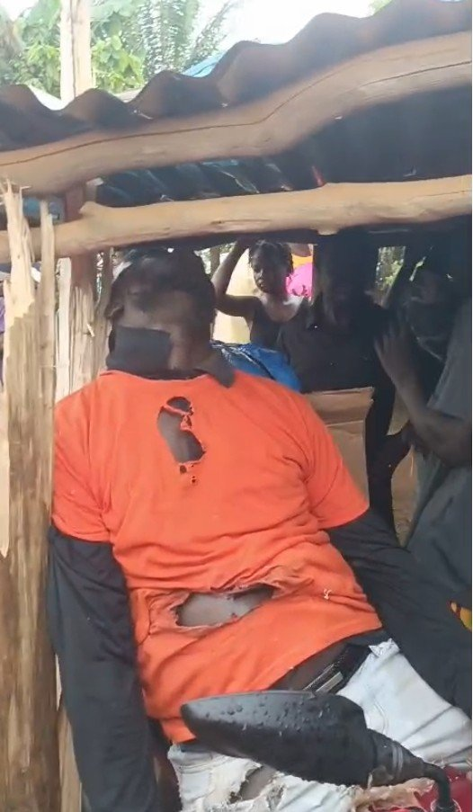
By Hogkins Tokpa
In a tragic news from Zacdon, District #2 in Grand Bassa County, a motorcyclist named Michael Kardyu met his sudden demise after being struck by lightning during a heavy rainstorm in Zacdon, Electoral District #2, Grand Bassa County.
Michael had left Buchanan City in the late afternoon en route to Wayzohn city. Seeking shelter under an old kitchen during the storm, he fell victim to a lightning strike that left him unconscious.
Bystanders who watched the lightning incident unfolded said they were shocked by the unexpected turn of events, serving as a chilling reminder of the dangers posed by nature’s wrath.
“While the rain was heavily falling with huge storm, he parked his motorbike to seek safety under the kitchen. Within minutes, he was struck by the lightning and he died instantly.” Rogie M. Peterson, Deputy Coordinator, Motorcycle Union, Wee District #2

