North Kivu: at least five dead and about fifteen missing after violent floods in Beni – DRC
https://gueules-afrique.com/nord-kivu-au-moins-cinq-morts-et-une-quinzaine-de-disparus-apres-de-violentes-inondations-a-beni/
8 August 2025
By Guelleafrique
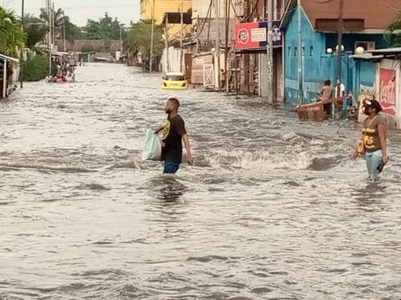
A torrential rain fell on the city of Beni (North Kivu) on the evening of Tuesday, August 5, causing a sudden rise of the waters of the Tuha River. The provisional death toll is at least five, including four washed away by the waters and another struck by lightning, according to local authorities.
The Kanzuli and Mambango neighborhoods were hit hardest. The inhabitants, surprised in full activity by the river — especially women doing laundry — had little time to react. Fifteen people are still missing, according to the Civil Protection Service, which is continuing the search with the help of volunteers.
At the same time, two homes in the Butanuka and Rwangoma neighborhoods were hit by lightning, leaving one dead and one injured, as well as extensive property damage.
Jean-Paul Kapitula, Civil Protection Coordinator of Beni, said he was deeply saddened by this tragedy and deplored the glaring lack of logistical means to carry out relief operations:
“We need resources to follow the course of the river, to fish the bodies, identify them and allow families to organize the funeral. We have volunteers and ideas, but we lack the tools,” he said.
Bungulu civil society reports that several families are pursuing desperate searches to find their loved ones, including at least five children aged between 6 and 14. It calls on the authorities to strengthen prevention mechanisms in the face of these recurrent natural disasters.

