**Lightning Strikes Kill Five in Ntungamo – Uganda**

<https://nilepost.co.ug/news/281955/lightning-strikes-kill-five-in-ntungamo>

20 August 2025

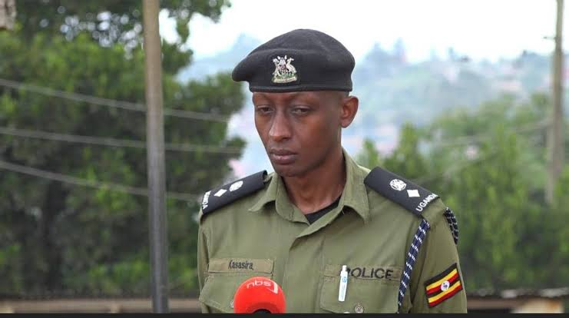  
  
*Rwizi Region Police spokesperson Samson Kasasira said the deceased include Edgar Taremwa, 38; Jackline Nduhukire, 44; Alexander Mwaka, 25; and two unknown male adults aged between 30 and 50, suspected to be from Ruhaama, Ntungamo District.*

By Alex Mugasha

Rwizi Region Police spokesperson Samson Kasasira said the deceased include Edgar Taremwa, 38; Jackline Nduhukire, 44; Alexander Mwaka, 25; and two unknown male adults aged between 30 and 50, suspected to be from Ruhaama, Ntungamo District.

Five people have died after being struck by lightning in Rwakashanga cell, Rwahi Town Council, Ntungamo District, as a sudden afternoon storm forced them to seek shelter on a veranda.

The Rwizi Region Police have confirmed a tragic incident in which five people were killed by lightning in Rwakashanga cell, Rwahi Town Council, Ntungamo District, at around 5pm on Tuesday, August 19, 2025, during a heavy downpour.

Rwizi Region Police spokesperson Samson Kasasira said the deceased include Edgar Taremwa, 38; Jackline Nduhukire, 44; Alexander Mwaka, 25; and two unknown male adults aged between 30 and 50, suspected to be from Ruhaama, Ntungamo District.

Kasasira explained that eight people had gone to work in gardens in Ruhwabwoba and Kidede, both in Rwakashanga cell, when the heavy rain forced them to seek shelter under a nearby veranda.

“As the doors were closed, lightning struck once, killing the five victims instantly,” he said.

Four of the bodies, which were identified, have been handed over to their families for burial, while the unidentified victim was taken to Itojo Hospital mortuary.