Boké: Lightning causes damage, a young man accused of being the cause - Guinea
By LEDJELY.COMSaturday, October 19, 2024 at 3:40 pm
https://ledjely.com/2024/10/19/boke-la-foudre-fait-des-degats-un-jeune-accuse-detre-a-lorigine/
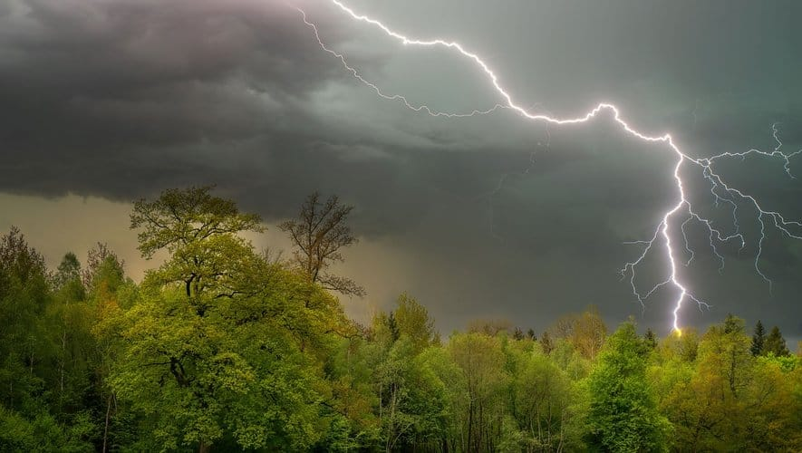
During the night of Thursday to Friday, lightning struck a compound twice in the orphanage sector, in the Yomboya district of the urban commune of Boké. No human lives were lost, but material damage was significant.
For Chantal Lamah, a dealer, it was a young man who was talking on the phone during the tornado who was the cause of their misfortune. "When the wind started with the lightning, a young man was there in front of a bedroom door, making a phone call. When we told him to stop, he refused. It was at that very moment that the lightning destroyed his cell phone and caused a short circuit that damaged all our electrical installations. Suddenly, we noticed a flash throughout the house ," she said.
As if to say that lightning hadn't finished with the young man, it struck the house for a second time, this time breaking the windows. “For a second time, lightning destroyed my grandmother's window and two other metal doors that we redid this morning. The neighbors next door were not so spared, it destroyed the ceilings of the house, the windows and pierced the sheets of metal ,” adds Chantal.
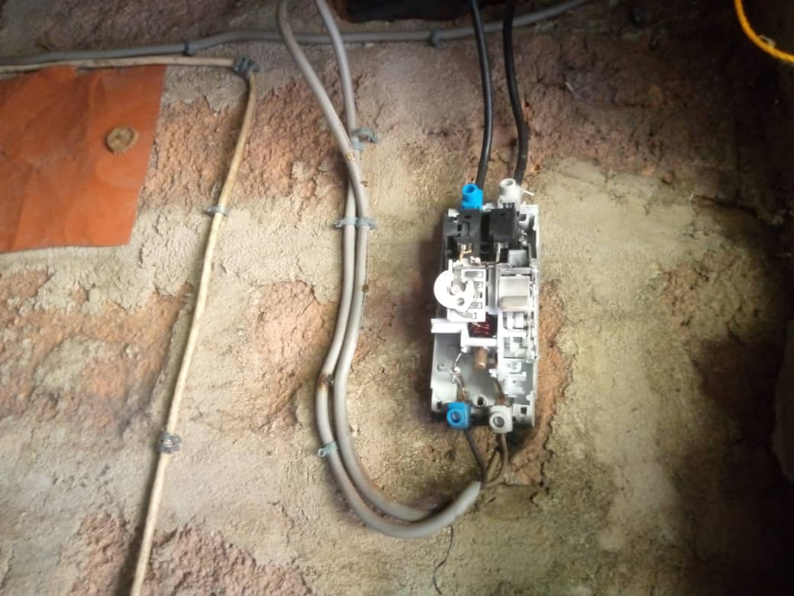
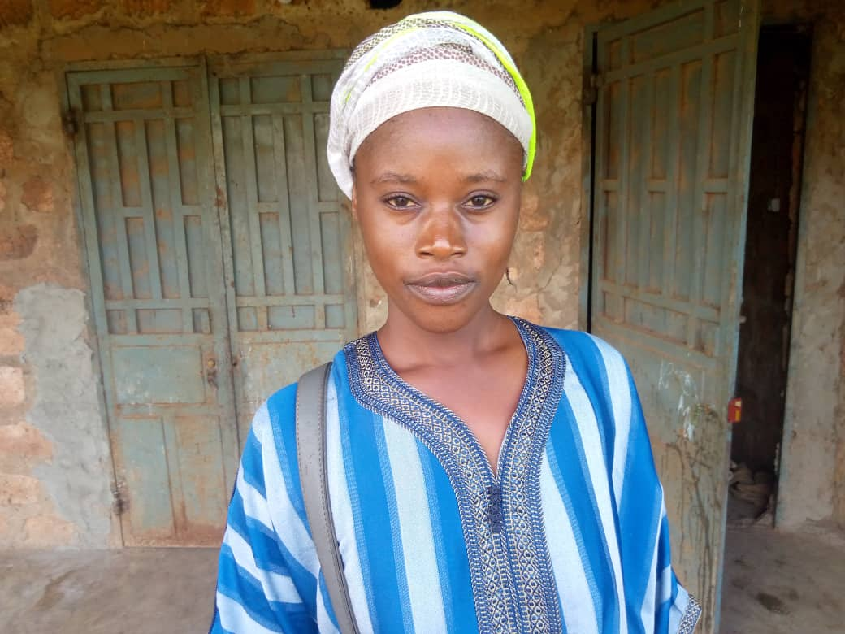
Visibly in grievance, the young man identified by the victims remains untraceable to this day. Chantal Lamah and others are also asking for help from people of goodwill. "The young man who is at the origin of this, we have not found him since the tragedy occurred. We ask the local authorities and all people of goodwill to help us. Let everyone do something for us ," she implores.
As a reminder, last year in this region, specifically in Wendhou bouro, lightning caused the death of 16 people.

