**Lightning strikes again in Sheema, killing two brothers – Uganda**

<https://tmafrica.co.ug/news/lightning-strikes-again-sheema-killing-two-brothers>

13 August, 2025

By Our Reporter

Sheema – Police in Sheema District are investigating a lightning strike that killed two brothers in Shuuku Town Council on August 12, 2025, adding to a string of similar tragedies that have claimed young lives in the district.   
The victims, Tugabiirwe Demus (14) and Twinomugisha Triva (12), were pupils at St. Charles Lwanga Primary School in Shuuku and residents of Kinogo Cell, Kishabya Ward. According to police, the boys had not attended school that day and were returning home from grazing goats when lightning struck at around 5:45 p.m. in Kisizi Central Cell.

Greater Bushenyi Region Acting Police Spokesperson SP Apollo Tayebwa confirmed the incident, saying officers visited the scene before transferring the bodies to Kabwohe Health Centre IV for a post-mortem examination to determine the exact cause of death.  
Sheema District LC5 Chairperson Jemimah Tumwijukye Buhanda visited the family of the deceased to offer condolences, describing the incident as a tragic reminder of the district’s vulnerability to lightning strikes.   
“We have lost two young lives with bright futures ahead of them. My heart goes out to the family during this difficult time,” she said. “As leaders, we must prioritise the installation of lightning arrestors in all schools and community centres to protect our people from such avoidable tragedies.”

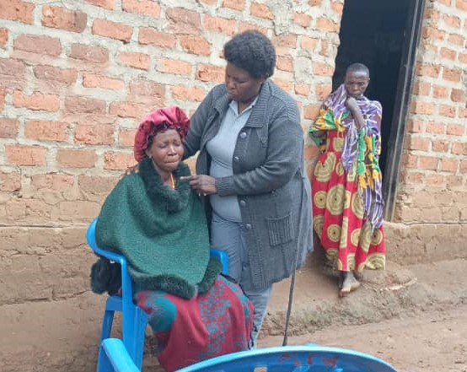  
*Jemimah Buhanda consoles a mother who lost two children in lightning strike*

A history of lightning tragedies in Sheema  
The Shuuku incident adds to a series of deadly lightning strikes in Sheema District:   
January 13, 2024 – Kitagata Central Primary School tragedy  
Four children from the same family — Trevor Mujuni (11), Shanitah Akankunda (9), Comfort Nahabwe (10) and Lonnet Ainembabazi (7) — were killed instantly when lightning struck a kitchen in Kimondo II Cell, Kitagata Town Council. All were pupils at Kitagata Central Primary School.   
June 18, 2025 – Rwengiri Primary School strike  
Two Primary Three pupils, Isabella Kemigisha (10) and Benson Ainomugisha (9), died when lightning struck during a heavy downpour at Rwengiri Primary School in Kigarama Sub-county. Fourteen other pupils were injured and rushed to Bushenyi Medical Centre.   
Local leaders say Sheema records several lightning strikes every year, often killing children or livestock. Many rural schools still lack lightning arrestors despite repeated safety appeals.   
SP Tayebwa has renewed calls for the mandatory installation of lightning protection systems in all school buildings, warning that Sheema’s repeated tragedies point to a dangerous and persistent pattern.