**"They were my only source of livelihood"- Two cows killed in lightning strike - Kenya**

<https://www.tv47.digital/they-were-my-only-source-of-livelihood-two-cows-killed-in-lightning-strike-95683/>

18 April 2025  
  
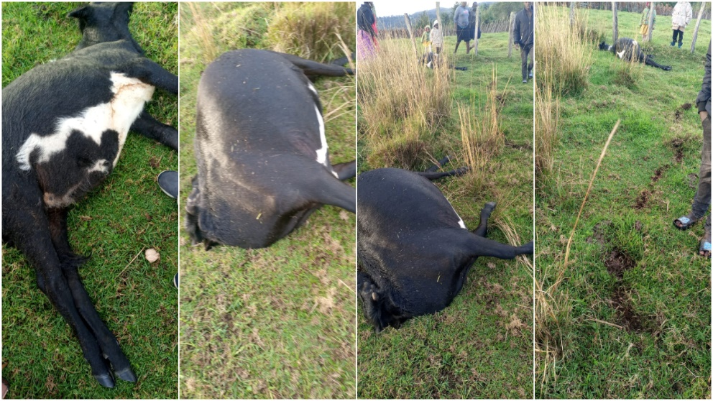  
  
Andrew Juma

Residents of Mbaya village, Lelan Location, in West Pokot County are living in fear and distress after [lightning struck](https://www.tv47.digital/14-people-killed-34-injured-as-lightning-strikes-church-76117/) and killed two cows on Thursday, April 17 evening.

Confirming the incident, Lelan Location Chief Daniel Nguriatudo said the tragedy struck at around 6:20 pm, shortly after a brief downpour, when the cows were grazing.

As a result, Petro Kudungole, a local farmer, has been left counting losses. The estimated value of the two animals is KSh100,000.

“I was just preparing to bring the animals back into the shed when I heard a loud bang. Moments later, I found my cows lying motionless,” Kudungole, visibly shaken, told TV47 Digital. “This is a huge loss for me. Those cows were my only source of livelihood.”

Residents of the area have called on the county government and local disaster response teams to support the affected family. Kudungole also appealed for assistance from the authorities, saying, “I hope the government or well-wishers can step in and help me recover from this loss. Replacing the animals will not be easy.”

**Similar tragedy**

This latest incident comes just a month after a similar tragedy in Kapkanyar Lelan division where a lightning strike killed nine cows belonging to the family of Kamaran Akoma. The family suffered an estimated loss of KSh540,000.

“This is the worst thing that has ever happened to us. We depended on these animals for our livelihood, and now we have nothing left,” said Akoma at the time.