Rains and Lightning Claim Lives in Hudeidah and Hajjah – Yemen
https://en.barran.press/news/6932
23 August 2025
By Barran Press
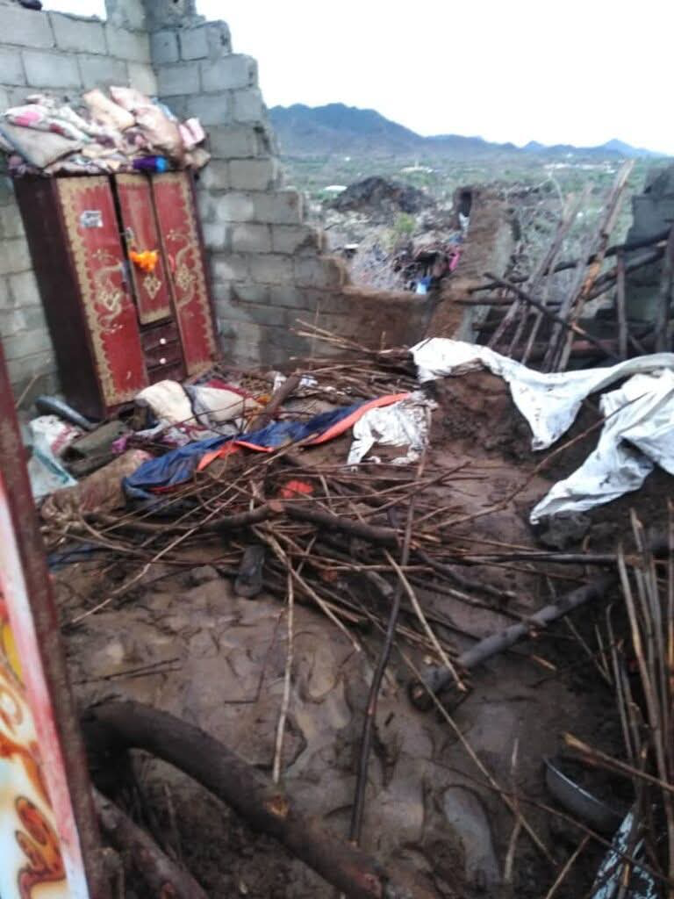
Heavy rainfall and severe weather have resulted in several fatalities across Yemen, with three children killed in a house collapse in Hajjah province and another child killed by a lightning strike in Hudeidah.
Local sources reported on Saturday that three children belonging to Yahya Abdullah Hajjaji died when the roof of a room in their home in Al-Khadra village, Kaidina district, collapsed under the weight of torrential rain. The collapse killed two girls and one boy. Their father sustained a severe spinal injury and was rushed to the hospital.
In Hudeidah province, a lightning strike killed a child named Mohammed Abdullah Al-Husseini. This latest death brings the total number of lightning-related fatalities to 63 across several Yemeni provinces since late June. The majority of the victims were in Hajjah (17 deaths), followed by Al-Mahwit (7), Al-Dhale'e (8), Amran (7), Dhamar (5), Sana'a (5), Ibb (4), Taiz (4), Al-Hudaydah (4), and Sa'ada (1).

