**33 Cows Struck Dead by Lightning in Fundong – Cameroon**<https://mimimefoinfos.com/36-cows-struck-dead-by-lightning-in-fundong/>

25 April 2025  
  
By Tata Mbunwe

[[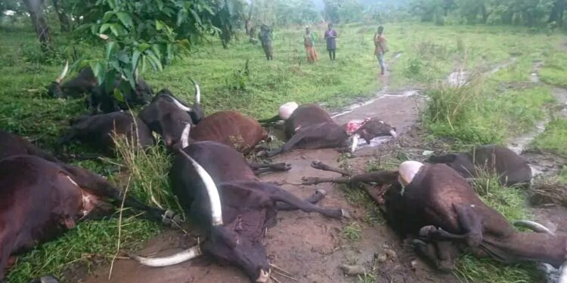](https://mimimefoinfos.com/wp-content/uploads/2025/04/1745563588572.jpg)](https://mimimefoinfos.com/wp-content/uploads/2025/04/1745563588572.jpg)

A lightning strike on Wednesday, April 23, killed 33 cattle at Mbongkisu village in Fundong, following a week of extreme weather incidents in Cameroon’s North West Region. The cattle belonged to Ardo Idrissu, Ardo of Mentang I Ardorate in Fundong subdivision, and Alhadji Hassana.

The cattle were grazing in an open field and were being driven by local cattle rearers when they were struck dead during a horrific thunderstorm that hit the grassfield community.

The tragedy has left the cattle owners devastated as they now count their losses in millions of CFA francs.

Mbongkisu villagers, on the other hand, see the tragedy as a spring feast, as families have been carving out chunks of meat from the dead animals for consumption.

This is obviously contrary to medical advice, which usually recommends that a veterinarian inspect the meat and determine its safety for consumption.

If the Muslim cattle owners were in charge, they would bury the dead animals because Islamic tradition views them as unclean and unfit for consumption.

**Not the First Time**

Lightning strikes leading to cattle deaths are a common occurrence in Fundong and other parts of the North West region.

[A similar incident at Bali Nyonga in Mezam Division,](https://mimimefoinfos.com/lightning-strikes-28-cattle-dead-in-bali-nyonga/) North West, in June last year left 28 cows dead.

At that time, the North West Regional Delegate for Public Health, [Dr Kingsley Che Soh, tried in vain to dissuade people from consuming meat](https://mimimefoinfos.com/public-health-delegate-cautions-population-against-eating-meat-from-dead-cows-in-bali-nyonga/) from the dead animals.

He stated that only a veterinarian’s recommendation could allow for the consumption of the meat within six hours of the cattle’s death.

But at the time he issued the caution statement, people had already carted away the meat for consumption.

The recent lightning strike in Fundong comes in the wake of extreme weather conditions witnessed in parts of the North West region over the past week.

Hailstorms devastated the villages of Akosia and Nfontah in Bafut Subdivision, and Kedjom Ketunguh in Tubah Subdivision over the week, casting a shadow over crop yields in these areas this year.

The National Climate Change Observatory in Cameroon, known as ONACC, had predicted a week of rough weather across the country between April 21 to 30.

The institution also foresaw the thunderstorm and lightning that hit Fundong, as well as the hailstorm in Bafut and Babanki.

[Mimi Mefo Info](http://www.mimimefoinfos.com/)