Four people struck by lightning as destructive storm tears through Zululand region - South Africa
https://www.citizen.co.za/zululand-observer/news-headlines/local-news/2026/03/03/four-people-struck-by-lightning-as-destructive-storm-tears-through-zululand-region/
Several homes have been damaged and towns left without power following a destructive storm that tore through parts of the Zululand region
3 March 2026
By Muzi Zincume
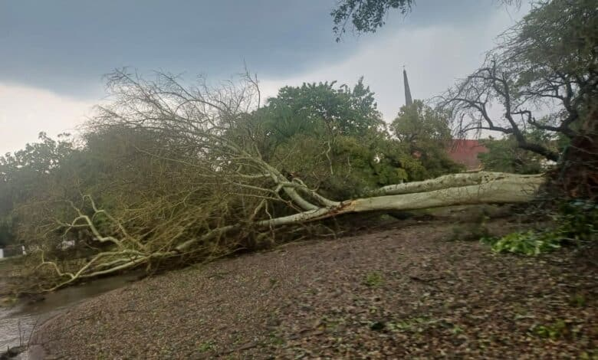Several trees were uprooted in uMkhanyakude District PHOTO: KZNCogta/Facebook
Four people were struck by lightning in two separate incidents in Jozini when a storm hit the area over the weekend.
uMkhanyakude District Mayor Siphile Mdaka said the victims were rushed to Shemula Clinic. This after heavy winds and rain resulted in massive destruction in uMkhanyakude on Sunday afternoon – with Hluhluwe and Mkuze hardest hit.
Hluhluwe town and surroundings are without electricity as some of the electricity poles were knocked down, while plantation trees were uprooted and strewn across the N2.
“We hope Eskom will be able to restore power within 24 hours. Our Disaster Management teams are out to assess the extent of damage,” said Mdaka.
Trail of devastation
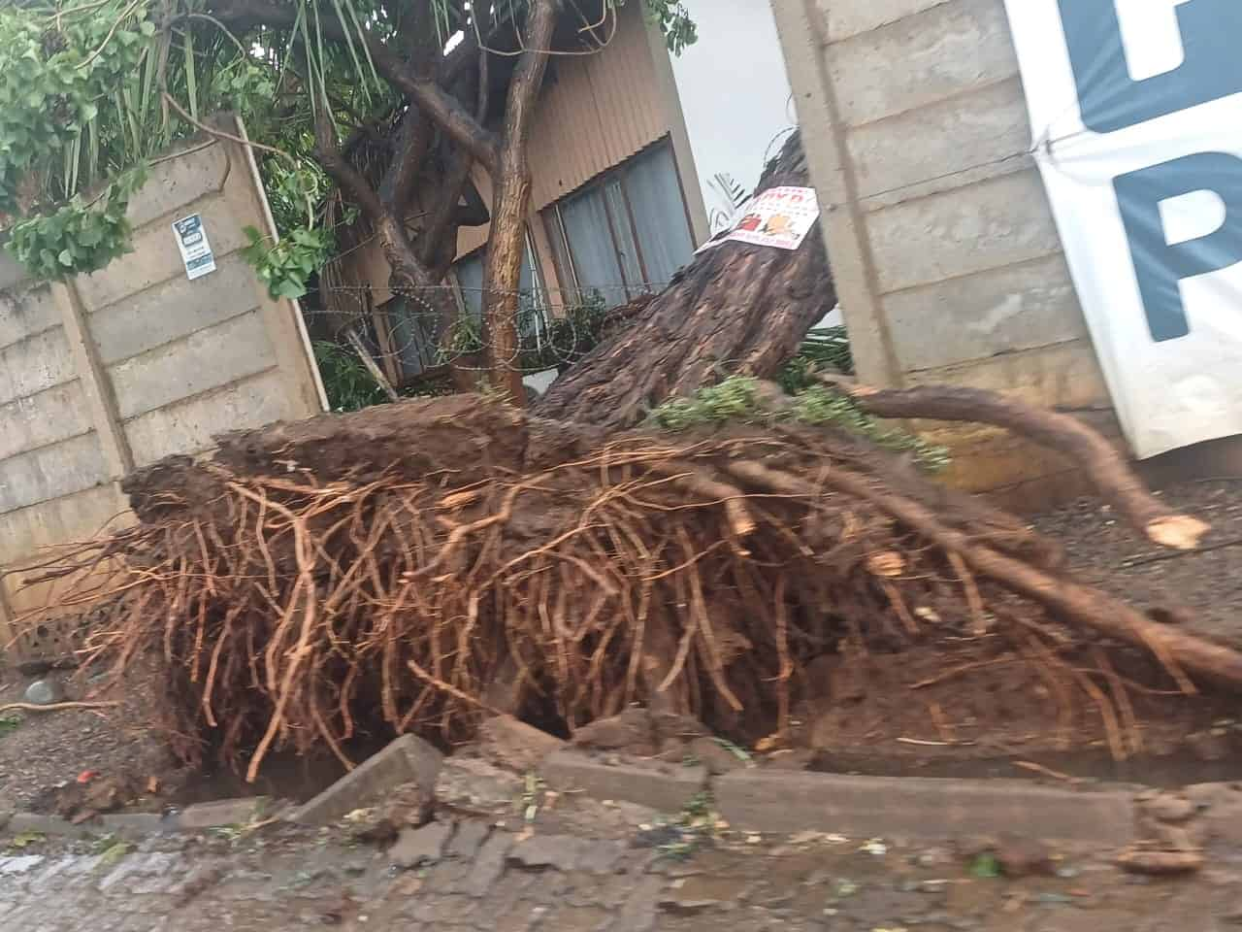
Several trees were uprooted in uMkhanyakude District PHOTO: KZNCogta/Facebook
In the Maphaya area, the Mthembu family lost a 10-room house to a lightning strike.
“No fatalities were reported and the family car parked in the garage was saved. Two families were displaced, and they are living with their neighbours,” said Mdaka.
Pongola was also severely affected as almost all roads in the CBD were blocked by fallen trees.
Pongola Mayor Bheki Thwala said only one accident was reported in the CBD, and no fatalities were reported.
“A motorist was driving through the CBD when he came across a tree blocking the road. He tried to stop his vehicle, but it veered off the road and came to a halt in the bushes.”
In Ncotshane township, a tree fell on a house, said Thwala, damaging the roof, while electricity poles were also blown over.
Assessment and clean-up
Cogta MEC Thulasizwe Buthelezi said the storm, which lasted about 30 minutes, resulted in localised flooding, fallen trees, and damage to property.
“Several roads were temporarily blocked by fallen trees, including the N2. Disaster management teams, working with Pongola Municipality, used municipal plant equipment to clear debris and reopen affected roads.
“While the full extent of the damage is still being assessed, no fatalities or injuries have been reported at this stage,” Buthelezi told Eyethu Bay Watch on Monday morning.
He added that the rapid deployment of Disaster Management teams aimed to ensure public safety and restore access where it had been disrupted.
“We appeal to residents to remain vigilant, avoid flooded areas, and exercise caution, particularly while assessments and clean-up operations continue. Disaster Management teams remain on the ground, working closely with local authorities to complete assessments, clear remaining obstructions, and provide assistance where required,” he said.

