**Parents of 3 kids who died after lightning strike emotional during funeral service: "It is sad" – Kenya**<https://www.tuko.co.ke/people/family/588235-parents-3-kids-died-lightnight-strike-emotional-funeral-service-sad/>

6 May 2025

By John Green: Reviewed By Mercy Nyambura

The heartbroken parents of the children who [died in Lusaka](https://www.tuko.co.ke/people/family/588071-tragedy-lightning-strikes-home-kills-3-siblings/), Zambia, following a lightning strike, were inconsolable during the funeral service.

*Zambian parents who lost their kids after a lightning strike in tears during a funeral service. Photo: Zambian Accurate Information.  
Source: Facebook*

Emmanuel Phiri and his wife were inconsolable during the church service as they mourned the death of their little ones.

Nathan Phiri, Emmanuel Jr. Phiri and Subilo Phiri unfortunately passed away after the fatal incident at home.

"Parents of the three young siblings who died in an inferno are comforted during a church service at Bread of Life Church International in Lusaka this morning. So sad," read the Facebook post.

**Zambian mum inconsolable during kids' funeral service**

Emmanuel's wife, who wore a white shirt, could not hide her emotions as she wept for her three children.

A woman beside her tried to comfort and console her, but her emotional wound was too deep for her to be calm.

The woman embraced her as she tried to wipe the freely flowing tears from the face of the bereaved.

On the other side, Emmanuel struggled to control his tears during the emotional service attended by friends and family.

A man next to him consoled him from time to time, trying to encourage him to be strong during the grieving moment.

Emmanuel tried to hide his face as he wiped his tears in a scene that broke the hearts of many netizens.

In another post, the family stood in front of three little coffins, where each child was put in preparation for their burial.

There were a few young men dressed as scouts who stood around the room, staring at the white coffins.

**Netizens console Zambian family**

Social media users were broken for the family as they headed to the comment section to react to the touching posts.

Hollah Msiska:

"Following from (Lilongwe ). Too bad! We, Malawians, also mourn with you. May the good Lord of mercies comfort you. My deepest heartfelt condolences to the family. May the souls of our departed innocent children rest in eternal peace. Sorry! Sorry! Sorry."

Sezongo Siamana Ceasar:

"Lord, this cup is too heavy to drink from. Lord, if this was your will, dear Lord, come to their aid and comfort them and be nearer to them. Three little coffins, dear Lord, hurt."

Mayaba Obright Nchete:

"We worry about what and how we will feed, dress and care for our children if we were to have nothing, but this pain of losing what is part of our life and consciousness is too much. God in heaven, we might be sinful, but please look at these people and wrap your hands around them, it is your will and let it be to the glory of your name, for this is heavy."

Kayambe kayambe:

"Heavenly Father, amid our sorrow, we come before You with heavy hearts, burdened by the loss of these precious children. The weight of their absence is like the heaviest of coffins, a reminder of the fragility of life and the unpredictability of your creation.

In Your mercy, we find hope. In your grace, we find healing. We trust that you will care for these little ones and their families, now and forevermore."

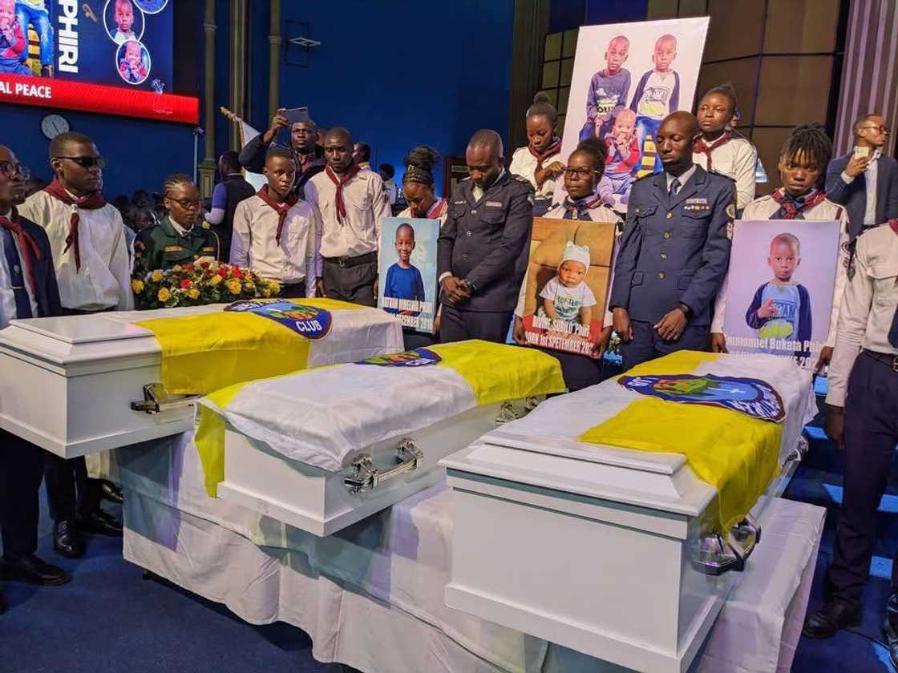Zambian siblings who died after a lightning strike during a burial service. Photo: NKANI.  
Source: Facebook

**How the 3 young siblings died**

The three [young siblings](https://www.tuko.co.ke/people/family/588071-tragedy-lightning-strikes-home-kills-3-siblings/), Nathan, Emmanuel and Subilo, aged seven, four, and two, died after a tragic lightning incident.

The tragedy occurred after the lightning hit their house, sparking a serious fire.

The siblings died in the fire, with their bodies being recovered from the charred remains of the house.

It also emerged that neighbours tried their best to stop the fire, but it overwhelmed them.

Three Nakuru boys who died while fishing buried

Closer home, grief engulfed three families in [Nakuru county](https://www.tuko.co.ke/tags/nakuru-county-news/) as they [laid to rest](https://www.tuko.co.ke/people/family/583016-nakuru-tears-flow-freely-families-bury-3-children-drowned-fishing-river/) three young boys who perished while fishing.

A joint memorial service was held at Karogoe Primary School, where they studied, before the boys were laid to rest.

Their relatives tearfully shared emotional tributes, struggling to come to terms with the devastating loss.